Ontology-based Expert System for a Generic Drug Production of Pharmaceutical Dosage Forms

Software Design Document

By

**Mr. Narongrit Saisuwan 542115017**

**Mr. Panupak Wichaidit 542115047**

Department of Software Engineering

College of Arts, Media and Technology

Chiang Mai University

Project Advisor

………………………………………..

**Dr. Chartchai Doungsa-ard**

# Document History

|  |  |  |  |  |  |  |
| --- | --- | --- | --- | --- | --- | --- |
| **Document Name** | **Version** | **Status** | **Date** | **Viewable** | **Reviewer** | **Responsible** |
| **Documents** | | | | | | |
| **Ontology-based Expert System for a Generic Drug Production of Pharmaceutical Dosage Forms –Software Design Document v.0.1.docx** | **0.1**   * Introduction * Class Diagram * Sequence Diagram | Draft | Jun. 4, 14 | NS, PW, CD | NS, PW | NS, PW |

Contents

[Document History ii](#_Toc391534009)

[Chapter 1 | Introduction 1](#_Toc391534010)

[Chapter 2 | Feature and class diagram relationship 2](#_Toc391534011)

[Chapter 3 | Class Diagram 3](#_Toc391534012)

[3.1 Feature 5: Manage the drug substance property 3](#_Toc391534013)

[3.1.1- CD-01: Solubility Class diagram 4](#_Toc391534014)

[3.1.2- CD-02: Degradation mechanism Class Diagram 9](#_Toc391534015)

[3.1.3- CD-03: Kinetic Reaction Class Diagram 14](#_Toc391534016)

[3.1.4- CD-04: Pka Class diagram 19](#_Toc391534017)

[3.1.5- CD-05: PartitionCoefficient Class diagram 24](#_Toc391534018)

[3.1.6- CD-06: Solidstate Class Diagram 29](#_Toc391534019)

[3.1.7- CD-07: Hygroscopicity Class Diagram 34](#_Toc391534020)

[3.1.8- CD-08: ParticleSize Class diagram 39](#_Toc391534021)

[3.1.9- CD-09: Flowability Class diagram 44](#_Toc391534022)

[3.1.10- CD-10: Density Class diagram 49](#_Toc391534023)

[3.1.11- CD-11: CompoundFunction Class diagram 54](#_Toc391534024)

[3.2 Feature 6: Manage the drug substance 59](#_Toc391534025)

[3.2.1- CD-12: Substance Class diagram 59](#_Toc391534026)

[3.3 Feature 7: Manage the drug Excipient 65](#_Toc391534027)

[3.3.1- CD-13: Substance Class diagram 66](#_Toc391534028)

[3.4 Feature 8: Manage the drug formulation 71](#_Toc391534029)

[3.4.1- CD-13: TabletFormulation Class diagram 71](#_Toc391534030)

[Chapter 4 | Sequence Diagram 76](#_Toc391534031)

[4.1- Feature 5: Manage the drug substance property 77](#_Toc391534032)

[4.1.1 URS-09: The user adds a new substance property into the system. 77](#_Toc391534033)

[4.1.2 URS-10: The user updates an existing substance property into the system. 88](#_Toc391534034)

[4.1.3 URS-11: The user deletes an existing substance property from the system. 99](#_Toc391534035)

[4.2- Feature 6: Manage the drug substance 110](#_Toc391534036)

[4.2.1 URS-12: The user adds a new substance to the system. 110](#_Toc391534037)

[4.2.2 URS-13: The user updates an existing substance in the system. 111](#_Toc391534038)

[4.2.3 URS-14: The user deletes an existing substance from the system. 112](#_Toc391534039)

[4.2.4 URS-15: The user views the substance in the system. 113](#_Toc391534040)

[4.3- Feature 7: Manage the drug substance 114](#_Toc391534041)

[4.3.1 URS-16: The user adds a new excipient to the system. 114](#_Toc391534042)

[4.3.2 URS-17: The user updates an existing excipient in the system. 115](#_Toc391534043)

[4.3.3 URS-18: The user deletes an existing excipient from the system. 116](#_Toc391534044)

[4.3.4 URS-19: The user views the excipient in the system. 117](#_Toc391534045)

[4.4- Feature 8: Manage the drug formulation 118](#_Toc391534046)

[4.4.1 URS-20: The user adds a new drug’s formulation to the system. 118](#_Toc391534047)

[4.4.2 URS-21: The user updates an existing drug’s formulation in the system. 119](#_Toc391534048)

[4.4.3 URS-22: The user deletes an existing drug’s formulation from the system. 120](#_Toc391534049)

[4.4.4 URS-23: The user views the drug’s formulation in the system. 121](#_Toc391534050)

# Chapter 1 | Introduction

Software Design Document (SDD) is translated the requirement into the detail design. The SDD also explains the system architecture in detail. The purposes of the description are making a same understanding about the system. In the 1st progress, the software design consists of the list of feature in a software requirement specification that is illustrated in Figure 1.

|  |  |  |  |  |
| --- | --- | --- | --- | --- |
| **No** | **Feature Name** | **URS No.** | **URS Name** | **Actor** |
| 5 | Manage the drug substance property | URS-09 | The user adds a new substance property into the system. | Expert Pharmacists, Administrator |
| URS-10 | The user updates an existing substance property into the system. |
| URS-11 | The user deletes an existing substance property from the system. |
| 6 | Manage the drug substance | URS-12 | The user adds a new substance into the system. | Expert Pharmacists, Administrator |
| URS-13 | The user updates an existing substance into the system. |
| URS-14 | The user deletes an existing substance from the system. |
| URS-15 | The user views the substance in the system. |
| 7 | Manage the drug excipient | URS-16 | The user adds a new excipient to the system. | Expert Pharmacists, Administrator |
| URS-17 | The user updates an existing drug excipient in the system. |
| URS-18 | The user delete an existing drug excipient in the system. |
| URS-19 | The user views all the drug excipient in the system. |
| 8 | Manage the drug formulation | URS-20 | The user adds a new drug formulation case into the system. | Expert Pharmacists, Administrator |
| URS-21 | The user updates an existing drug formulation case in the system. |
| URS-22 | The user deletes an existing drug formulation case in the system. |
| URS-23 | The user views all of the formulation in the system. |

Table 1: The list of feature in software requirement specification in the 1st progress

# Chapter 2 | Feature and class diagram relationship

In the 1st progress, the feature in the table 1 is related with the class diagram that show on the list below this passage.

**Feature 5: Manage the drug substance property**

* CD-01: solubility class diagram
* CD-02: Degradation mechanism Class Diagram
* CD-03: Kinetic Reaction Class Diagram
* CD-04 :PKA Class Diagram
* CD-05: Partition Coefficient Class Diagram
* CD-06 : Solid state class diagram
* CD-07 :Hygroscopicity class diagram
* CD-09 :Particle Size class diagram
* CD-10 :Flow ability class diagram
* CD-11 :Density class diagram
* CD-12 : Compound Function class diagram

**Feature 6: Manage the drug substance**

* CD-13 :Substance class diagram

**Feature 7: Manage the drug excipient**

* CD-14 : Excipient class diagram

**Feature 8: Manage the drug formulation**

* CD-15 :Tablet Formulation class diagram

# Chapter 3 | Class Diagram

## 3.1 Feature 5: Manage the drug substance property

The feature 5 is the substance property management. The users can add, update and delete the substance property. In the Ontology base expert system for generic drug production of pharmaceutical dosage form, there are 9 substance properties such as solubility, Degradation mechanism, Kinetic reaction, Pka, Partition Coefficient, Solid-state, Hygroscopicity, Flow ability, Particle Size and Density. Each substance property is a necessary attribute to make a substance. The relationship between substance entity and substance property entity is illustrated in the Figure 01 below on this passage.

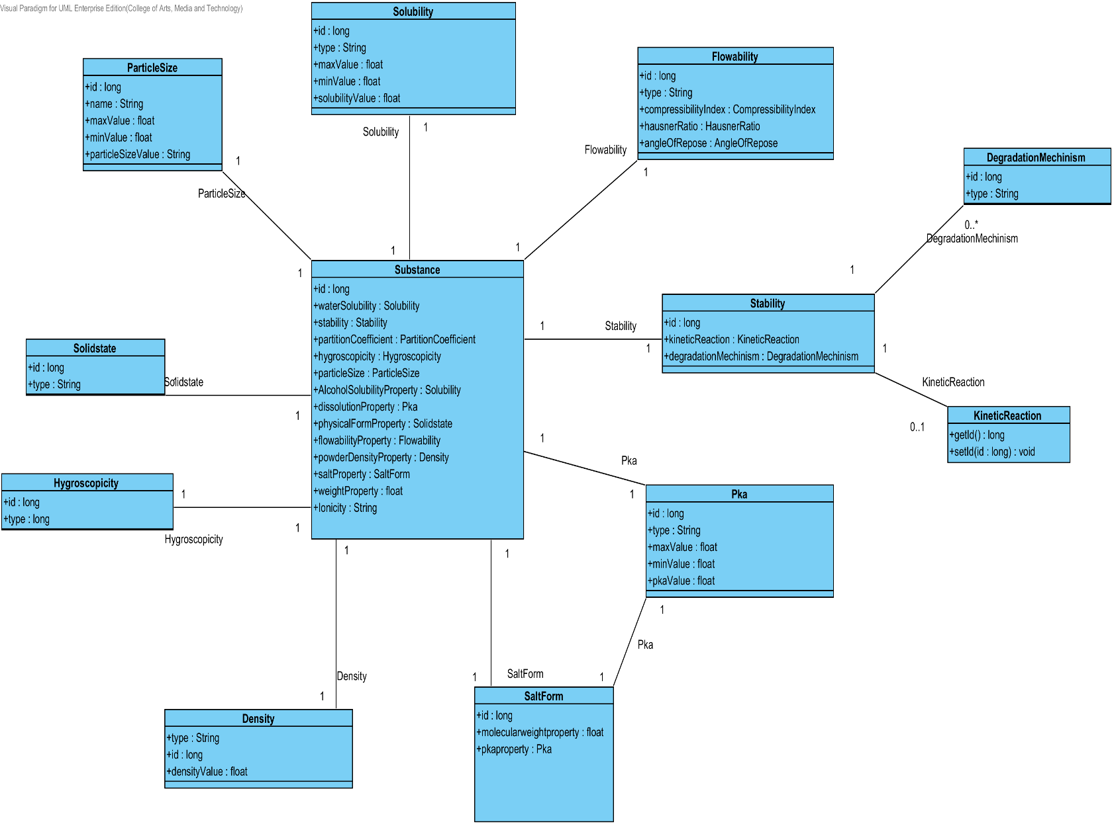

**Figure- 01: The entity relationship between a substance property and a substance.**

### 3.1.1- CD-01: Solubility Class diagram

##### 3.1.1.1: Class diagram

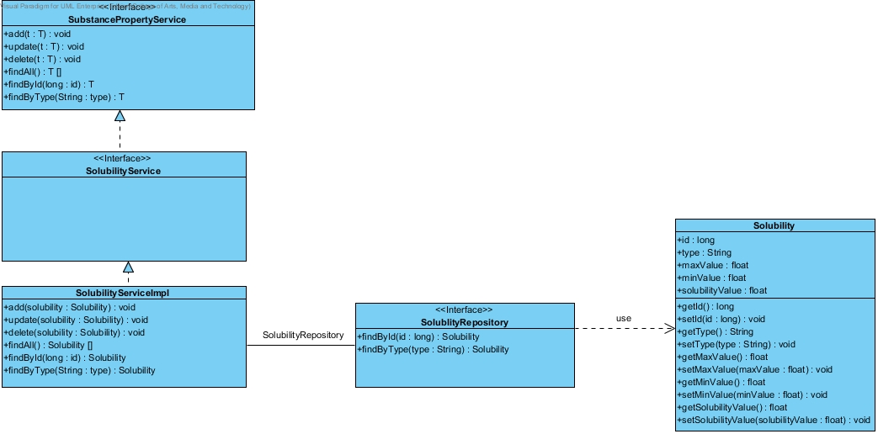

**Figure 02 - CD-01: Solubility Class diagram**

##### 3.1.1.2: Class description

From the figure 2, it can divide into 5 important classes. The detail of each class is described on the next paragraph.

###### 3.1.1.2.1 Solubility class

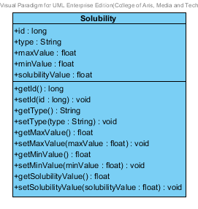

**Figure 03 – The solubility class**

Solubility class is a part of drug’s substance. Solubility class is an entity class that will be saved to the system. The solubility class consists of 5 attributes follow the list below this passage.

3.1.1.2.1.1: Attribute description

* + - **Id** – the identity of the solubility class. Id attribute is a long number.
    - **Type** – the type of the solubility class. In the pharmacy, the solubility type shows a good or bad soluble in each substance. The solubility type value is string.
    - **Max Value** - The max value of each type of solubility. The pharmacists can use the max value and min value for solubility type identification.
    - **Min Value** – The min value of each type of solubility. The pharmacists can use the max value and min value for solubility type identification.
    - **Solubility value** - The solubility value is a value of each type of the solubility. The solubility value is stable value. The value is float number.

3.1.1.2.1.2: Method description

* + - **Getter and Setter method** – It used when the system set value and get value.

###### 3.1.1.2.2 SolubilityRepository Interface

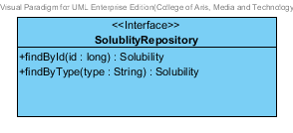

**Figure 04 – The solubility repository interface**

SolubilityRepository Interface is an interface that use for CRUD with entity classes in the system. The most of SolubilityRepository interface’s method is generated from Spring data MongoDB framework. SolubilityRepository interface consists of 5 methods is shown below this passage.

3.1.1.2.2.1: Attribute description

N/A

3.1.1.2.2.2: Method description

* + - **Save (solubility: Solubility)** - The save method is generated from Spring data MongoDB framework. This method is used when the user wants to add a new solubility or update existing solubility to the system. The input variable is a solubility object.
    - **Delete (solubility: Solubility)** – The delete method is generated from Spring data MongoDB framework. This method is used when the user wants to delete the solubility from the system. The input variable is solubility object.
    - **findAll (): Solubility []** – The findAll method is generated from Spring data MongoDB framework. This method is used when the user wants to retrieve all of solubility data from the system. The result of this method is a list of solubility object.
    - **findById (id: long): Solubility** – The findById method is used when the user wants to retrieve the solubility data from the system. The system gets a solubility object by the id of solubility. .
    - **findByType(type: String)** – The findBytype method is used when the user wants to retrieve the solubility data from the system. The system gets a solubility object by the type of solubility.

###### 3.1.1.2.3 SolubilityService

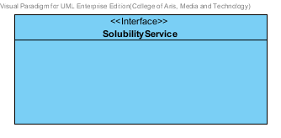

**Figure 05 – The solubility service Interface.**

SolubilityService is business processing logic for solubility entity. SolubilityService manages the solubility data through the SolubilityRepository interface. SolubilityService consists of 6 methods follow the list below this passage.

3.1.1.2.3.1: Attribute description

N/A

3.1.1.2.3.2: Method description

* + - **add (solubility: Solubility)** – The add method is used when the user wants to add the new solubility to the system. This method add a new solubility by input variable of solubility object.
    - **update (solubility: Solubility)** - The update method is used when the user wants to update the existing solubility in the system. This method update solubility by input variable of solubility object.
    - **delete (solubility: Solubility)** – The delete method is used when the user wants to deletes the existing solubility from the system. This method delete the solubility by input variable of solubility object.
    - **findAll() : Solubility[]** – The findAll method is used, when the user wants to get all solubility data in the system. This method is return as a list of solubility object.
    - **findById(id : long) : Solubility** – The findById method is used, when the user wants to get the solubility data in the system. The method gets solubility by id.
    - **findByType(type : String)** –The findByType method is used when the user wants to get solubility data in the system. The method get the solubility data by a type.

###### 3.1.1.2.4 SolubilityServiceImpl

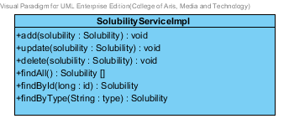

**Figure 06 – The solubility service Impl class**

SolubilityServiceImpl is the solubility service class that implements the method from SolubilityService. So, the method of SolubilityServiceImpl is same as SolubilityService.

3.1.1.2.4.1: Attribute description

* + - **SolubilityRepository** – the repository of solubility. This attribute is used for solubility data management.

3.1.1.2.4.2: Method description

Same as SolubilityService

###### 3.1.1.2.5 SubstancePropertyService

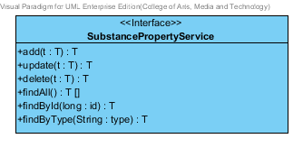

**Figure 07 – The substance property service interface**

SubstancePropertyService is the generic interface that is parameterized over a type. The type of parameter is followed the entity object that user inputs.

### 3.1.2- CD-02: Degradation mechanism Class Diagram

##### D:\All for desktop\Senior project\Software design\DrugExpertClassDiagram(jpg file)\Excipient Package\CD-02 _Degradation mechinism Class Diagram.jpg3.1.2.1: Class diagram

**Figure 08 - CD-02: Degradation mechanism Class Diagram**

##### 3.1.2.2: Class description

From the figure 8, it can divide into 4 important classes. The detail of each class is described on the next paragraph.

###### 3.1.2.2.1 DegradationMechinism class

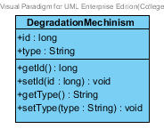

**Figure 09 – The Degradation Mechanism class**

DegradationMechinism class is a part of drug’s substance. DegradationMechinism class is an entity class that will be saved to the system. The DegradationMechinism class consists of 2 attributes follow the list below this passage.

3.1.2.2.1.1: Attribute description

* + - **Id** – The identity of the degradationMechinism class. Id attribute is a long number.
    - **Type** – The type of the degradationMechinism class. In the pharmacy, the degradationMechinism type show process of degrading in each substance. The degradationMechinism type attribute is string.

3.1.2.2.1.2: Method description

* + - **Getter and Setter method** – It used when the system set value and get value.

###### 3.1.2.2.2 DegradationMechinism Repository Interface

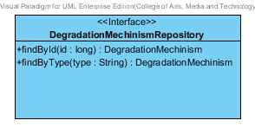

**Figure -10: The Degradation Mechanism Repository**

DegradationMechinismRepository Interface is an interface that use for CRUD with entity classes in the system. The most of DegradationMechinismRepository interface’s method is generated from Spring data MongoDB framework. DegradationMechinismRepository interface consists of 5 methods is shown below this passage.

3.1.2.2.2.1: Attribute description

N/A

3.1.2.2.2.2: Method description

* + - **Save (degradationMechinism: DegradationMechinism)** - The save method is generated from Spring data MongoDB framework. This method is used when the user want to add a new DegradationMechinism or update existing DegradationMechinism to the system. The input variable is a DegradationMechinism object.
    - **Delete (degradationMechinism: DegradationMechinism)** – The delete method is generated from Spring data MongoDB framework. This method is used when the user wants to delete the degradationMechinism from the system. The input variable is degradationMechinism object.
    - **findAll (): DegradationMechinism []** – The findAll is generated from Spring data MongoDB framework. This method is used when the user wants to retrieve all of degradationMechinism data from the system. The result of this method is a list of degradationMechinism.
    - **findById (id: long): DegradationMechinism** – The findById method is generated from Spring data MongoDB framework. The developer can makes configuration at this method for query the data by themselves. The findById is used when the user wants to retrieve the degradationMechinism data from the system. The input variable is id. The findById gets the DegradationMechinism object by the id of DegradationMechinism.
    - **findByType (type: String)** – The findByType method is generated from Spring data MongoDB framework. The developer can make configuration at this method for query the data by themselves. The findBytype method is used when the user wants to retrieve the degradationMechinism data from the system. The findByType gets the DegradationMechinism object by the type of DegradationMechinism.

###### 3.1.2.2.3 DegradationMechinismService

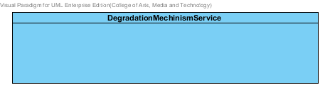

**Figure -11: The Degradation Mechanism Service**

DegradationMechinismService is business processing logic for DegradationMechinism entity. DegradationMechinismService manages the degradationMechinism data through the DegradationMechinismRepository interface. DegradationMechinismService consists of 6 methods follow the list below this passage.

3.1.2.2.3.1: Attribute description

N/A

3.1.2.2.3.2: Method description

* + - **add (degradationMechinism: DegradationMechinism)** – The add method is used when the user wants to add the new DegradationMechinism to the system. The input variable of this method is the degradationMechinism object.
    - **update (degradationMechinism: DegradationMechinism)** - The update method is used when the user wants to update the existing degradationMechinism in the system. This method update the degradationMechinism by input variable of degradationMechinism object.
    - **delete (degradationMechinism: DegradationMechinism)** – The delete method is used when the user wants to deletes the existing degradationMechinism from the system. This method delete the degradationMechinism by input variable of degradationMechinism object.
    - **findAll():DegradationMechinism []** – The findAll method is used when the user wants to get all data of degradationMechinism in the system. This method is return as a list of degradationMechinism.
    - **findById (id: long): DegradationMechinism** – The findById method is used when the user wants to get the degradationMechinism data in the system. The method get the degradationMechinism object by a type of DegradationMechinism.
    - **findByType(type: String) : DegradationMechinism** –The findByType method is used when the user wants to get degradationMechinism data in the system. The method get the degradationMechinism object by a type of DegradationMechinism.

###### 3.1.2.2.4 DegradationMechinismServiceImpl

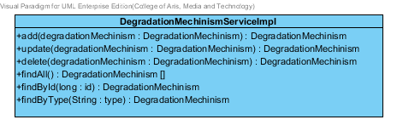

**Figure -12: The Degradation Mechanism Service**

DegradationMechinismServiceImpl is the service class that implements the method from DegradationMechinismService. So, the method of DegradationMechinismServiceImpl is same as DegradationMechinismService.

3.1.2.2.4.1: Attribute description

* + - **DegradationMechinismRepository** – the repository of DegradationMechinism. This attribute is used for DegradationMechinism data management.

3.1.2.2.4.2: Method description

Same as DegradationMechinismService

###### 3.1.2.2.5 SubstancePropertyService

Same as SubstancePropertyService at Solubility class diagram.

### 3.1.3- CD-03: Kinetic Reaction Class Diagram

##### 3.1.3.1: Class diagram

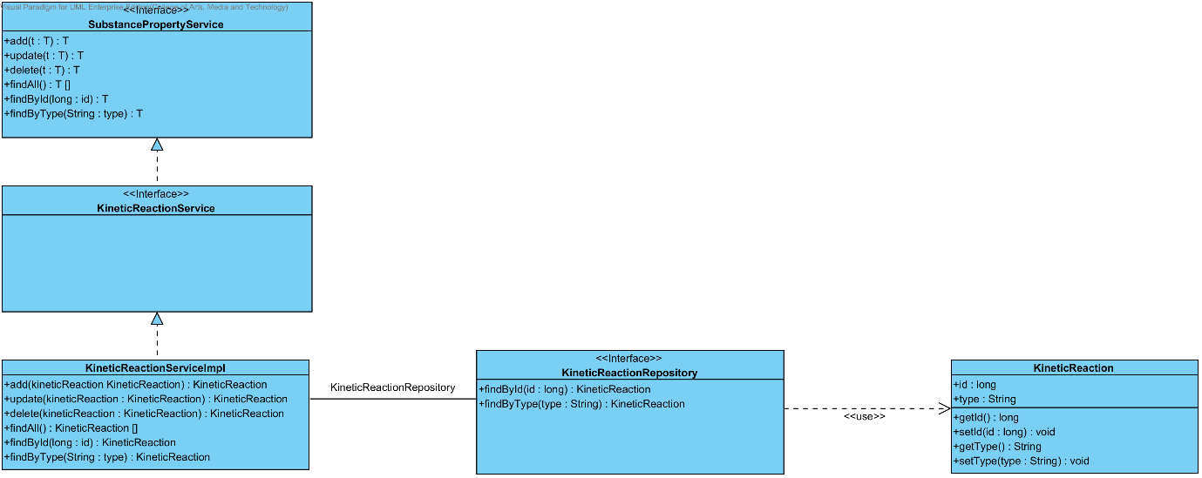

**Figure 12 - CD-03: Kinetic Reaction Class Diagram**

##### 3.1.3.2: Class description

From the figure 8, it can divide into 4 important classes. The detail of each class is described on the next paragraph.

###### 3.1.3.2.1 Kinetic Reaction class

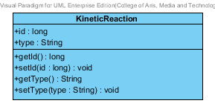

**Figure 13 – The Kinetic Reaction class**

KineticReaction class is a part of drug’s substance. KineticReaction class is an entity class that will be saved to the system. The KineticReaction class consists of 2 attributes follow the list below this passage.

3.1.3.2.1.1: Attribute description

* + - **Id** – The identity of the kineticReaction class. Id attribute is a long number.
    - **Type** – The type of the kineticReaction class. In the pharmacy, the kineticReaction type shows the reaction of a substance motion. The kineticReaction type attribute is a string.

3.1.3.2.1.2: Method description

* + - **Getter and Setter method** – It used when the system set value and get value.

###### 3.1.3.2.2 KineticReaction Repository Interface

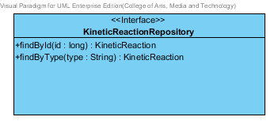

**Figure -14: The KineticReaction Repository**

KineticReactionRepository Interface is an interface that use for CRUD with entity classes in the system. The most of KineticReaction interface’s method is generated from Spring data MongoDB framework. KineticReaction interface consists of 5 methods is shown below this passage.

3.1.3.2.2.1: Attribute description

N/A

3.1.3.2.2.2: Method description

* + - **Save (kineticReaction: KineticReaction)** - The save method is generated from Spring data MongoDB framework. This method is used when the user wants to add a new KineticReaction or update existing KineticReaction to the system. The input variable is a KineticReaction object.
    - **Delete (kineticReaction: KineticReaction)** – The delete method is generated from Spring data MongoDB framework. This method is used when the user wants to delete the KineticReaction from the system. The input variable is KineticReaction object.
    - **findAll ():KineticReaction []** – The findAll is generated from Spring data MongoDB framework. This method is used when the user wants to retrieve all of KineticReaction data from the system. The result of this method is a list of kineticReaction.
    - **findById (id: long): KineticReaction** – The findById method is generated from Spring data MongoDB framework. The developers can make configuration at this method for query the data by themselves. The findById is used when the user wants to retrieve the kineticReaction data from the system. The input variable is id. The findById gets the kineticReaction object by the kineticReaction’s Id.
    - **findByType (type: String)** – The findByType method is generated from Spring data MongoDB framework. The developers can make configuration at this method for query the data by themselves. The findBytype method is used when the user wants to retrieve the kineticReaction data from the system. The findByType gets the kineticReaction object by the kineticReaction’s type.

###### 3.1.3.2.3 KineticReactionService

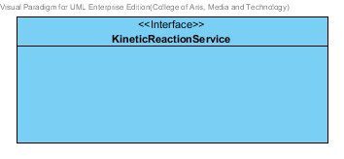

**Figure -15: The KineticReaction Service**

KineticReactionService is business processing logic for KineticReaction entity. KineticReactionService manages the kineticReaction data through the KineticReactionRepository interface. KineticReactionService consists of 6 methods follow the list below this passage.

3.1.3.2.3.1: Attribute description

N/A

3.1.3.2.3.2: Method description

* + - **add (kineticReaction: KineticReaction)** – The add method is used when the user wants to add the new kineticReaction to the system. This method add a new kineticReaction by input variable of kineticReaction object.
    - **update (kineticReaction: KineticReaction)** - The update method is used when the user wants to update the existing kineticReaction in the system. This method update the kineticReaction by input variable of kineticReaction object.
    - **delete (kineticReaction: KineticReaction)** – The delete method is used when the user wants to deletes the existing kineticReaction from the system. This method delete the kineticReaction by input variable of kineticReaction object.
    - **findAll():KineticReaction []** – The findAll method is used when the user wants to get all data of kineticReaction in the system. This method is return as a list of kineticReaction.
    - **findById (id: long): KineticReaction** – The findById method is used when the user wants to get the kineticReaction data in the system. The method get the kineticReaction object by a type of KineticReaction.
    - **findByType(type: String) : KineticReaction** –The findByType method is used when the user wants to get kineticReaction data in the system. The method get the kineticReaction object by a type of KineticReaction.

###### 3.1.3.2.4 KineticReactionServiceImpl



**Figure -16: The KineticReactionServiceImpl**

KineticReactionServiceImpl is the service class that implements the method from KineticReactionService. So, the method of KineticReactionServiceImpl is same as KineticReactionService.

3.1.3.2.4.1: Attribute description

* + - **KineticReactionRepository** – the repository of ▪ KineticReaction.

This attribute is used for KineticReaction data management.

3.1.3.2.4.2: Method description

Same as KineticReactionServiceImpl

###### 3.1.3.2.5 SubstancePropertyService

Same as SubstancePropertyService at Solubility class diagram.

### 3.1.4- CD-04: Pka Class diagram

##### 3.1.4.1: Class diagram

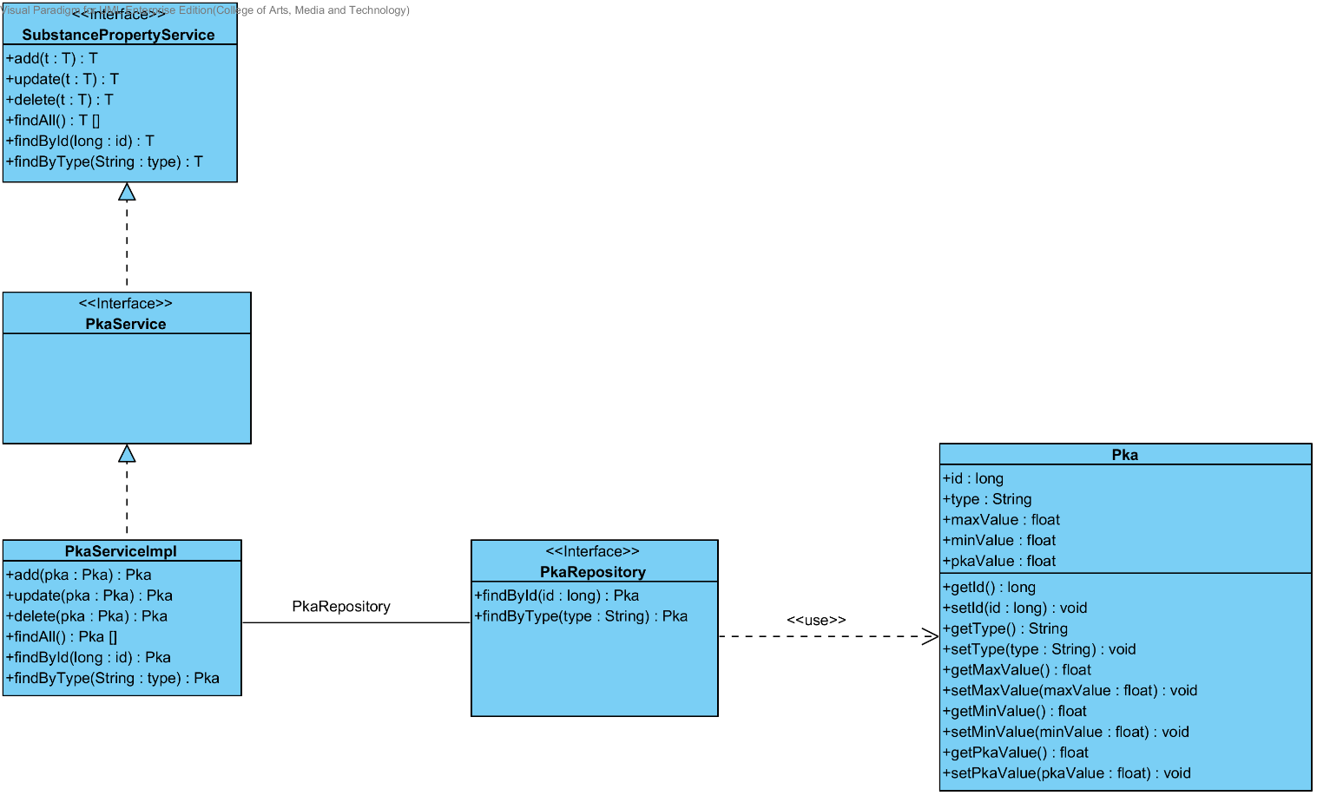

**Figure 17 - CD-04: Pka Class diagram**

##### 3.1.4.2: Class description

From the figure 17, it can divide into 4 important classes. The detail of each class is described on the next paragraph.

###### 3.1.4.2.1 Pka class

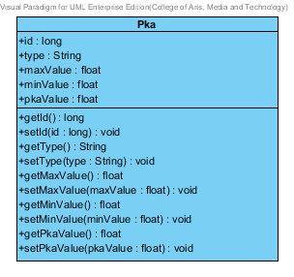

**Figure 18 – The pka class**

Pka class is a part of drug’s substance. Pka class is an entity class that will be saved to the system. The pka class consists of 5 attributes follow the list below this passage.

3.1.4.2.1.1: Attribute description

* + - **Id** – the identity of the pka class. Id attribute is a long number.
    - **Type** – the type of the pka class. In the pharmacy, the pka type shows a pka in each substance property. The pka type value is string.
    - **Max Value** - The max value of each type of pka. The pharmacists can use the max value and min value for pka type identification.
    - **Min Value** – The min value of each type of pka. The pharmacists can use the max value and min value for pka type identification.
    - **Pka value** - The pka value is a value of each type of the pka. The pka value is stable value. The value is float number.

3.1.4.2.1.2: Method description

* + - **Getter and Setter method** – It used when the system set value and get value.

###### 3.1.4.2.2 PkaRepository Interface

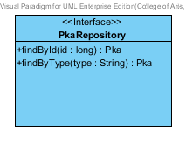

**Figure 19 – The pka repository interface**

PkaRepository Interface is an interface that use for CRUD with entity classes in the system. The most of PkaRepository interface’s method is generated from Spring data MongoDB framework. PkaRepository interface consists of 5 methods is shown below this passage.

3.1.4.2.2.1: Attribute description

N/A

3.1.4.2.2.2: Method description

* + - **Save (pka: Pka)** - The save method is generated from Spring data MongoDB framework. This method is used when the user wants to add a new pka or update existing pka to the system. The input variable is a pka object.
    - **Delete (pka: Pka)** – The delete method is generated from Spring data MongoDB framework. This method is used when the user wants to delete the pka from the system. The input variable is pka object.
    - **findAll (): Pka []** – The findAll method is generated from Spring data MongoDB framework. This method is used when the user wants to retrieve all of pka data from the system. The result of this method is a list of pka object.
    - **findById (id: long): Pka** – The findById method is used when the user wants to retrieve the pka data from the system. The system gets a pka object by the id of pka .
    - **findByType(type: String)** – The findBytype method is used when the user wants to retrieve the pka data from the system. The system gets a pka object by the type of pka.

###### 3.1.4.2.3 PkaService

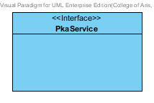

**Figure 20 – The pka service Interface.**

PkaService is business processing logic for the pka entity. PkaService manages the pka data through the PkaRepository interface. PkaService consists of 6 methods follow the list below this passage.

3.1.4.2.3.1: Attribute description

N/A

3.1.4.2.3.2: Method description

* + - **add (pka: Pka)** – The add method is used when the user wants to add the new pka to the system. This method add a new pka by input variable of pka object.
    - **update (pka: Pka)** - The update method is used when the user wants to update the existing pka in the system. This method update the pka by input variable of pka object.
    - **delete (pka: Pka)** – The delete method is used when the user wants to deletes the existing pka from the system. This method delete the pka by input variable of pka object.
    - **findAll() : Pka[]** – The findAll method is used, when the user wants to get all pka data in the system. This method is return as a list of pka object.
    - **findById(id : long) : Pka** – The findById method is used, when the user wants to get the pka object from the system. The method gets pka by Pka’s id .
    - **findByType(type : String)** –The findByType method is used when the user wants to get pka object from the system. The method get the pka data by a type.

###### 3.1.4.2.4 PkaServiceImpl

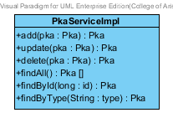

**Figure 21 – The PkaServiceImpl class**

PkaServiceImpl is the pka service class that implements the method from PkaService. So, the method of PkaServiceImpl is same as PkaService.

3.1.4.2.4.1: Attribute description

* + - **PkaRepository** – the repository of Pka. This attribute is used for Pka data management.

3.1.4.2.4.2: Method description

Same as PkaService

###### 3.1.4.2.5 SubstancePropertyService

Same as SubstancePropertyService at Solubility class diagram.

### 3.1.5- CD-05: PartitionCoefficient Class diagram

##### 3.1.5.1: Class diagram

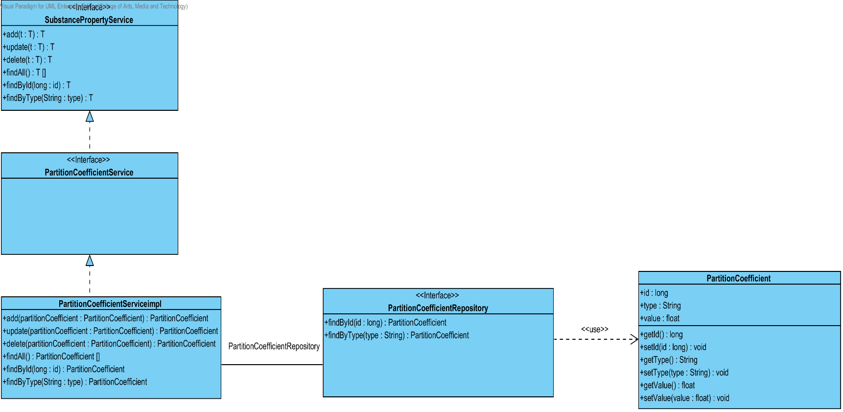

**Figure 20 - CD-05: PartitionCoefficient Class diagram**

##### 3.1.5.2: Class description

From the figure 17, it can divide into 4 important classes. The detail of each class is described on the next paragraph.

###### 3.1.5.2.1 PartitionCoefficient class

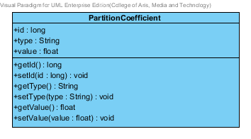

**Figure 21 – The PartitionCoefficient class**

PartitionCoefficient class is a part of drug’s substance. PartitionCoefficient class is an entity class that will be saved to the system. The PartitionCoefficient class consists of 5 attributes follow the list below this passage.

3.1.5.2.1.1: Attribute description

* + - **Id** – the identity of the PartitionCoefficient class. Id attribute is a long number.
    - **Type** – the type of the PartitionCoefficient class. In the pharmacy, the Partition Coefficient type shows a type of partition coefficient in each substance property. The PartitionCoefficient type value is string.
    - **PartitionCoefficient value** - The PartitionCoefficient value is a value of each type of the Partition Coefficient. The Partition Coefficient value is stable value. The value is float number.

3.1.5.2.1.2: Method description

* + - **Getter and Setter method** – It used when the system set value and get value.

###### 3.1.5.2.2 PartitionCoefficientRepository Interface

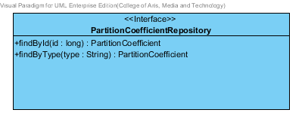

**Figure 22 – The PartitionCoefficient repository interface**

PartitionCoefficient Repository Interface is an interface that use for CRUD with entity classes in the system. The most of PartitionCoefficientRepository interface’s method is generated from Spring data MongoDB framework. PartitionCoefficient Repository interface consists of 5 methods is shown below this passage.

3.1.5.2.2.1: Attribute description

N/A

3.1.5.2.2.2: Method description

* + - **Save (partitionCoefficient: PartitionCoefficient)** - The save method is generated from Spring data MongoDB framework. This method is used when the user wants to add a new PartitionCoefficient or update existing PartitionCoefficient to the system. The input variable is a PartitionCoefficient object.
    - **Delete (partitionCoefficient: PartitionCoefficient)** – The delete method is generated from Spring data MongoDB framework. This method is used when the user wants to delete the partitionCoefficient from the system. The input variable is the partitionCoefficient object.
    - **findAll (): PartitionCoefficient []** – The findAll method is generated from Spring data MongoDB framework. This method is used when the user wants to retrieve all of partitionCoefficient data from the system. The result of this method is a list of partitionCoefficient object.
    - **findById (id: long): Pka** – The findById method is used when the user wants to retrieve the PartitionCoefficient data from the system. The system gets a PartitionCoefficient object by the id of PartitionCoefficient.
    - **findByType(type: String)** – The findBytype method is used when the user wants to retrieve the partitionCoefficient data from the system. The system gets a partitionCoefficient object by the type of partitionCoefficient.

###### 3.1.5.2.3 PartitionCoefficientService

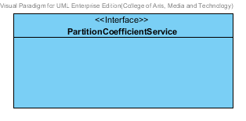

**Figure 23 – The PartitionCoefficient service Interface.**

PartitionCoefficientService is business processing logic for PartitionCoefficient entity. PartitionCoefficientService manages the partitionCoefficient data through the PartitionCoefficient Repository interface. PartitionCoefficientService consists of 6 methods follow the list below this passage.

3.1.5.2.3.1: Attribute description

N/A

3.1.5.2.3.2: Method description

* + - **add (partitionCoefficient: PartitionCoefficient)** – The add method is used when the user wants to add the new PartitionCoefficient to the system. This method add a new PartitionCoefficient by input variable of PartitionCoefficient object.
    - **update (partitionCoefficient: PartitionCoefficient)** - The update method is used when the user wants to update the existing PartitionCoefficient in the system. This method update the PartitionCoefficient by input variable of PartitionCoefficient object.
    - **delete (partitionCoefficient: PartitionCoefficient)** – The delete method is used when the user wants to deletes the existing PartitionCoefficient from the system. This method delete the PartitionCoefficient by input variable of PartitionCoefficient object.
    - **findAll() : PartitionCoefficient []** – The findAll method is used, when the user wants to get all PartitionCoefficient data in the system. This method is return as a list of PartitionCoefficient object.
    - **findById(id : long) : PartitionCoefficient** – The findById method is used, when the user wants to get the PartitionCoefficient object from the system. The method gets pka by PartitionCoefficient’s id .
    - **findByType(type : String) : PartitionCoefficient** –The findByType method is used when the user wants to get PartitionCoefficient object from the system. The method get the PartitionCoefficient data by a type.

###### 3.1.5.2.4 PartitionCoefficientServiceImpl

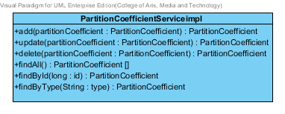

**Figure 24 – The PartitionCoefficientImpl class**

PartitionCoefficientImpl is the PartitionCoefficient service class that implements the method from PartitionCoefficientService. So, the method of PartitionCoefficientServiceImpl is same as PartitionCoefficientService.

3.1.4.2.4.1: Attribute description

* + - **PartitionCoefficientRepository** – the repository of PartitionCoefficient. This attribute is used for PartitionCoefficient data management.

3.1.4.2.4.2: Method description

Same as PartitionCoefficientService

###### 3.1.4.2.5 SubstancePropertyService

Same as SubstancePropertyService at Solubility class diagram.

### 3.1.6- CD-06: Solidstate Class Diagram

##### 3.1.6.1: Class diagram

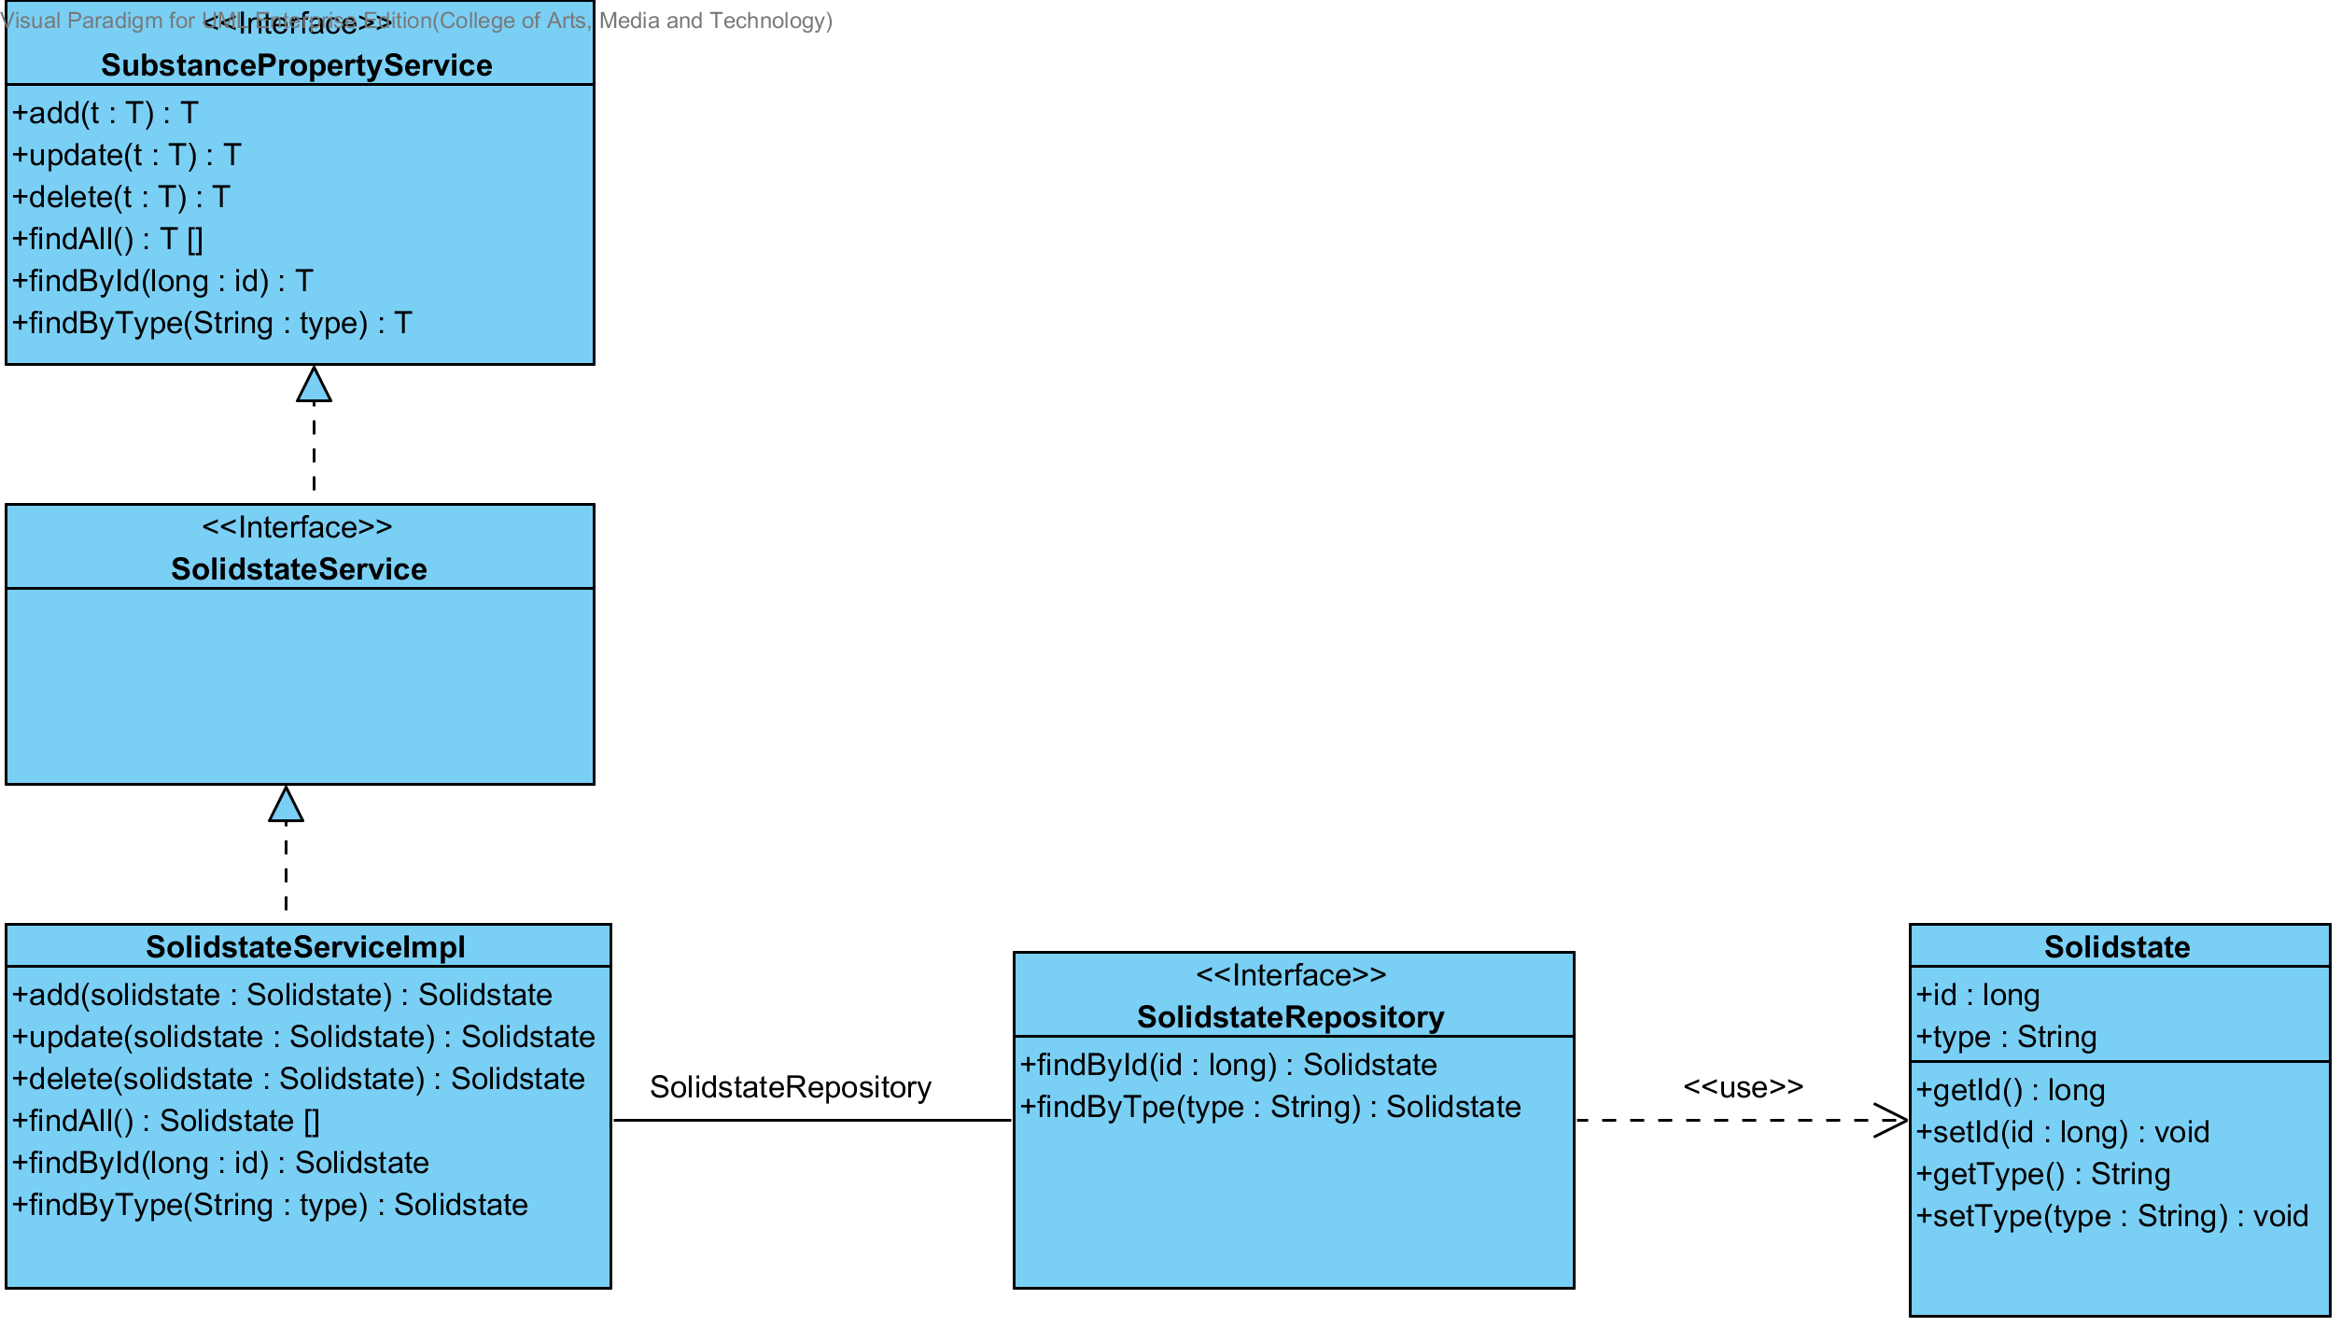

**Figure 25 - CD-06: Solidstate Class Diagram**

##### 3.1.6.2: Class description

From the figure 25, it can divide into 4 important classes. The detail of each class is described on the next paragraph.

###### 3.1.6.2.1 Solidstate class

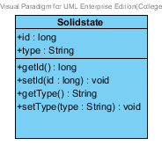

**Figure 26 – The Solidstate class**

Solidstate class is a part of drug’s substance. Solidstate class is an entity class that will be saved to the system. The Solidstate class consists of 2 attributes follow the list below this passage.

3.1.6.2.1.1: Attribute description

* + - **Id** – The identity of the Solidstate class. Id attribute is a long number.
    - **Type** – The type of the Solidstate class. In the pharmacy, the Solidstate type shows the level of solid in each Solidstate. The Solidstate type attribute is a string.

3.1.6.2.1.2: Method description

* + - **Getter and Setter method** – It used when the system set value and get value.

###### 3.1.6.2.2 Solidstate Repository Interface

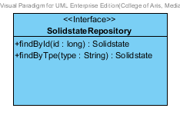

**Figure -27: The Solidstate Repository**

SolidstateRepository Interface is an interface that use for CRUD with entity classes in the system. The most of Solidstate interface’s method is generated from Spring data MongoDB framework. Solidstate interface consists of 5 methods is shown below this passage.

3.1.6.2.2.1: Attribute description

N/A

3.1.6.2.2.2: Method description

* + - **Save (solidstate: Solidstate)** - The save method is generated from Spring data MongoDB framework. This method is used when the user wants to add a new Solidstate or update existing Solidstate to the system. The input variable is a Solidstate object.
    - **Delete (solidstate: Solidstate)** – The delete method is generated from Spring data MongoDB framework. This method is used when the user wants to delete the Solidstate from the system. The input variable is Solidstate object.
    - **findAll (): Solidstate []** – The findAll is generated from Spring data MongoDB framework. This method is used when the user wants to retrieve all of Solidstate data from the system. The result of this method is a list of Solidstate.
    - **findById (id: long): Solidstate** – The findById method is generated from Spring data MongoDB framework. The developers can make configuration at this method for query the data by themselves. The findById is used when the user wants to retrieve the Solidstate data from the system. The findById gets the Solidstate object by the Solidstate’s Id.
    - **findByType (type: String)** – The findByType method is generated from Spring data MongoDB framework. The developers can make configuration at this method for query the data by themselves. The findBytype method is used when the user wants to retrieve the Solidstate data from the system. The findByType gets the Solidstate object by the Solidstate’s type.

###### 3.1.6.2.3 SolidstateService

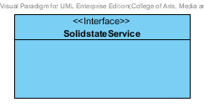

**Figure -28: The Solidstate Service**

SolidstateService is business processing logic for Solidstate entity. SolidstateService manages the Solidstate data through the SolidstateRepository interface. SolidstateService consists of 6 methods follow the list below this passage.

3.1.6.2.3.1: Attribute description

N/A

3.1.6.2.3.2: Method description

* + - **add (solidstate: Solidstate)** – The add method is used when the user wants to add the new Solidstate to the system. This method add a new Solidstate by input variable of Solidstate object.
    - **update (solidstate: Solidstate)** - The update method is used when the user wants to update the existing Solidstate in the system. This method update the Solidstate by input variable of Solidstate object.
    - **delete (solidstate: Solidstate)** – The delete method is used when the user wants to deletes the existing Solidstate from the system. This method delete the Solidstate by input variable of Solidstate object.
    - **findAll():Solidstate []** – The findAll method is used when the user wants to get all data of Solidstate in the system. This method is return as a list of Solidstate.
    - **findById (id: long): Solidstate** – The findById method is used when the user wants to get the Solidstate data in the system. The method get the Solidstate object by a type of Solidstate.
    - **findByType(type: String) : Solidstate** –The findByType method is used when the user wants to get Solidstate data in the system. The method get the Solidstate object by a type of Solidstate.

###### 3.1.6.2.4 SolidstateServiceImpl

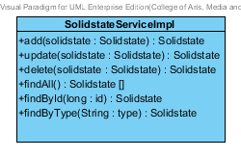

**Figure -29: The SolidstateServiceImpl**

SolidstateServiceImpl is the service class that implements the method from SolidstateService. So, the method of SolidstateServiceImpl is same as SolidstateService.

3.1.6.2.4.1: Attribute description

* + - **SolidstateRepository** – the repository of Solidstate. This attribute is used for Solidstate data management.

3.1.6.2.4.2: Method description

Same as KineticReactionServiceImpl

###### 3.1.6.2.5 SubstancePropertyService

Same as SubstancePropertyService at Solubility class diagram.

### 3.1.7- CD-07: Hygroscopicity Class Diagram

##### 3.1.7.1: Class diagram

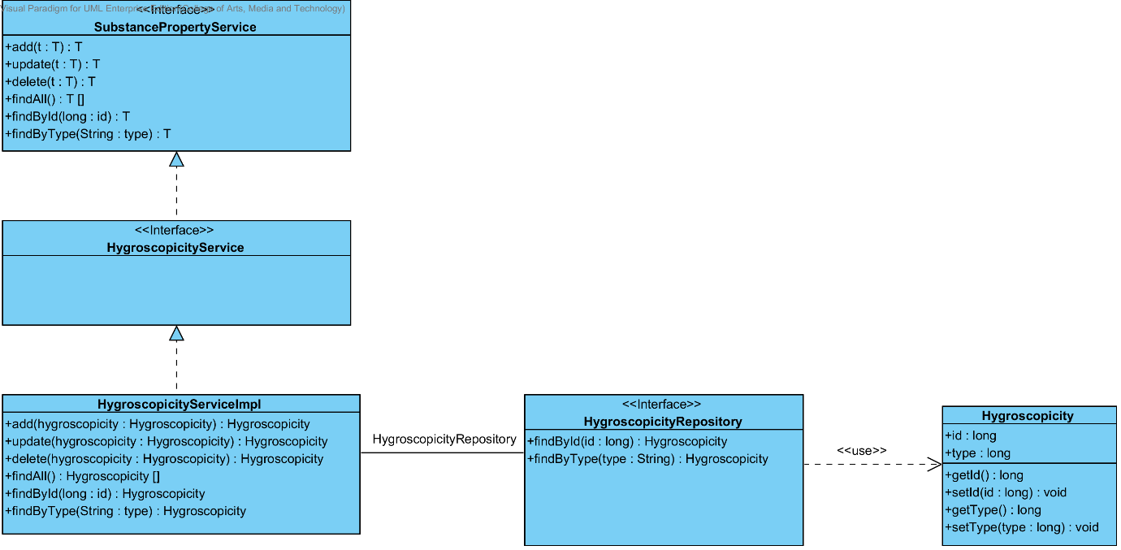

**Figure 30 - CD-07: Hygroscopicity Class Diagram**

##### 3.1.7.2: Class description

From the figure 30, it can divide into 4 important classes. The detail of each class is described on the next paragraph.

###### 3.1.7.2.1 Hygroscopicity class

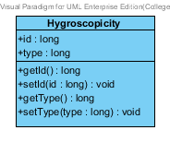

**Figure 31 – The Hygroscopicity class**

Hygroscopicity class is a part of drug’s substance. Hygroscopicity class is an entity class that will be saved to the system. The Hygroscopicity class consists of 2 attributes follow the list below this passage.

3.1.7.2.1.1: Attribute description

* + - **Id** – The identity of the Hygroscopicity class. Id attribute is a long number.
    - **Type** – The type of the Hygroscopicity class. The Hygroscopicity type attribute is a string.

3.1.7.2.1.2: Method description

* + - **Getter and Setter method** – It used when the system set value and get value.

###### 3.1.7.2.2 HygroscopicityRepository Interface

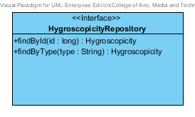

**Figure -32: The Hygroscopicity Repository**

HygroscopicityRepository Interface is an interface that use for CRUD with entity classes in the system. The most of Hygroscopicity interface’s method is generated from Spring data MongoDB framework. Hygroscopicity interface consists of 5 methods is shown below this passage.

3.1.7.2.2.1: Attribute description

N/A

3.1.7.2.2.2: Method description

* + - **Save (hygroscopicity: Hygroscopicity)** - The save method is generated from Spring data MongoDB framework. This method is used when the user wants to add a new Hygroscopicity or update existing Hygroscopicity to the system. The input variable is a Hygroscopicity object.
    - **Delete (hygroscopicity: Hygroscopicity)** – The delete method is generated from Spring data MongoDB framework. This method is used when the user wants to delete the Hygroscopicity from the system. The input variable is Hygroscopicity object.
    - **findAll ():Hygroscopicity []** – The findAll is generated from Spring data MongoDB framework. This method is used when the user wants to retrieve all of Hygroscopicity data from the system. The result of this method is a list of Hygroscopicity.
    - **findById (id: long): Hygroscopicity** – The findById method is generated from Spring data MongoDB framework. The developers can make configuration at this method for query the data by themselves. The findById is used when the user wants to retrieve the Hygroscopicity data from the system. The findById gets the Hygroscopicity object by the Hygroscopicity’s Id.
    - **findByType (type: String) : Hygroscopicity** – The findByType method is generated from Spring data MongoDB framework. The developers can make configuration at this method for query the data by themselves. The findBytype method is used when the user wants to retrieve the Hygroscopicity data from the system. The findByType gets the Hygroscopicity object by the Hygroscopicity’s type.

###### 3.1.7.2.3 HygroscopicityService

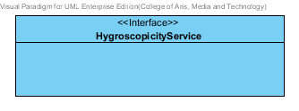

**Figure -33: The Hygroscopicity Service**

HygroscopicityService is business processing logic for Hygroscopicity entity. HygroscopicityService manages the Hygroscopicity data through the HygroscopicityRepository interface. HygroscopicityService consists of 6 methods follow the list below this passage.

3.1.7.2.3.1: Attribute description

N/A

3.1.7.2.3.2: Method description

* + - **add (hygroscopicity: Hygroscopicity)** – The add method is used when the user wants to add the new Hygroscopicity to the system. This method add a new Hygroscopicity by input variable of Hygroscopicity object.
    - **update (hygroscopicity: Hygroscopicity)** - The update method is used when the user wants to update the existing Hygroscopicity in the system. This method update the Hygroscopicity by input variable of Hygroscopicity object.
    - **delete (hygroscopicity: Hygroscopicity)** – The delete method is used when the user wants to deletes the existing Hygroscopicity from the system. This method delete the Hygroscopicity by input variable of Hygroscopicity object.
    - **findAll():Hygroscopicity []** – The findAll method is used when the user wants to get all data of Hygroscopicity in the system. This method is return as a list of Hygroscopicity.
    - **findById (id: long): Hygroscopicity** – The findById method is used when the user wants to get the Hygroscopicity data in the system. The method get the Hygroscopicity object by a type of Hygroscopicity.
    - **findByType(type: String) : Hygroscopicity** –The findByType method is used when the user wants to get Hygroscopicity data in the system. The method get the Hygroscopicity object by a type of Hygroscopicity.

###### 3.1.7.2.4 HygroscopicityServiceImpl

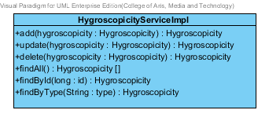

**Figure -34: The HygroscopicityServiceImpl**

HygroscopicityServiceImpl is the service class that implements the method from HygroscopicityService. So, the method of HygroscopicityServiceImpl is same as HygroscopicityService.

3.1.6.2.4.1: Attribute description

* + - **HygroscopicityRepository** – the repository of Hygroscopicity. This attribute is used for Hygroscopicity data management.

3.1.6.2.4.2: Method description

Same as HygroscopicityServiceImpl

###### 3.1.6.2.5 SubstancePropertyService

Same as SubstancePropertyService at Solubility class diagram.

### 3.1.8- CD-08: ParticleSize Class diagram

##### 3.1.8.1: Class diagram

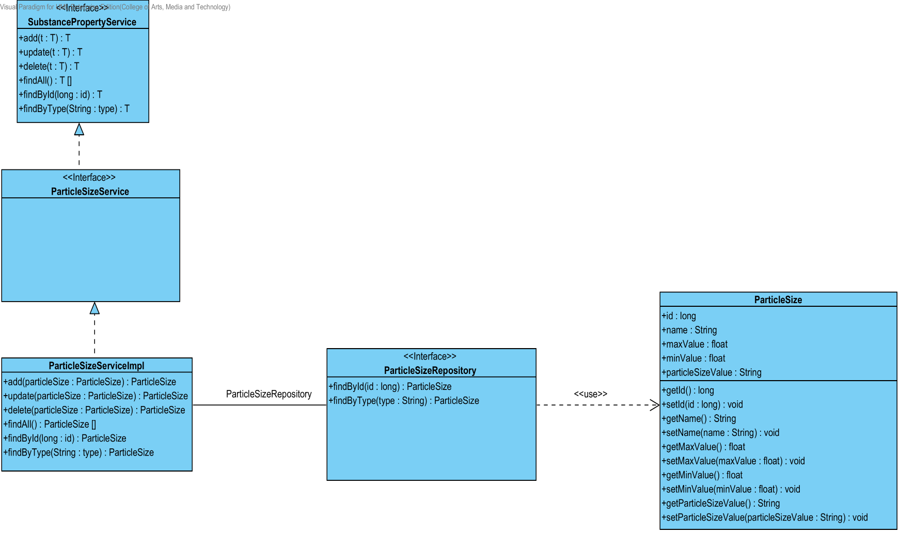

**Figure 35 - CD-08: ParticleSize Class diagram**

##### 3.1.8.2: Class description

From the figure 35, it can divide into 4 important classes. The detail of each class is described on the next paragraph.

###### 3.1.8.2.1 ParticleSize class

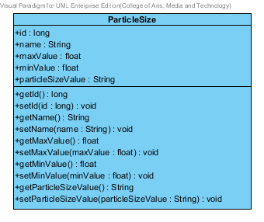

**Figure 36 – The ParticleSize class**

ParticleSize class is a part of drug’s substance. ParticleSize class is an entity class that will be saved to the system. The ParticleSize class consists of 5 attributes follow the list below this passage.

3.1.8.2.1.1: Attribute description

* + - **Id** – the identity of the ParticleSize class. Id attribute is a long number.
    - **Type** – the type of the ParticleSize class. The ParticleSize type value is string.
    - **Max Value** - The max value of each type of ParticleSize. The pharmacists can use the max value and min value for ParticleSize type identification.
    - **Min Value** – The min value of each type of ParticleSize. The pharmacists can use the max value and min value for ParticleSize type identification.
    - **ParticleSize value** - The ParticleSize value is a value of each type of the ParticleSize. The ParticleSize value is stable value. The value is float number.

3.1.8.2.1.2: Method description

* + - **Getter and Setter method** – It used when the system set value and get value.

###### 3.1.8.2.2 ParticleSizeRepository Interface

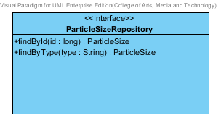

**Figure 37 – The ParticleSizeRepository interface**

ParticleSizeRepository Interface is an interface that use for CRUD with entity classes in the system. The most of ParticleSizeRepository interface’s method is generated from Spring data MongoDB framework. ParticleSizeRepository interface consists of 5 methods is shown below this passage.

3.1.8.2.2.1: Attribute description

N/A

3.1.8.2.2.2: Method description

* + - **Save (particleSize: ParticleSize)** - The save method is generated from Spring data MongoDB framework. This method is used when the user wants to add a new ParticleSize or update existing ParticleSize to the system. The input variable is a ParticleSize object.
    - **Delete (ParticleSize: ParticleSize)** – The delete method is generated from Spring data MongoDB framework. This method is used when the user wants to delete the ParticleSize from the system. The input variable is ParticleSize object.
    - **findAll ():ParticleSize []** – The findAll method is generated from Spring data MongoDB framework. This method is used when the user wants to retrieve all of ParticleSize data from the system. The result of this method is a list of ParticleSize object.
    - **findById (id: long): ParticleSize** – The findById method is used when the user wants to retrieve the ParticleSize data from the system. The system gets a ParticleSize object by the id of ParticleSize .
    - **findByType(type: String)** – The findBytype method is used when the user wants to retrieve the ParticleSize data from the system. The system gets a ParticleSize object by the type of ParticleSize.

###### 3.1.8.2.3 ParticleSize Service

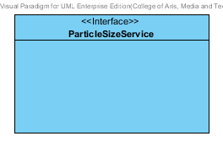

**Figure 38 – The ParticleSizeService Interface.**

ParticleSizeService is business processing logic for the particlesize entity. ParticleSizeService manages the ParticleSize data through the ParticleSizeRepository interface. ParticleSizeService consists of 6 methods follow the list below this passage.

3.1.8.2.3.1: Attribute description

N/A

3.1.8.2.3.2: Method description

* + - **add (particleSize: ParticleSize)** – The add method is used when the user wants to add the new particleSize to the system. This method add a new particleSize by input variable of particleSize object.
    - **update (particleSize: ParticleSize)** - The update method is used when the user wants to update the existing particleSize in the system. This method update the particleSize by input variable of particleSize object.
    - **delete (particleSize: ParticleSize)** – The delete method is used when the user wants to deletes the existing particleSize from the system. This method delete the particleSize by input variable of particleSize object.
    - **findAll() : ParticleSize []** – The findAll method is used, when the user wants to get all particleSize data in the system. This method is return as a list of particleSize object.
    - **findById(id : long) : ParticleSize** – The findById method is used, when the user wants to get the particleSize object from the system. The method gets particleSize by particleSize’s id .
    - **findByType(type : String)** –The findByType method is used when the user wants to get the particleSize object from the system. The method get the particleSize data by a type.

###### 3.1.8.2.4 ParticleSizeServiceImpl

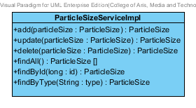

**Figure 39 – The ParticleSizeServiceImpl class**

ParticleSizeServiceImpl is the ParticleSize service class that implements the method from ParticleSizeService. So, the method of ParticleSizeServiceImpl is same as ParticleSizeService.

3.1.8.2.4.1: Attribute description

* + - **ParticleSizeRepository** – the repository of ParticleSize. This attribute is used for ParticleSize data management.

3.1.8.2.4.2: Method description

Same as ParticleSize Service

###### 3.1.8.2.5 SubstancePropertyService

Same as SubstancePropertyService at Solubility class diagram.

### 3.1.9- CD-09: Flowability Class diagram

##### 3.1.9.1: Class diagram

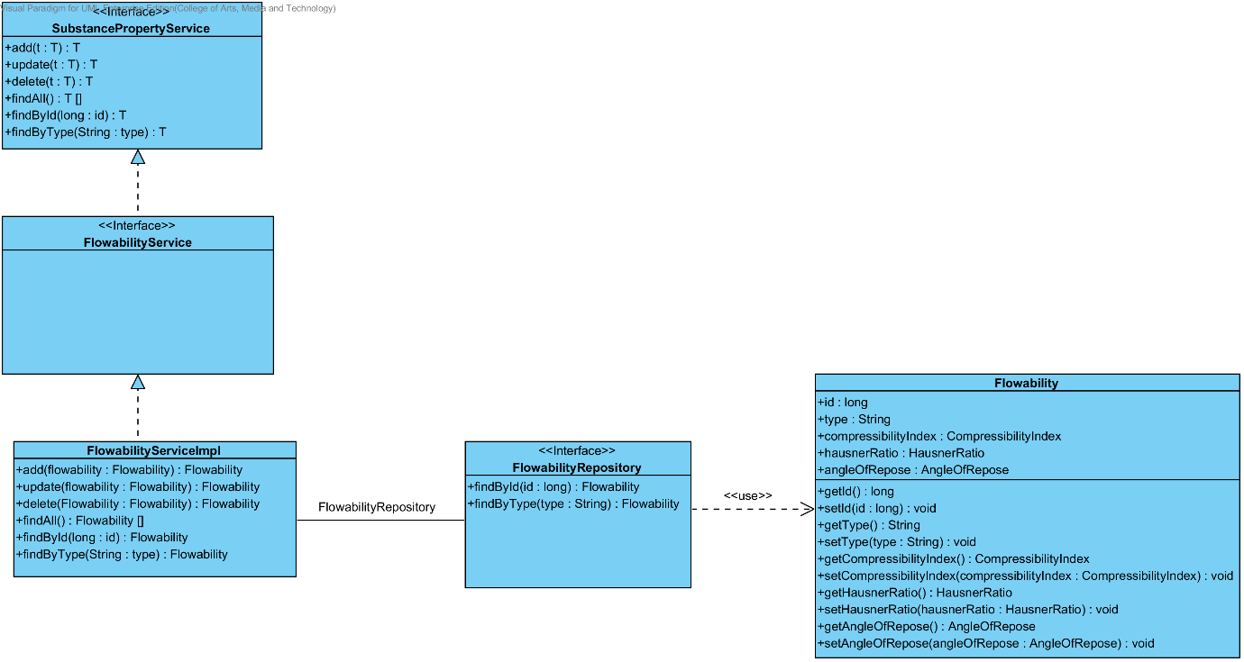

**Figure 40 - CD-09: Flowability Class diagram**

##### 3.1.9.2: Class description

From the figure 40, it can divide into 4 important classes. The detail of each class is described on the next paragraph.

###### 3.1.9.2.1 ParticleSize class

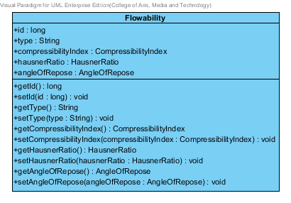

**Figure 41 – The Flowability class**

Flowability class is a part of drug’s substance. Flowability class is an entity class that will be saved to the system. The Flowability class consists of 5 attributes follow the list below this passage.

3.1.9.2.1.1: Attribute description

* + - **Id** – the identity of the Flowability class. Id attribute is a long number.
    - **Type** – the type of the Flowability class. The Flowability type value is string.
    - **CompressibilityIndex** – The compressibilityIndex of the flowability. The compressibilityIndex attribute is a CompressibilityIndex object.
    - **HausnerRatio** – The hausnerRatio of the flowability. The hausnerRatio attribute is a HausnerRatio object.
    - **AngleOfRepose** – The AngleOfRepose of the flowability. The AngleOfRepose attribute is an AngleOfRepose object.

3.1.9.2.1.2: Method description

* + - **Getter and Setter method** – It used when the system set value and get value.

###### 3.1.9.2.2 FlowabilityRepository Interface

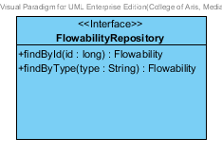

**Figure 42 – The FlowabilityRepository interface**

FlowabilityRepository Interface is an interface that use for CRUD with entity classes in the system. The most of FlowabilityRepository interface’s method is generated from Spring data MongoDB framework. FlowabilityRepository interface consists of 5 methods is shown below this passage.

3.1.9.2.2.1: Attribute description

N/A

3.1.9.2.2.2: Method description

* + - **Save (flowability: Flowability)** - The save method is generated from Spring data MongoDB framework. This method is used when the user wants to add a new Flowability or update existing Flowability to the system. The input variable is a Flowability object.
    - **Delete (flowability: Flowability)** – The delete method is generated from Spring data MongoDB framework. This method is used when the user wants to delete the Flowability from the system. The input variable is Flowability object.
    - **findAll ():Flowability []** – The findAll method is generated from Spring data MongoDB framework. This method is used when the user wants to retrieve all of Flowability data from the system. The result of this method is a list of Flowability object.
    - **findById (id: long): Flowability** – The findById method is used when the user wants to retrieve the Flowability data from the system. The system gets a Flowability object by the id of Flowability .
    - **findByType(type: String)** – The findBytype method is used when the user wants to retrieve the Flowability data from the system. The system gets a Flowability object by the type of Flowability.

###### 3.1.9.2.3 Flowability Service

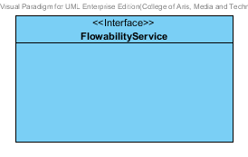

**Figure 43 – The FlowabilityService Interface.**

FlowabilityService is business processing logic for the pka entity. FlowabilityService manages the Flowability data through the FlowabilityRepository interface. FlowabilityService consists of 6 methods follow the list below this passage.

3.1.9.2.3.1: Attribute description

N/A

3.1.9.2.3.2: Method description

* + - **add (flowability: Flowability)** – The add method is used when the user wants to add the new flowability to the system. This method add a new flowability by input variable of flowability object.
    - **update (flowability: Flowability)** - The update method is used when the user wants to update the existing flowability in the system. This method update the flowability by input variable of flowability object.
    - **delete (flowability: Flowability)** – The delete method is used when the user wants to deletes the existing flowability from the system. This method delete the flowability by input variable of flowability object.
    - **findAll() : Flowability []** – The findAll method is used, when the user wants to get all Flowability data in the system. This method is return as a list of Flowability object.
    - **findById(id : long) : Flowability** – The findById method is used, when the user wants to get the flowability object from the system. The method gets flowability by Pka’s id .
    - **findByType(type : String)** –The findByType method is used when the user wants to get the flowability object from the system. The method get the flowability data by a type.

###### 3.1.9.2.4 FlowabilityServiceImpl

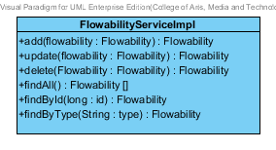

**Figure 44 – The FlowabilityServiceImpl class**

FlowabilityServiceImpl is the Flowability service class that implements the method from FlowabilityService. So, the method of FlowabilityServiceImpl is same as FlowabilityService.

3.1.9.2.4.1: Attribute description

* + - **FlowabilityRepository** – the repository of Flowability. This attribute is used for Flowability data management.

3.1.9.2.4.2: Method description

Same as Flowability Service

###### 3.1.9.2.5 SubstancePropertyService

Same as SubstancePropertyService at Solubility class diagram.

### 3.1.10- CD-10: Density Class diagram

##### D:\All for desktop\Senior project\Software design\DrugExpertClassDiagram(jpg file)\CD-10 _Density class diagram.png3.1.10.1: Class diagram

**Figure 45 - CD-10: Density Class diagram**

##### 3.1.10.2: Class description

From the figure 45, it can divide into 4 important classes. The detail of each class is described on the next paragraph.

###### 3.1.10.2.1 Density class

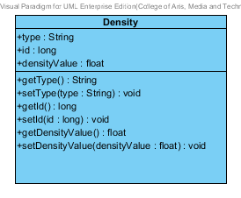

**Figure 46 – The Density class**

Density class is a part of drug’s substance. Density class is an entity class that will be saved to the system. The Density class consists of 5 attributes follow the list below this passage.

3.1.8.2.1.1: Attribute description

* + - **Id** – the identity of the Density class. Id attribute is a long number.
    - **Type** – the type of the Density class. The Density type value is string.
    - **Density value** - The density value is a value of each type of the Density. The density value is stable value. The value is float number.

3.1.8.2.1.2: Method description

* + - **Getter and Setter method** – It used when the system set value and get value.

###### 3.1.10.2.2 DensityRepository Interface

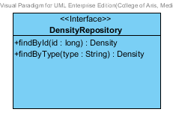

**Figure 47 – The DensityRepository interface**

DensityRepository Interface is an interface that use for CRUD with entity classes in the system. The most of DensityRepository interface’s method is generated from Spring data MongoDB framework. DensityRepository interface consists of 5 methods is shown below this passage.

3.1.10.2.2.1: Attribute description

N/A

3.1.10.2.2.2: Method description

* + - **Save (density: Density)** - The save method is generated from Spring data MongoDB framework. This method is used when the user wants to add a new density or update existing density to the system. The input variable is a density object.
    - **Delete (density: Density)** – The delete method is generated from Spring data MongoDB framework. This method is used when the user wants to delete the density from the system. The input variable is density object.
    - **findAll ():Density []** – The findAll method is generated from Spring data MongoDB framework. This method is used when the user wants to retrieve all of density data from the system. The result of this method is a list of density object.
    - **findById (id: long): Density** – The findById method is used when the user wants to retrieve the density data from the system. The system gets a density object by the id of density.
    - **findByType(type: String) : Density** – The findBytype method is used when the user wants to retrieve the density data from the system. The system gets a density object by the type of density.

###### 3.1.10.2.3 Density Service

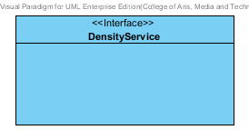

**Figure 48 – The DensityService Interface.**

DensityService is business processing logic for the density entity. DensityService manages the density data through the DensityRepository interface. DensityService consists of 6 methods follow the list below this passage.

3.1.10.2.3.1: Attribute description

N/A

3.1.10.2.3.2: Method description

* + - **add (density: Density)** – The add method is used when the user wants to add the new density to the system. This method add a new density by input variable of density object.
    - **update (density: Density)** - The update method is used when the user wants to update the existing density in the system. This method update the density by input variable of density object.
    - **delete (density: Density)** – The delete method is used when the user wants to deletes the existing density from the system. This method delete the density by input variable of density object.
    - **findAll() : Density []** – The findAll method is used, when the user wants to get all density data in the system. This method is return as a list of density object.
    - **findById(id : long) : Density** – The findById method is used, when the user wants to get the density object from the system. The method gets density by density’s id .
    - **findByType(type : String) : Density** –The findByType method is used when the user wants to get the density object from the system. The method get the density data by a type.

###### 3.1.10.2.4 DensityServiceImpl

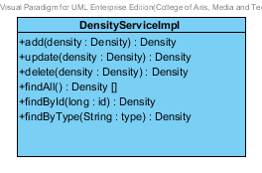

**Figure 49 – The DensityServiceImpl class**

DensityServiceImpl is the Density service class that implements the method from DensityService. So, the method of DensityServiceImpl is same as DensityService.

3.1.10.2.4.1: Attribute description

* + - **DensityRepository** – the repository of Density. This attribute is used for Density data management.

3.1.10.2.4.2: Method description

Same as Density Service

###### 3.1.10.2.5 SubstancePropertyService

Same as SubstancePropertyService at Solubility class diagram.

### 3.1.11- CD-11: CompoundFunction Class diagram

##### 3.1.11.1: Class diagram

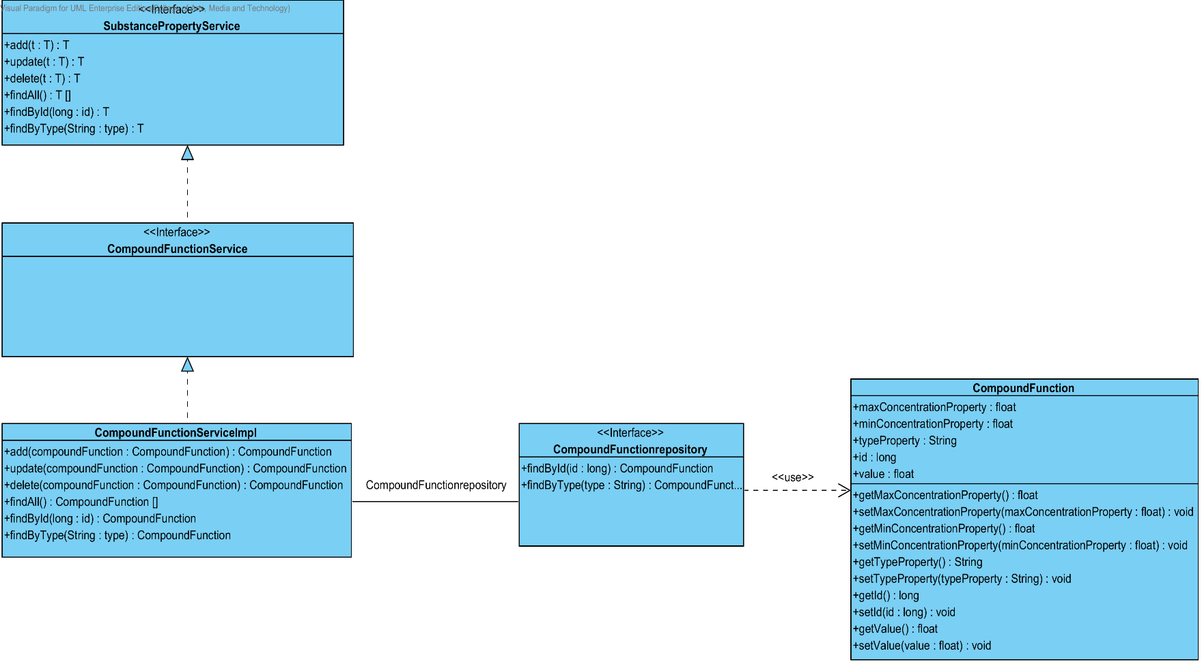

**Figure 50 - CD-11: CompoundFunction Class diagram**

##### 3.1.11.2: Class description

From the figure 50, it can divide into 4 important classes. The detail of each class is described on the next paragraph.

###### 3.1.11.2.1 CompoundFunction class

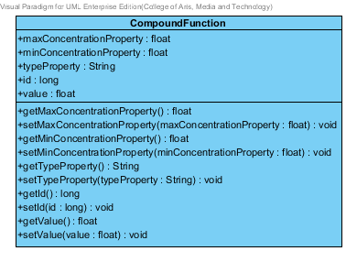

**Figure 51 – The CompoundFunction class**

CompoundFunction class is a part of drug’s substance. CompoundFunction class is an entity class that will be saved to the system. The CompoundFunction class consists of 5 attributes follow the list below this passage.

3.1.8.2.1.1: Attribute description

* + - **Id** – the identity of the CompoundFunction class. Id attribute is a long number.
    - **Type** – the type of the CompoundFunction class. The CompoundFunction type value is string.
    - **Max Value** - The max value of each type of CompoundFunction. The pharmacists can use the max value and min value for CompoundFunction type identification.
    - **Min Value** – The min value of each type of CompoundFunction. The pharmacists can use the max value and min value for CompoundFunction type identification.
    - **CompoundFunction value** - The CompoundFunction value is a value of each type of the CompoundFunction. The CompoundFunction value is stable value. The value is float number.

3.1.8.2.1.2: Method description

* + - **Getter and Setter method** – It used when the system set value and get value.

###### 3.1.11.2.2 CompoundFunctionRepository Interface

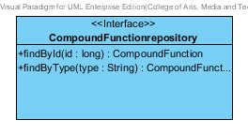

**Figure 52 – The CompoundFunctionRepository interface**

CompoundFunctionRepository Interface is an interface that use for CRUD with entity classes in the system. The most of CompoundFunctionRepository interface’s method is generated from Spring data MongoDB framework. CompoundFunctionRepository interface consists of 5 methods is shown below this passage.

3.1.11.2.2.1: Attribute description

N/A

3.1.11.2.2.2: Method description

* + - **Save (compoundFunction: CompoundFunction)** - The save method is generated from Spring data MongoDB framework. This method is used when the user wants to add a new CompoundFunction or update existing CompoundFunction to the system. The input variable is a CompoundFunction object.
    - **Delete (compoundFunction: CompoundFunction)** – The delete method is generated from Spring data MongoDB framework. This method is used when the user wants to delete the CompoundFunction from the system. The input variable is the CompoundFunction object.
    - **findAll () : CompoundFunction []** – The findAll method is generated from Spring data MongoDB framework. This method is used when the user wants to retrieve all of CompoundFunction data from the system. The result of this method is a list of CompoundFunction object.
    - **findById (id: long): CompoundFunction** – The findById method is used when the user wants to retrieve the CompoundFunction data from the system. The system gets a CompoundFunction object by the CompoundFunction’s id.
    - **findByType(type: String)** – The findBytype method is used when the user wants to retrieve the CompoundFunction data from the system. The system gets a CompoundFunction object by the type of CompoundFunction.

###### 3.1.11.2.3 CompoundFunction Service

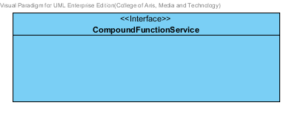

**Figure 53 – The CompoundFunctionService Interface.**

CompoundFunctionService is business processing logic for the CompoundFunction entity. CompoundFunctionService manages the CompoundFunction data through the CompoundFunction Repository interface. CompoundFunctionService consists of 6 methods follow the list below this passage.

3.1.11.2.3.1: Attribute description

N/A

3.1.11.2.3.2: Method description

* + - **add (compoundFunction: CompoundFunction)** – The add method is used when the user wants to add the new CompoundFunction to the system. This method add a new CompoundFunction by input variable of CompoundFunction object.
    - **update (compoundFunction: CompoundFunction)** - The update method is used when the user wants to update the existing CompoundFunction in the system. This method update the CompoundFunction by input variable of CompoundFunction object.
    - **delete (compoundFunction: CompoundFunction)** – The delete method is used when the user wants to deletes the existing compoundFunction from the system. This method delete the compoundFunction by input variable of compoundFunction object.
    - **findAll() : compoundFunction []** – The findAll method is used, when the user wants to get all compoundFunction data in the system. This method is return as a list of compoundFunction object.
    - **findById(id : long) : CompoundFunction** – The findById method is used, when the user wants to get the CompoundFunction object from the system. The method gets the compoundFunction object by a compoundFunction’s id.
    - **findByType(type : String)** –The findByType method is used when the user wants to get the compoundFunction object from the system. The method get the compoundFunction data by a type.

###### 3.1.11.2.4 CompoundFunctionServiceImpl

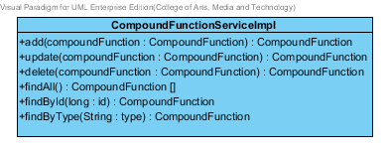

**Figure 54 – The CompoundFunctionServiceImpl class**

CompoundFunctionServiceImpl is the CompoundFunction service class that implements the method from CompoundFunctionService. So, the method of CompoundFunction ServiceImpl is same as the compoundFunctionService.

3.1.11.2.4.1: Attribute description

* + - **CompoundFunctionRepository** – the repository of CompoundFunction. This attribute is used for CompoundFunction data management.

3.1.11.2.4.2: Method description

Same as CompoundFunction Service

###### 3.1.11.2.5 SubstancePropertyService

Same as SubstancePropertyService at Solubility class diagram.

## 3.2 Feature 6: Manage the drug substance

The feature 6 is the substance management. The users can add, update, delete and view the substance. Each substance is created from 9 substance properties that shown on a previous feature. An entity relationship between substance and substance’s property has been shown on the Figure 01.

### 3.2.1- CD-12: Substance Class diagram

##### D:\All for desktop\Senior project\Software design\DrugExpertClassDiagram(jpg file)\CD-12 _Substance class diagram.png3.2.1.1: Class diagram

**Figure 55 - CD-12: Substance Class diagram**

##### 3.2.1.2: Class description

From the figure 12, it can divide into 4 important classes. The detail of each class is described on the next paragraph.

###### 3.2.1.2.1 Substance class

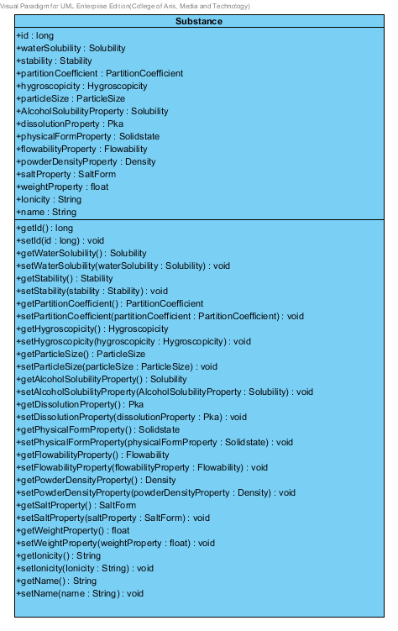

**Figure 56 – The substance class**

Substance is a part of drug’s excipient. Substance class is an entity class that will be saved to the system. The substance class consists of 15 attributes follow the list below this passage.

3.2.1.2.1.1: Attribute description

* + - **Id** – the identity of the substance class. Id attribute is a long number.
    - **Name** – the name of the substance class. The substance name is shown the name of each excipient.
    - **waterSolubility** – the water solubility of substance. In the pharmacy, how good or bad of the water solubility. The water solubility attribute is Solubility object
    - **Stability –** the stability of substance. The stability consist of Degradation mechanism and Kinetic reaction. The stability attribute is stability object.
    - **PartitionCoefficient** – the partition coefficient of the substance. The partition Coefficient attribute is a PartitionCoefficient object.
    - **hygroscopicity** - the hygroscopicity of the substance. The hygroscopicity attribute is a hygroscopicity object.
    - **particleSize**- the particleSize of the substance. The particleSize attribute is a particleSize object.
    - **alcoholSolubilityProperty**- the alcoholSolubilityProperty of the substance. The hygroscopicity attribute is a solubility object.
    - **dissolutionProperty**- the dissolutionProperty of the substance. The dissolutionProperty attribute is a Pka object.
    - **physicalFormProperty**- the physicalFormProperty of the substance. The physicalFormProperty attribute is a Solidstate object.
    - **flowabilityProperty**- the flowabilityProperty of the substance. The flowabilityProperty attribute is a flowability object.
    - **powderDensityProperty**- the powderDensityProperty of the substance. The powderDensityProperty attribute is a density object.
    - **saltProperty**- the saltProperty of the substance. The saltProperty attribute is a saltForm object.
    - **weightProperty**- the weightProperty of the substance. The weightProperty is show the weight value of each substance. The weightProperty attribute is a float number.
    - **Ionicity**- the lonicity of the substance. The lonicity attribute is a String.

3.2.1.2.1.2: Method description

* + - **Getter and Setter method** – It used when the system set value and get value.

###### 3.2.1.2.2 SubstanceRepository Interface

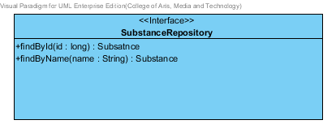

**Figure 57 – The substance repository interface**

SubstanceRepository Interface is an interface that use for CRUD with entity classes in the system. The most of SubstanceRepository interface’s method is generated from Spring data MongoDB framework. SubstanceRepository interface consists of 5 methods is shown below this passage.

3.2.1.2.2.1: Attribute description

N/A

3.2.1.2.2.2: Method description

* + - **Save (substance: Substance)** - The save method is generated from Spring data MongoDB framework. This method is used when the user wants to add a new substance or update existing substance to the system. The input variable is a substance object.
    - **Delete (substance: Substance)** – The delete method is generated from Spring data MongoDB framework. This method is used when the user wants to delete the substance from the system. The input variable is substance object.
    - **findAll (): Substance []** – The findAll method is generated from Spring data MongoDB framework. This method is used when the user wants to retrieve all of substance data from the system. The result of this method is a list of substance object.
    - **findById (id: long): Substance** – The findById method is used when the user wants to retrieve the substance data from the system. The system gets a substance object by the id of substance.
    - **findByName(name: String) : Substance** – The findBytype method is used when the user wants to retrieve the substance data from the system. The system gets a substance object by the name of substance.

###### 3.2.1.2.3 SubstanceService

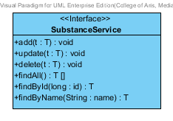

**Figure 58 – The substance service Interface.**

SubstanceService is business processing logic for solubility entity. SubstanceService manages the solubility data through the SubstanceRepository interface. SubstanceService consists of 6 methods follow the list below this passage.

3.2.1.2.3.1: Attribute description

N/A

3.2.1.2.3.2: Method description

* + - **add (substance: Substance)** – The add method is used when the user wants to add the new substance to the system. This method add a new substance by input variable of substance object.
    - **update (substance: Substance)** - The update method is used when the user wants to update the existing substance in the system. This method update substance by input variable of substance object.
    - **delete (substance: Substance)** – The delete method is used when the user wants to deletes the existing substance from the system. This method delete the substance by input variable of substance object.
    - **findAll() : Substance []** – The findAll method is used, when the user wants to get all substance data in the system. This method is return as a list of substance object.
    - **findById(id : long) : Substance** – The findById method is used, when the user wants to get the substance data in the system. The method gets substance by id.
    - **findByName(name : String)** –The findByName method is used when the user wants to get substance data in the system. The method get the substance data by a name.

###### 3.2.1.2.4 SubstanceServiceImpl

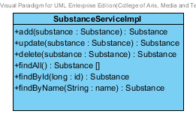

**Figure 59 – The SubstanceServiceImpl class**

SubstanceServiceImpl is the substance service class that implements the method from SubstanceService. So, the method of SubstanceServiceImpl is same as SubstanceService.

3.2.1.2.4.1: Attribute description

* + - **SubstanceRepository** – the repository of substance. This attribute is used for substance data management.

3.2.1.2.4.2: Method description

Same as SubstanceService

## 3.3 Feature 7: Manage the drug Excipient

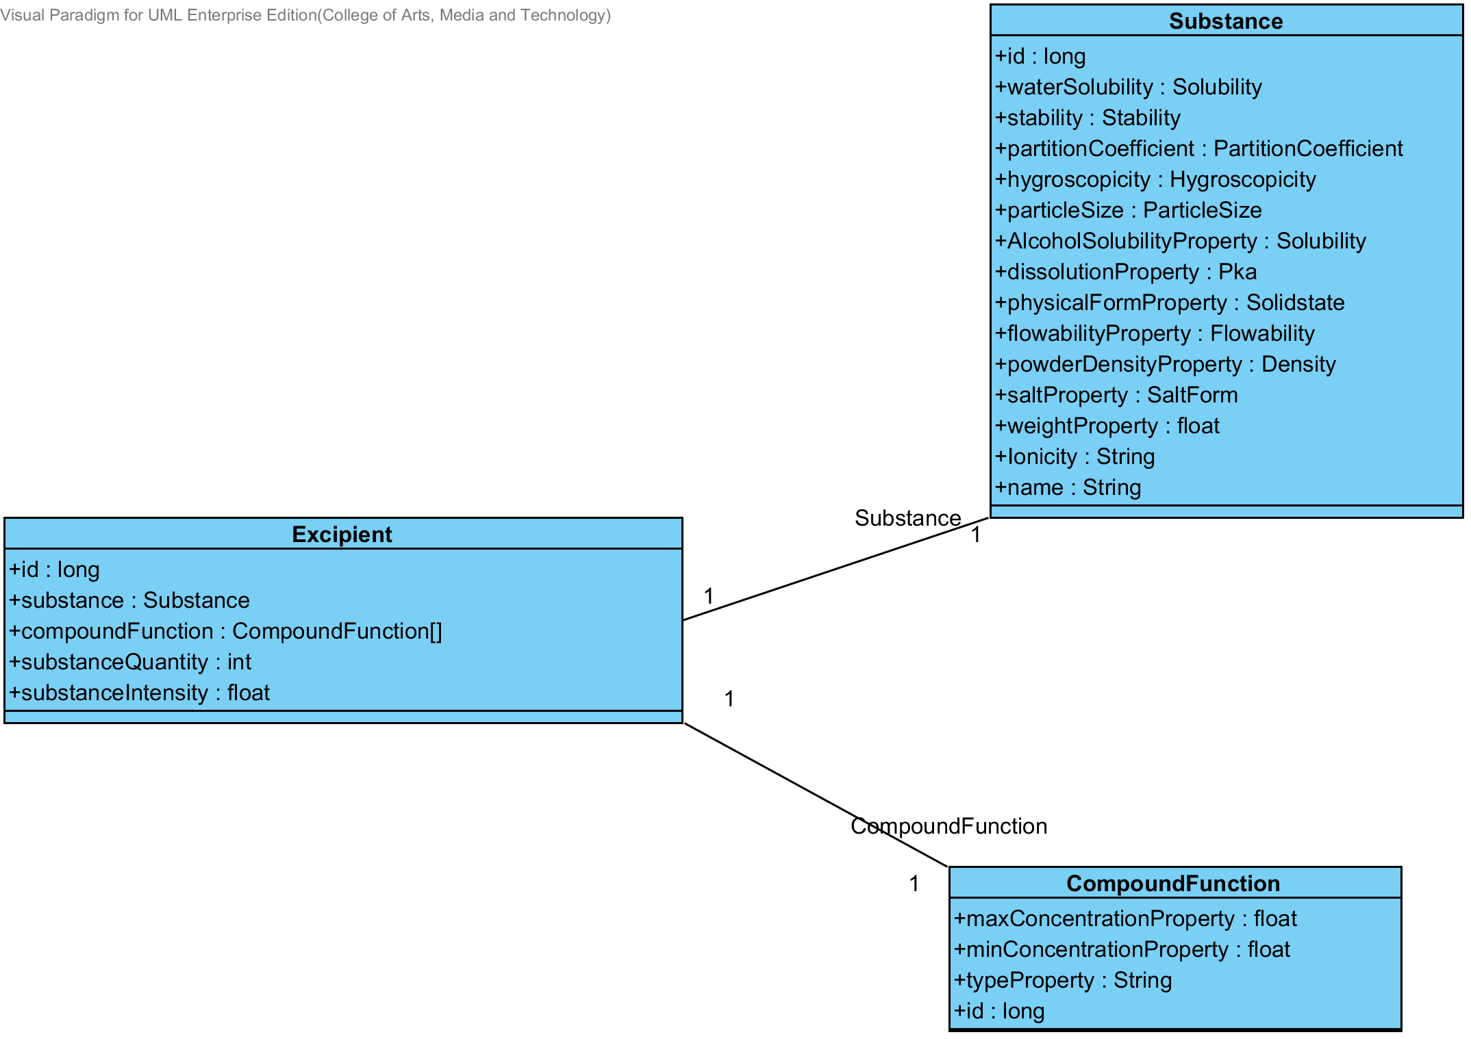 The feature 7 is the excipient management. The users can add, update, delete and view the excipient. Each excipient is created from the substance and compoundfunction. . The relationship between excipient entity, substance entity and compoundfunction is illustrated in the Figure 60 below on this passage.

**Figure- 60: The entity relationship between an excipient, substance and compoundFunction.**

### 3.3.1- CD-13: Substance Class diagram

##### 3.3.1.1: Class diagram

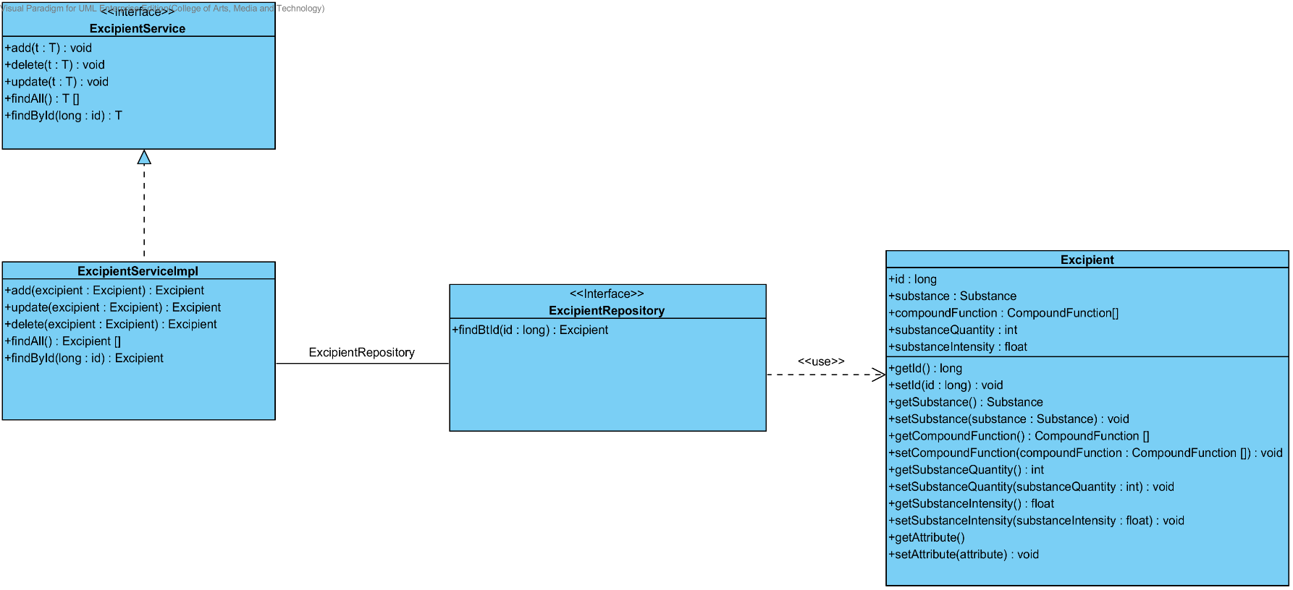

**Figure 61- CD-13: Excipient Class diagram**

##### 3.3.1.2: Class description

From the figure 12, it can divide into 4 important classes. The detail of each class is described on the next paragraph.

###### 3.3.1.2.1 Excipient class

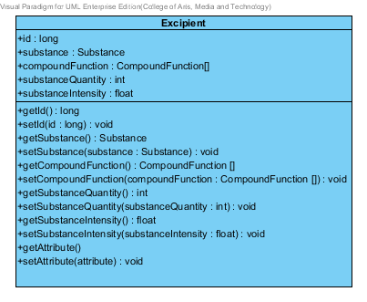

**Figure 62 – The excipient class**

Excipient is a part of drug’s formulation. Excipient class is an entity class that will be saved to the system. The excipient class consists of 5 attributes follow the list below this passage.

3.3.1.2.1.1: Attribute description

* + - **Id** – the identity of the excipient class. Id attribute is a long number.
    - **Substance** – the substance of the excipient class. The substance attribute is a substance object.
    - **CompoundFunction –**the compoundFunction of the excipient class .The user can set the compoundFunction in each substance.The compoundFunction is a compoundFunction object.
    - **substanceQuantity** – the substance quantity of the excipient. The substance quantity is integer number.
    - **substanceIntensity** –the substance intensity of the excipient. The substance intensity is the float value.

3.3.1.2.1.2: Method description

* + - **Getter and Setter method** – It used when the system set value and get value.

###### 3.3.1.2.2 ExcipientRepository Interface

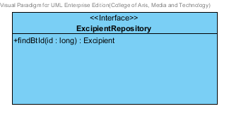

**Figure 63 – The excipient repository interface**

ExcipientRepository Interface is an interface that use for CRUD with entity classes in the system. The most of ExcipientRepository interface’s method is generated from Spring data MongoDB framework. ExcipientRepository interface consists of 4 methods is shown below this passage.

3.2.1.2.2.1: Attribute description

N/A

3.2.1.2.2.2: Method description

* + - **Save (excipient: Excipient)** - The save method is generated from Spring data MongoDB framework. This method is used when the user wants to add a new excipient or update existing excipient to the system. The input variable is a excipient object.
    - **Delete (excipient: Excipient)** – The delete method is generated from Spring data MongoDB framework. This method is used when the user wants to delete the excipient from the system. The input variable is excipient object.
    - **findAll ():Excipient []** – The findAll method is generated from Spring data MongoDB framework. This method is used when the user wants to retrieve all of excipient data from the system. The result of this method is a list of excipient object.
    - **findById (id: long): Excipient** – The findById method is used when the user wants to retrieve the excipient data from the system. The system gets a excipient object by the id of excipient.

###### 3.3.1.2.3 ExcipientService

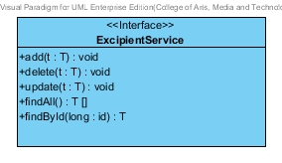

**Figure 64 – The ExcipientService Interface.**

ExcipientService is business processing logic for excipient entity. ExcipientService manages the excipient data through the ExcipientRepository interface. ExcipientService consists of 6 methods follow the list below this passage.

3.2.1.2.3.1: Attribute description

N/A

3.2.1.2.3.2: Method description

* + - **add (excipient: Excipient)** – The add method is used when the user wants to add the new excipient to the system. This method add a new excipient by input variable of excipient object.
    - **update (excipient: Excipient)** - The update method is used when the user wants to update the existing excipient in the system. This method update excipient by input variable of excipient object.
    - **delete (excipient: Excipient)** – The delete method is used when the user wants to deletes the existing excipient from the system. This method delete the excipient by input variable of excipient object.
    - **findAll() : Excipient []** – The findAll method is used, when the user wants to get all excipient data in the system. This method is return as a list of excipient object.
    - **findById(id : long) :** Excipient – The findById method is used, when the user wants to get the excipient data in the system. The method gets excipient by id.

###### 3.3.1.2.4 ExcipientServiceImpl

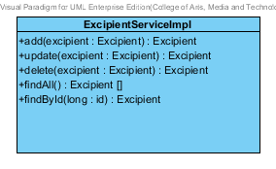

**Figure 65 – The ExcipientServiceImpl class**

ExcipientServiceImpl is the excipient service class that implements the method from ExcipientService. So, the method of ExcipientServiceImpl is same as ExcipientService.

3.3.1.2.4.1: Attribute description

* + - **ExcipientRepository** – the repository of excipient. This attribute is used for excipient data management.

3.3.1.2.4.2: Method description

Same as ExcipientService

## 3.4 Feature 8: Manage the drug formulation

The feature 8 is the drug’s formulation management. The users can add, update, delete and view the formulation. Each drug’s formulation is created from the excipient. The relationship between drug’s formulation and the excipient is illustrated in the Figure 66 below on this passage.

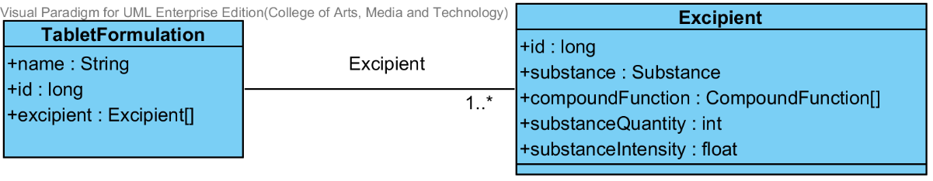

**Figure- 66: The entity relationship between a drug’s formulation and the excipient.**

### 3.4.1- CD-13: TabletFormulation Class diagram

##### 3.4.1.1: Class diagram

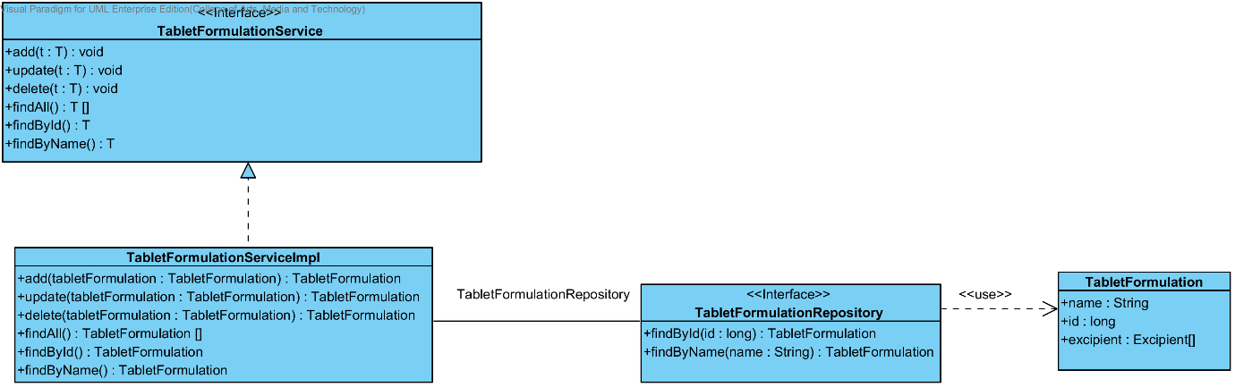

**Figure 67- CD-14: TabletFormulation Class diagram**

##### 3.4.1.2: Class description

From the figure 12, it can divide into 4 important classes. The detail of each class is described on the next paragraph.

###### 3.4.1.2.1 TabletFormulation class

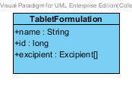

**Figure 68 – The TabletFormulation class**

TabletFormulation class is an entity class that will be saved to the system. The TabletFormulation class consists of 5 attributes follow the list below this passage.

3.4.1.2.1.1: Attribute description

* + - **Id** – the identity of the TabletFormulation class. Id attribute is a long number.
    - **Name** – the name of the TabletFormulation class. The TabletFormulation attribute is a TabletFormulation object.
    - **Excipient –**the excipient of the TabletFormulation. The user can set the excipient more than 1 excipient in each tabletformulation.

3.4.1.2.1.2: Method description

* + - **Getter and Setter method** – It used when the system set value and get value.

###### 3.4.1.2.2 TabletFormulationRepository Interface

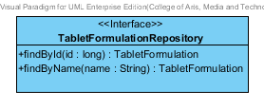

**Figure 69 – The TabletFormulation interface**

TabletFormulationRepository Interface is an interface that use for CRUD with entity classes in the system. The most of TabletFormulationRepository interface’s method is generated from Spring data MongoDB framework. TabletFormulationRepository interface consists of 4 methods is shown below this passage.

3.4.1.2.2.1: Attribute description

N/A

3.4.1.2.2.2: Method description

* + - **Save (tabletFormulation: TabletFormulation)** - The save method is generated from Spring data MongoDB framework. This method is used when the user wants to add a new tabletFormulation or update existing tabletFormulation to the system. The input variable is an tabletFormulation object.
    - **Delete (tabletFormulation: TabletFormulation)** – The delete method is generated from Spring data MongoDB framework. This method is used when the user wants to delete the tabletFormulation from the system. The input variable is tabletFormulation object.
    - **findAll ():TabletFormulation []** – The findAll method is generated from Spring data MongoDB framework. This method is used when the user wants to retrieve all of tabletFormulation data from the system. The result of this method is a list of tabletFormulation object.
    - **findById (id: long): TabletFormulation** – The findById method is used when the user wants to retrieve the tabletFormulation data from the system. The system gets a tabletFormulation object by the id of tabletFormulation.
    - **findByName (name: String): TabletFormulation** – The findById method is used when the user wants to retrieve the tabletFormulation data from the system. The system gets a tabletFormulation object by the name of tabletFormulation.

###### 3.4.1.2.3 TabletFormulationService

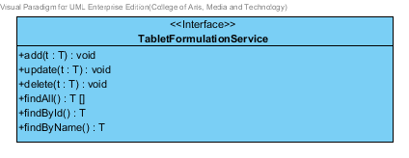

**Figure 70 – The TabletFormulationService Interface.**

TabletFormulationService is business processing logic for TabletFormulation entity. TabletFormulationService manages the TabletFormulation data through the TabletFormulationRepository interface. TabletFormulationService consists of 6 methods follow the list below this passage.

3.4.1.2.3.1: Attribute description

N/A

3.4.1.2.3.2: Method description

* + - **add (tabletFormulation: TabletFormulation)** – The add method is used when the user wants to add the new tabletFormulation to the system. This method add a new tabletFormulation by input variable of tabletFormulation object.
    - **update (tabletFormulation: TabletFormulation)** - The update method is used when the user wants to update the existing tabletFormulation in the system. This method update tabletFormulation by input variable of tabletFormulation object.
    - **delete (tabletFormulation: TabletFormulation)** – The delete method is used when the user wants to deletes the existing excipient from the system. This method delete the TabletFormulation by input variable of TabletFormulation object.
    - **findAll() : TabletFormulation []** – The findAll method is used, when the user wants to get all tabletFormulation data in the system. This method is return as a list of tabletFormulation object.
    - **findByName(name : String) : TabletFormulation** – The findById method is used, when the user wants to get the tabletFormulation data in the system. The method gets tabletFormulation by name.

###### 3.4.1.2.4 TabletFormulationServiceImpl

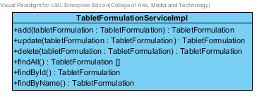

**Figure 71 – The TabletFormulationServiceImpl class**

TabletFormulationServiceImpl is the tabletformulation service class that implements the method from TabletFormulationService. So, the method of TabletFormulationServiceImpl is same as TabletFormulationService.

3.4.1.2.4.1: Attribute description

* + - **TabletFormulationRepository** – the repository of tabletFormulation. This attribute is used for tabletFormulation data management.

3.4.1.2.4.2: Method description

Same as TabletFormulationService

# Chapter 4 | Sequence Diagram

In the 1st progress the URS is related with the list of sequence diagram that shown below this passage.

|  |  |  |  |  |
| --- | --- | --- | --- | --- |
| **No** | **Feature Name** | **URS No.** | **URS Name** | **Sequence Diagram** |
| 5 | Manage the drug substance property | URS-09 | The user adds a new substance property into the system. | SD-9A, SD-9B, SD-9C, SD-9D, SD-9E, SD-9F, SD-9G, SD-9H, SD-9I, SD-9J, SD-9K |
| URS-10 | The user updates an existing substance property into the system. | SD-10A, SD-10B, SD-10C, SD-10D, SD-10E, SD-10F, SD-10G, SD-10H, SD-10I, SD-10J, SD-10K |
| URS-11 | The user deletes an existing substance property from the system. | SD-11A, SD-11B, SD-11C, SD-11D, SD-11E, SD-11F, SD-11G, SD-11H, SD-11I, SD-11J, SD-11K |
| 6 | Manage the drug substance | URS-12 | The user adds a new substance into the system. | SD-12 |
| URS-13 | The user updates an existing substance into the system. | SD-13 |
| URS-14 | The user deletes an existing substance from the system. | SD-14 |
| URS-15 | The user views the substance in the system. | SD-15 |
| 7 | Manage the drug excipient | URS-16 | The user adds a new excipient to the system. | SD-16 |
| URS-17 | The user updates an existing drug excipient in the system. | SD-17 |
| URS-18 | The user delete an existing drug excipient in the system. | SD-18 |
| URS-19 | The user views all the drug excipient in the system. | SD-19 |
| 8 | Manage the drug formulation | URS-20 | The user adds a new drug formulation case into the system. | SD-20 |
| URS-21 | The user updates an existing drug formulation case in the system. | SD-21 |
| URS-22 | The user deletes an existing drug formulation case in the system. | SD-22 |
| URS-23 | The user views all of the formulation in the system. | SD-23 |

## 4.1- Feature 5: Manage the drug substance property

### 4.1.1 URS-09: The user adds a new substance property into the system.

In the sequence diagram, the user can add a new substance property to the system. Firstly, the user opens the substance property adding page, than the user inputs substance property value such as name, max value min value and substance value. The substance property controller gets the data from the user, after that the controller chooses appropriate SubstanceProperty’s service for saving a new substance property to the system. Finally, the substance property controller show a new substance property on the successful adding substance property page to user.

##### 4.1.1.1 SD-09A: The user add a new drug substance property into the system (Solubility).

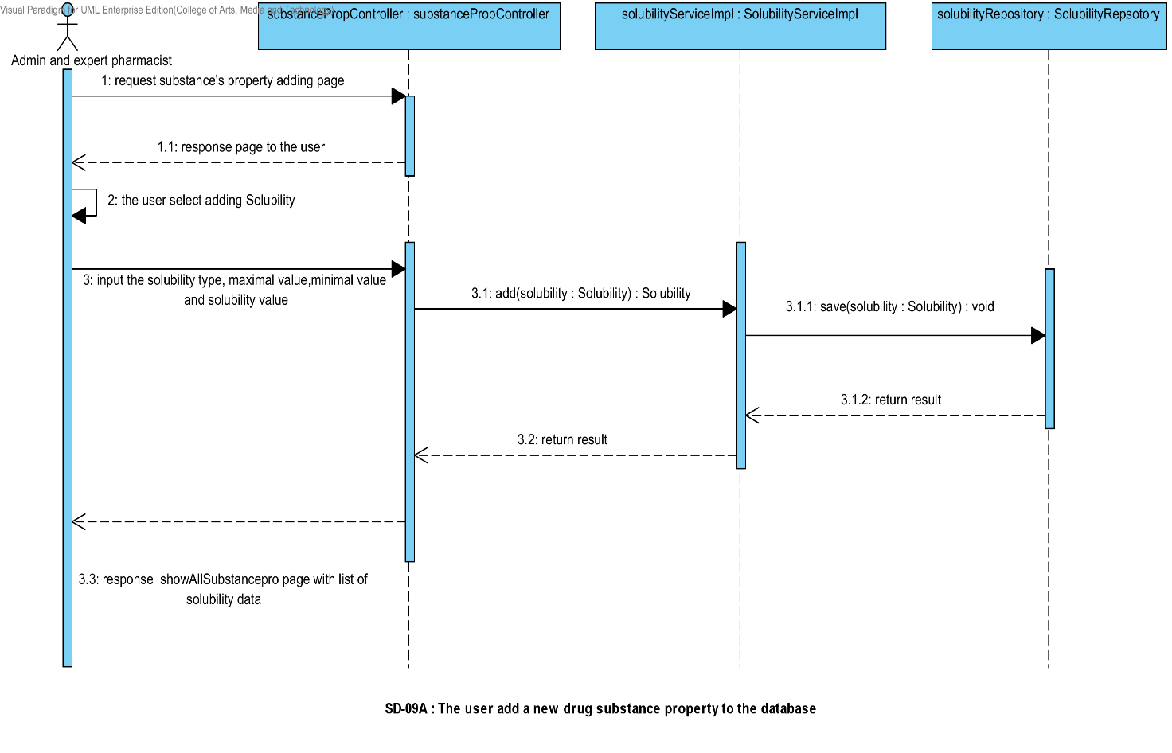

##### 4.1.1.2 SD-09B: The user add a new drug substance property into the system (DegradationMechanism).

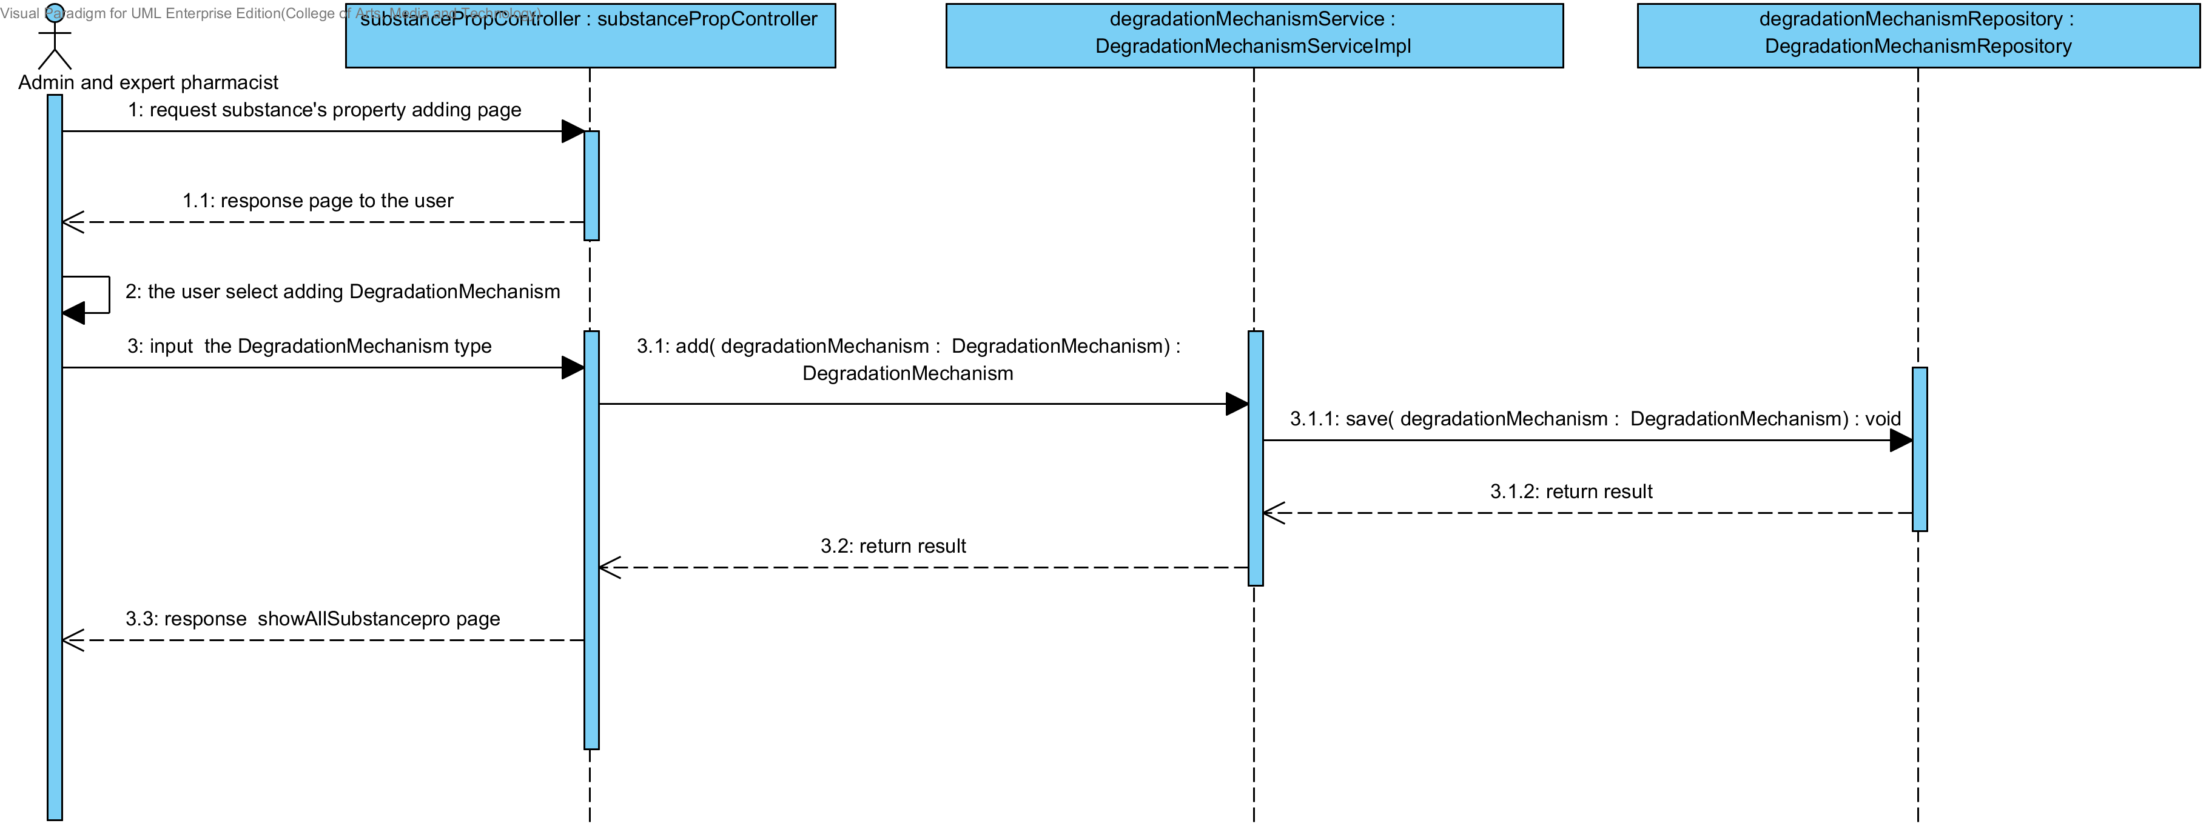

##### 4.1.1.3 SD-09C: The user add a new drug substance property into the system (Kinetic Reaction).

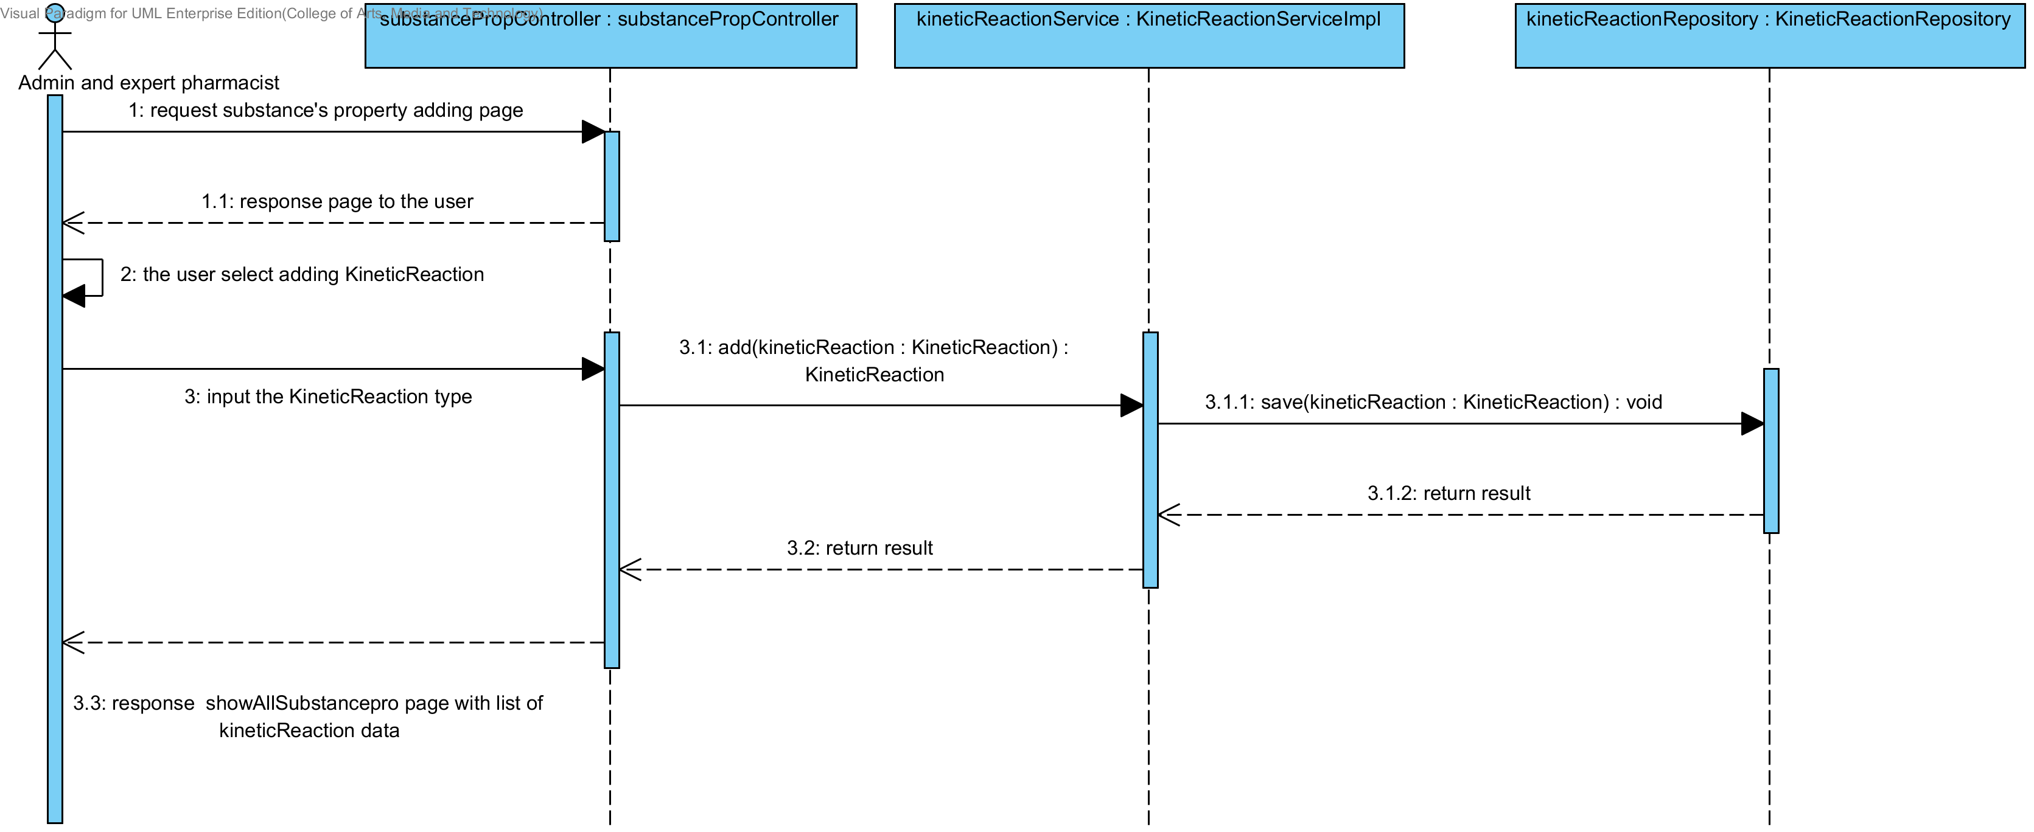

##### 4.1.1.4 SD-09D: The user add a new drug substance property into the system (Pka).

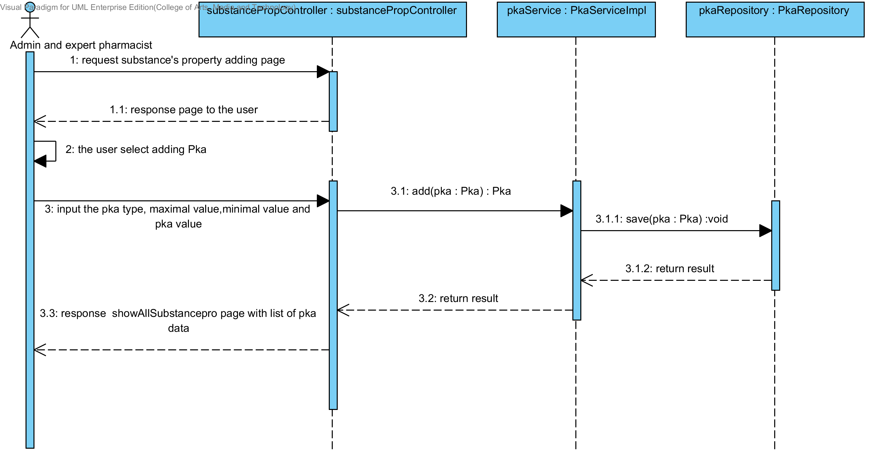

##### 4.1.1.5 SD-09E: The user add a new drug substance property into the system (PartitionCoefficient).

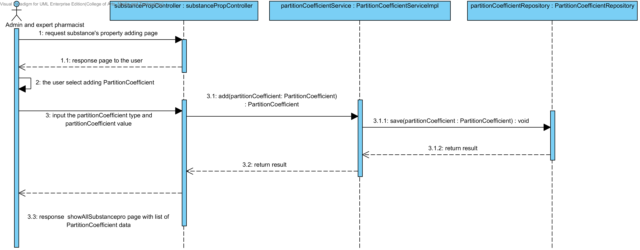

##### 4.1.1.6 SD-09F: The user add a new drug substance property into the system (Solidstate).

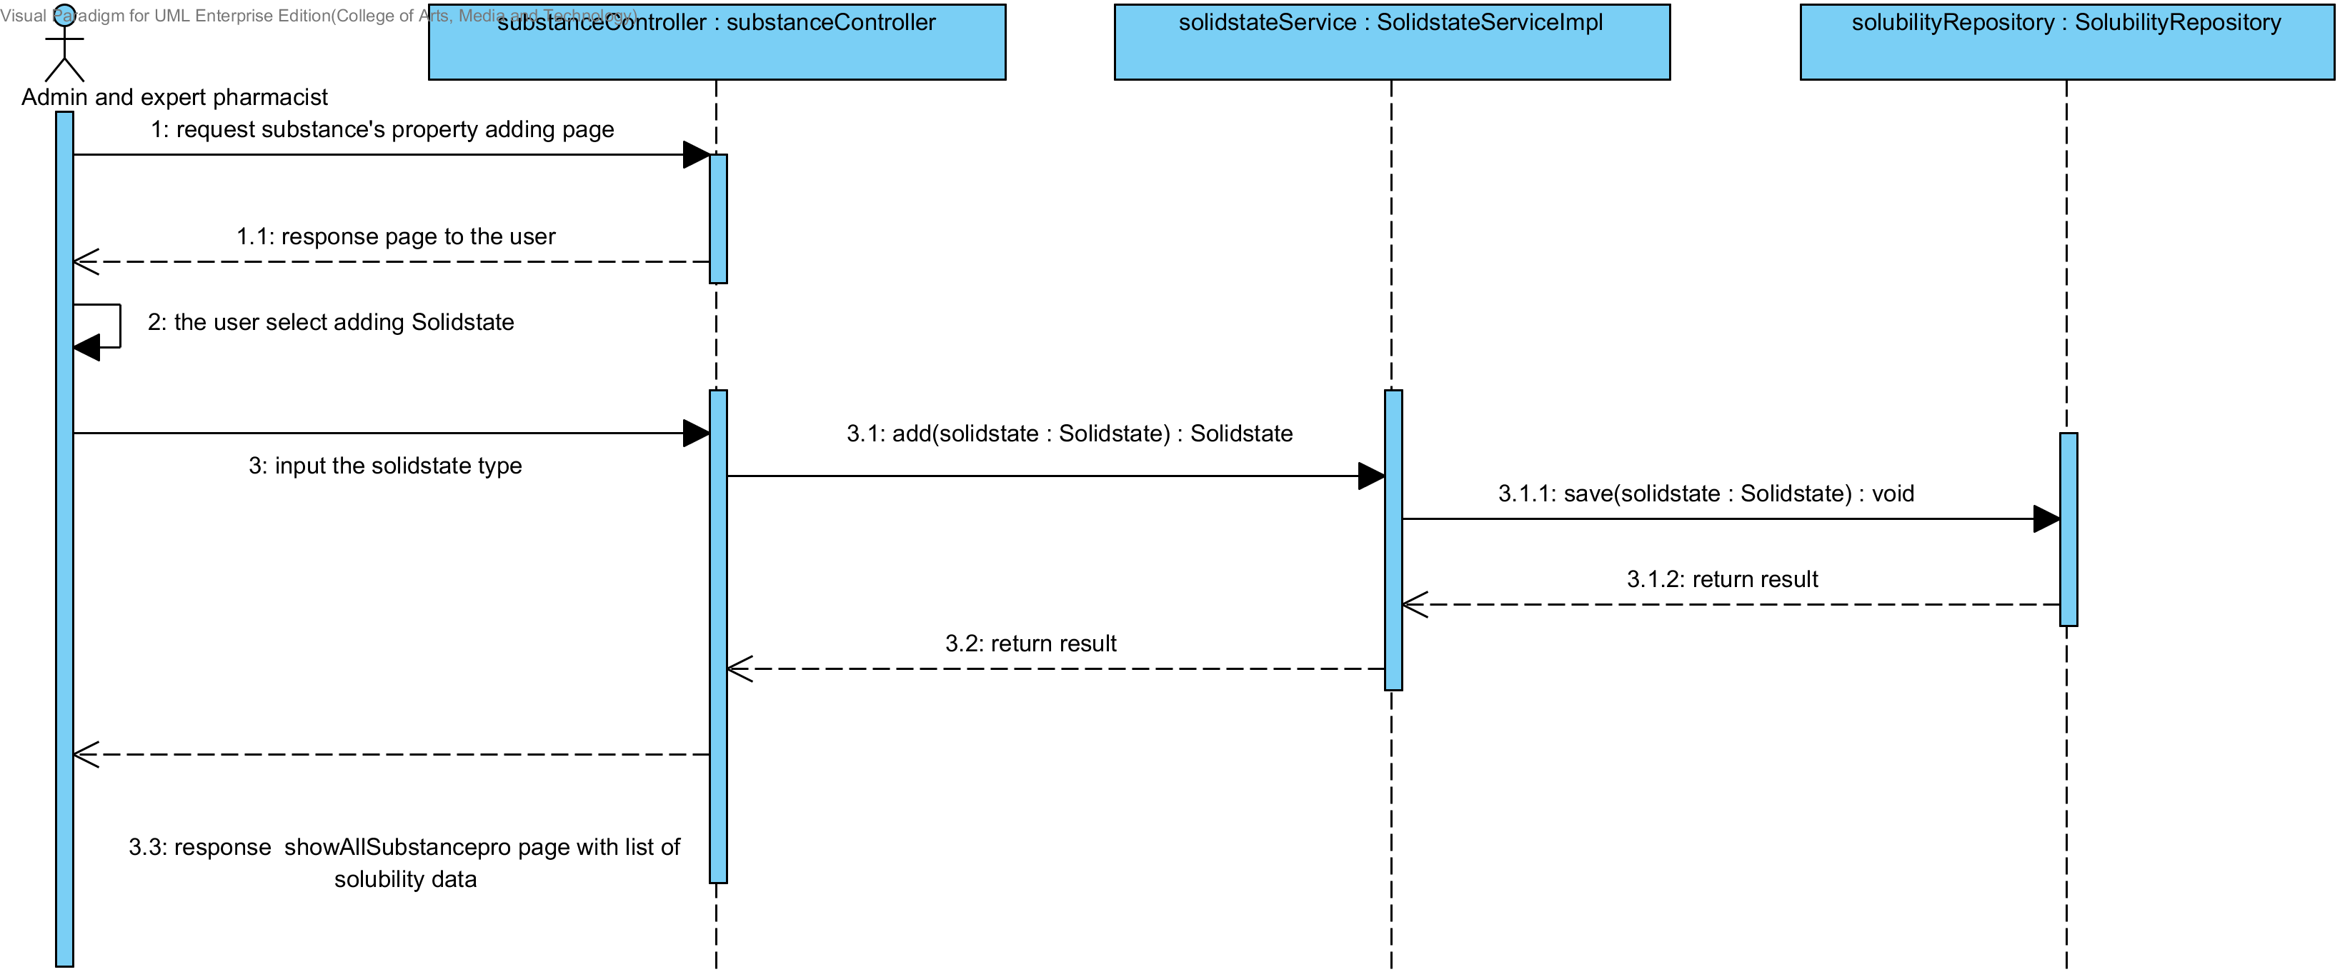

##### 4.1.1.7 SD-09G: The user add a new drug substance property into the system (Hygroscopicity).

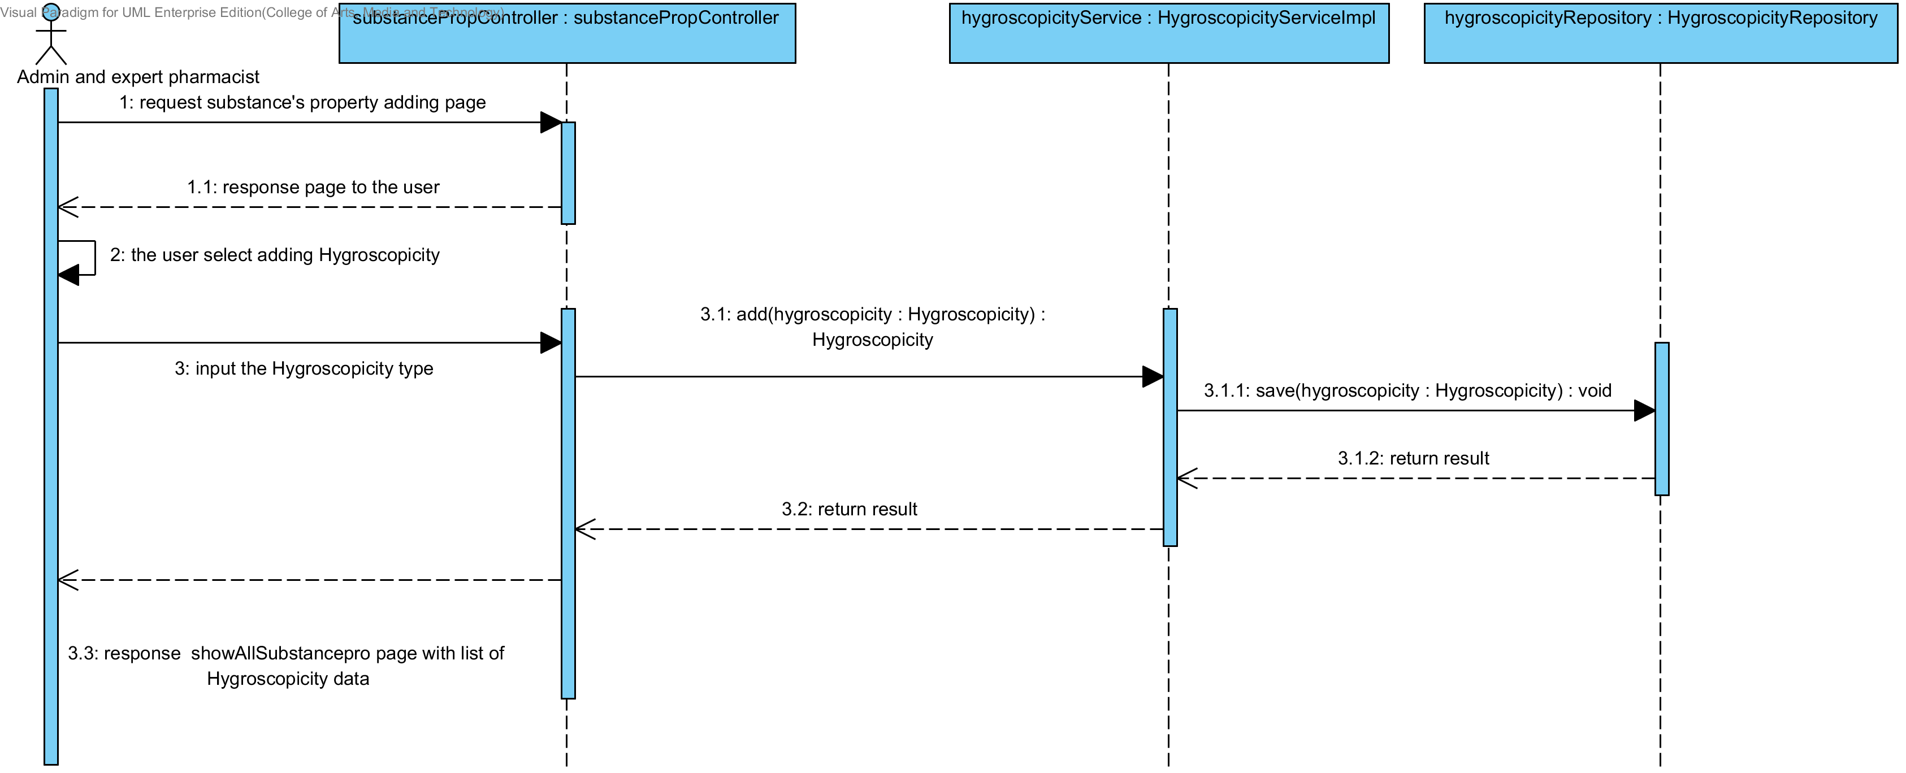

##### 4.1.1.8 SD-09H: The user add a new drug substance property into the system (ParticleSize).

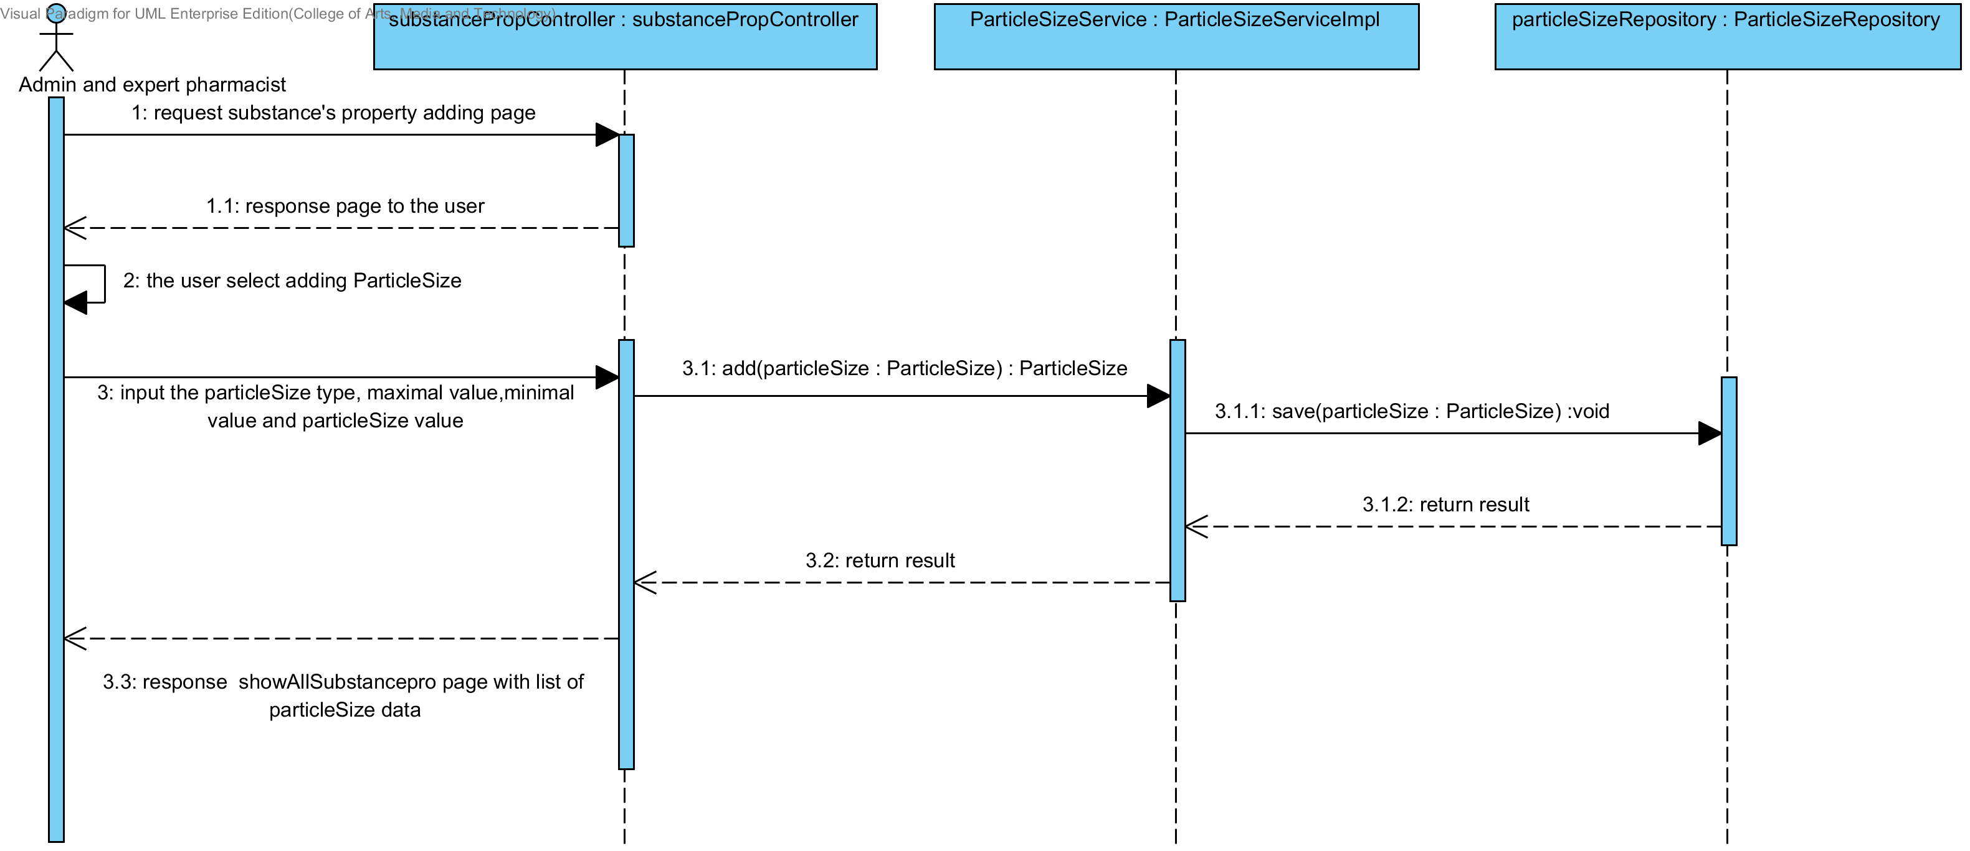

##### 4.1.1.9 SD-09I: The user add a new drug substance property into the system (Flowability).

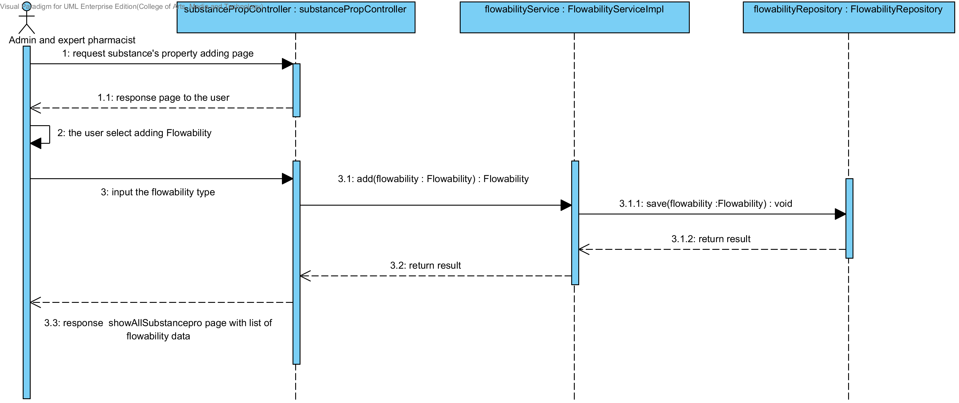

##### 4.1.1.10 SD-09J: The user add a new drug substance property into the system (Density).

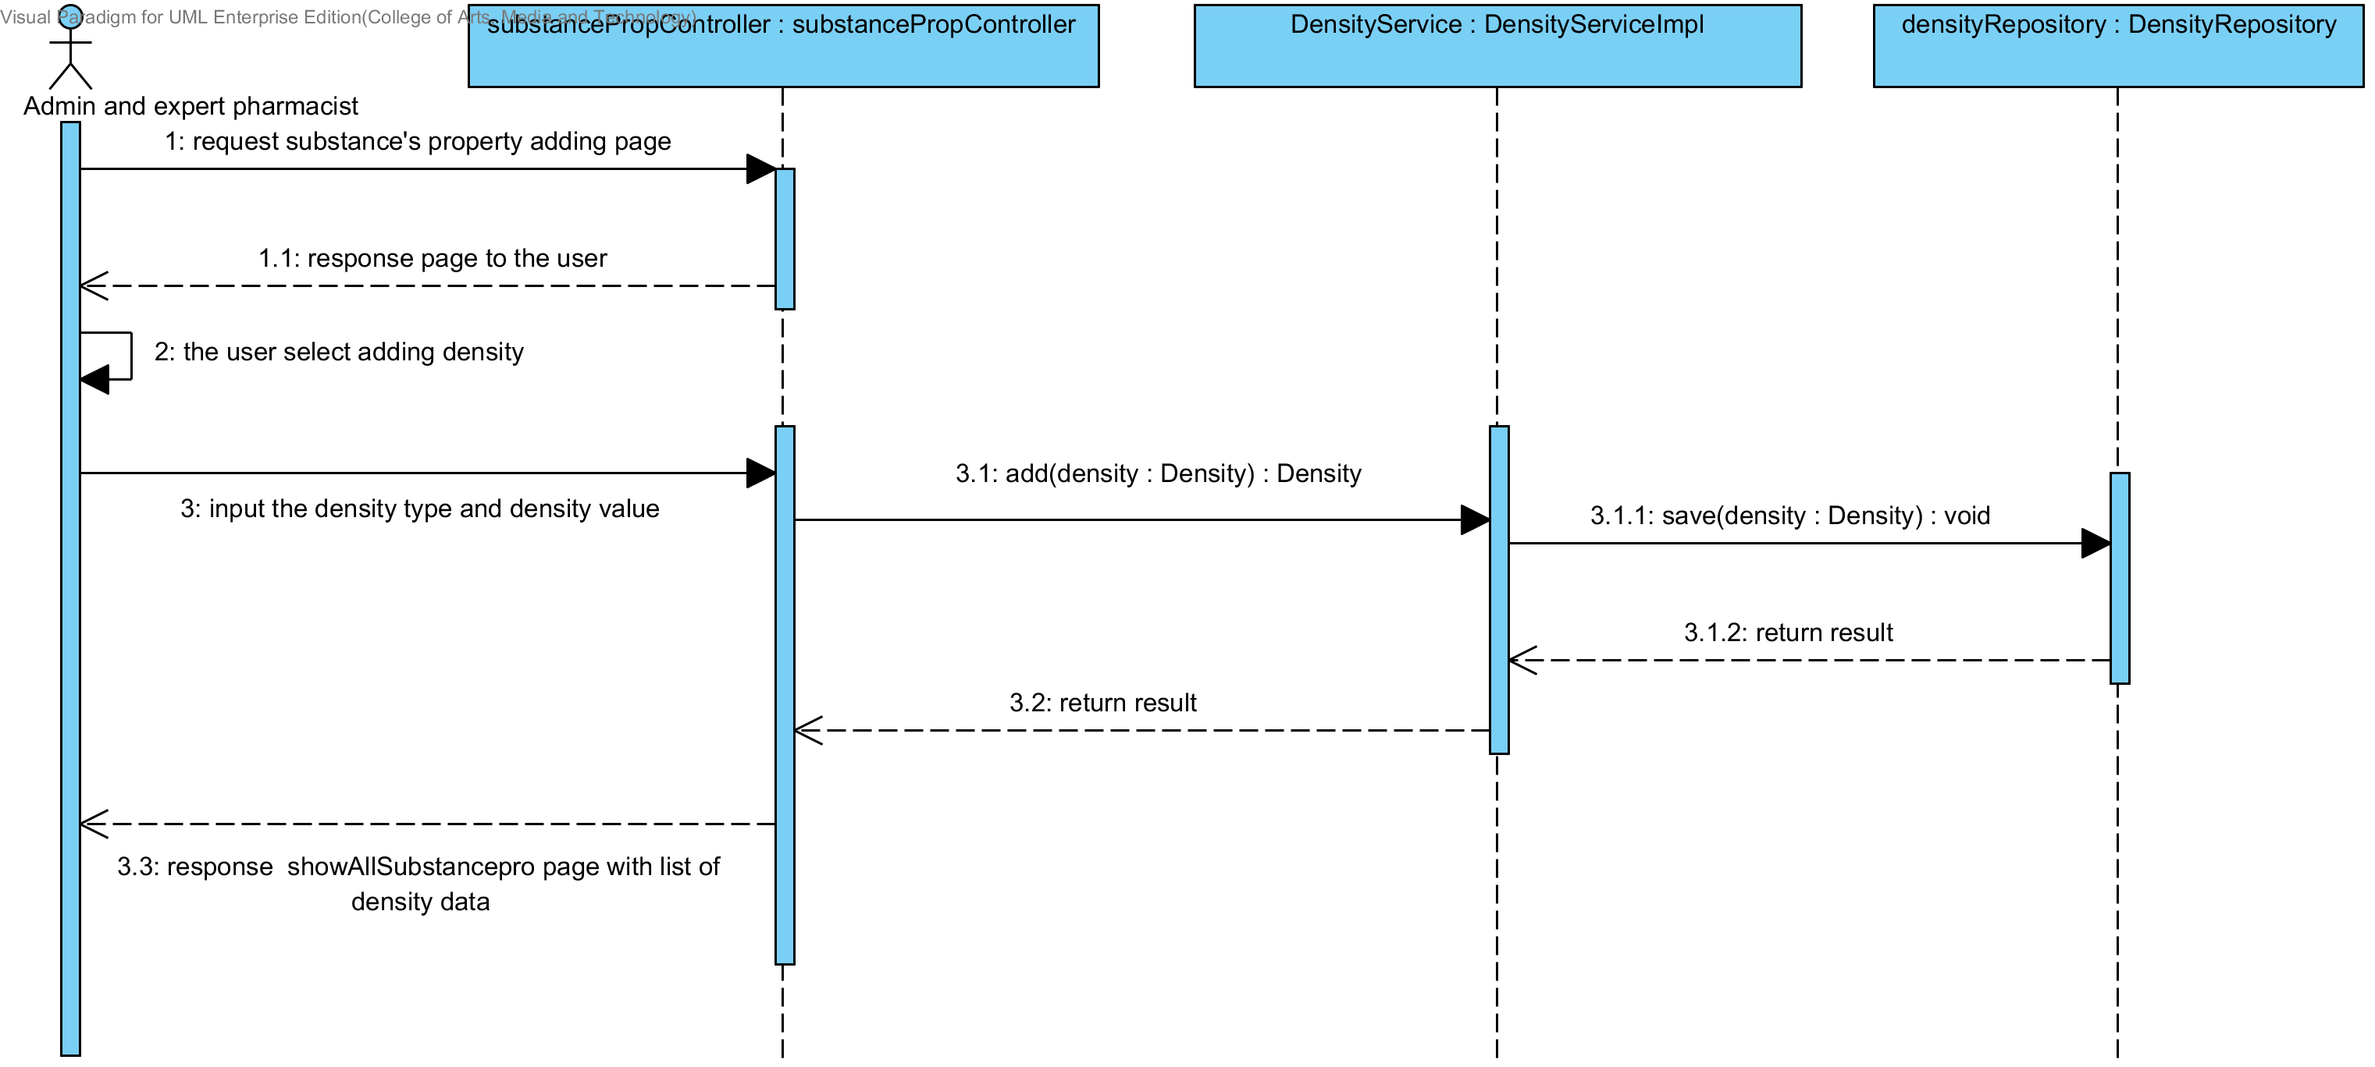

##### 4.1.1.11 SD-09K: The user add a new drug substance property into the system (Compound function).

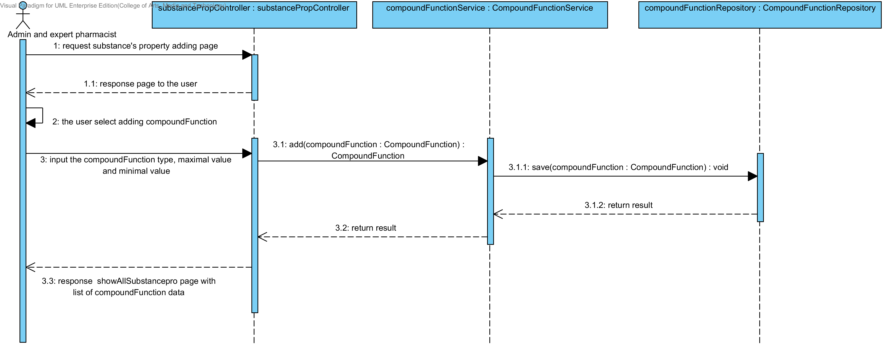

### 4.1.2 URS-10: The user updates an existing substance property into the system.

In the sequence diagram, the user can updates an existing substance property to the system. Firstly, the user opens the substance property updating page. The system shows all substance property data to the user, then the user selects the substance property for making substance property updating, after that, the user inputs substance property value such as name, max value min value and substance's property value. The substance property controller gets the data from the user, after that the controller chooses appropriate SubstanceProperty’s service for updating the existing substance property to the system. Finally, the substance property controller shows a substance property that already update on the successful adding substance property page to the user.

##### 4.1.2.1 SD-10A: The user updates an existing substance’s property into the system (Solubility).

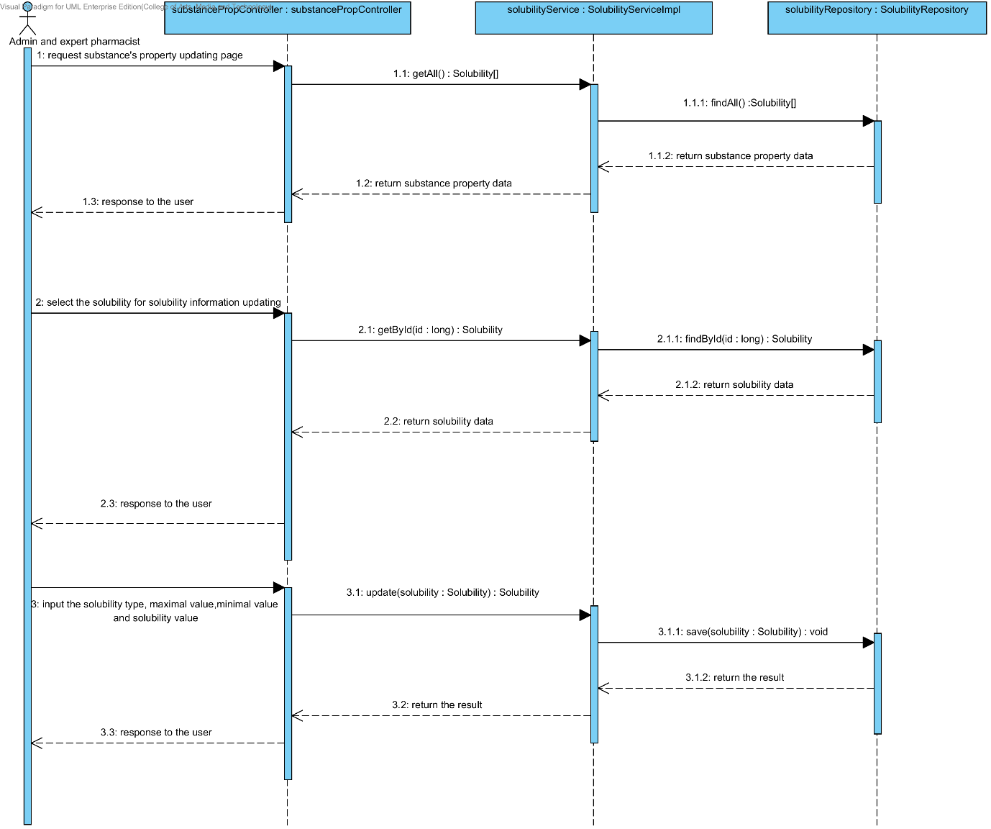

##### 4.1.2.2 SD-10B: The user updates an existing substance property into the system (DegradationMechanism).

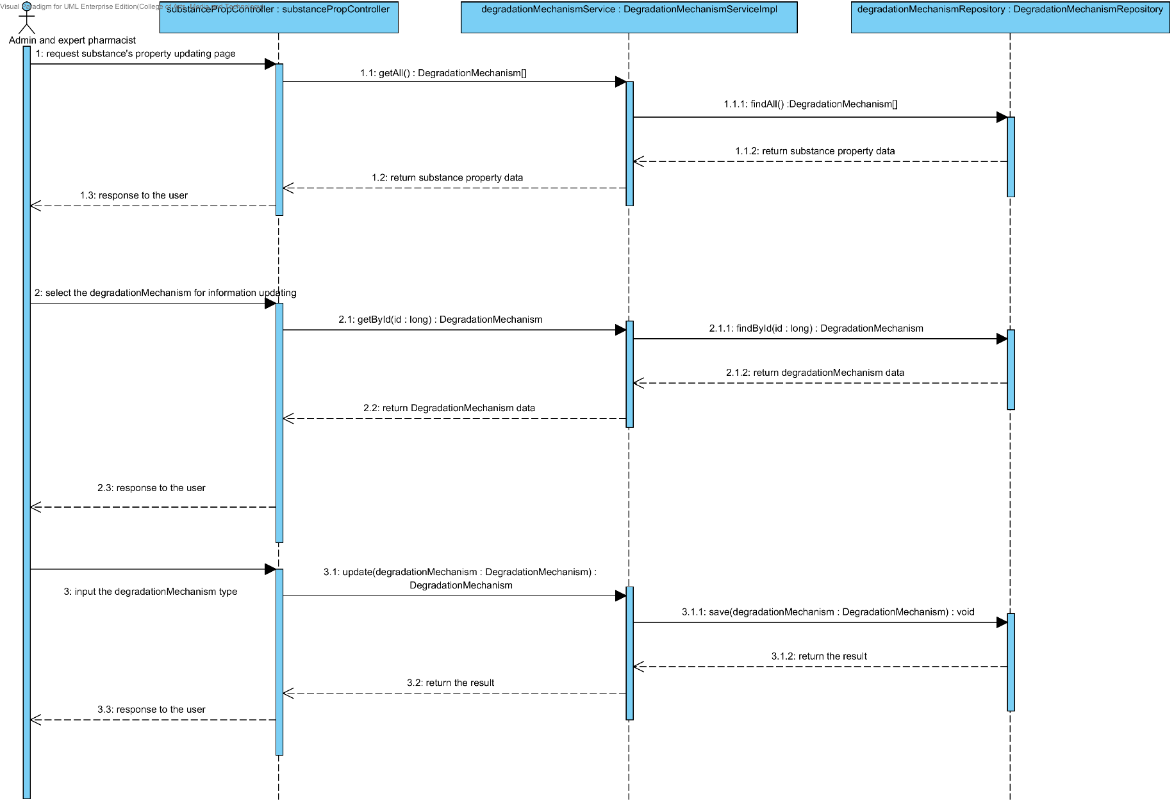

##### 4.1.2.3 SD-10C: The user updates an existing substance property into the system (Kinetic Reaction).

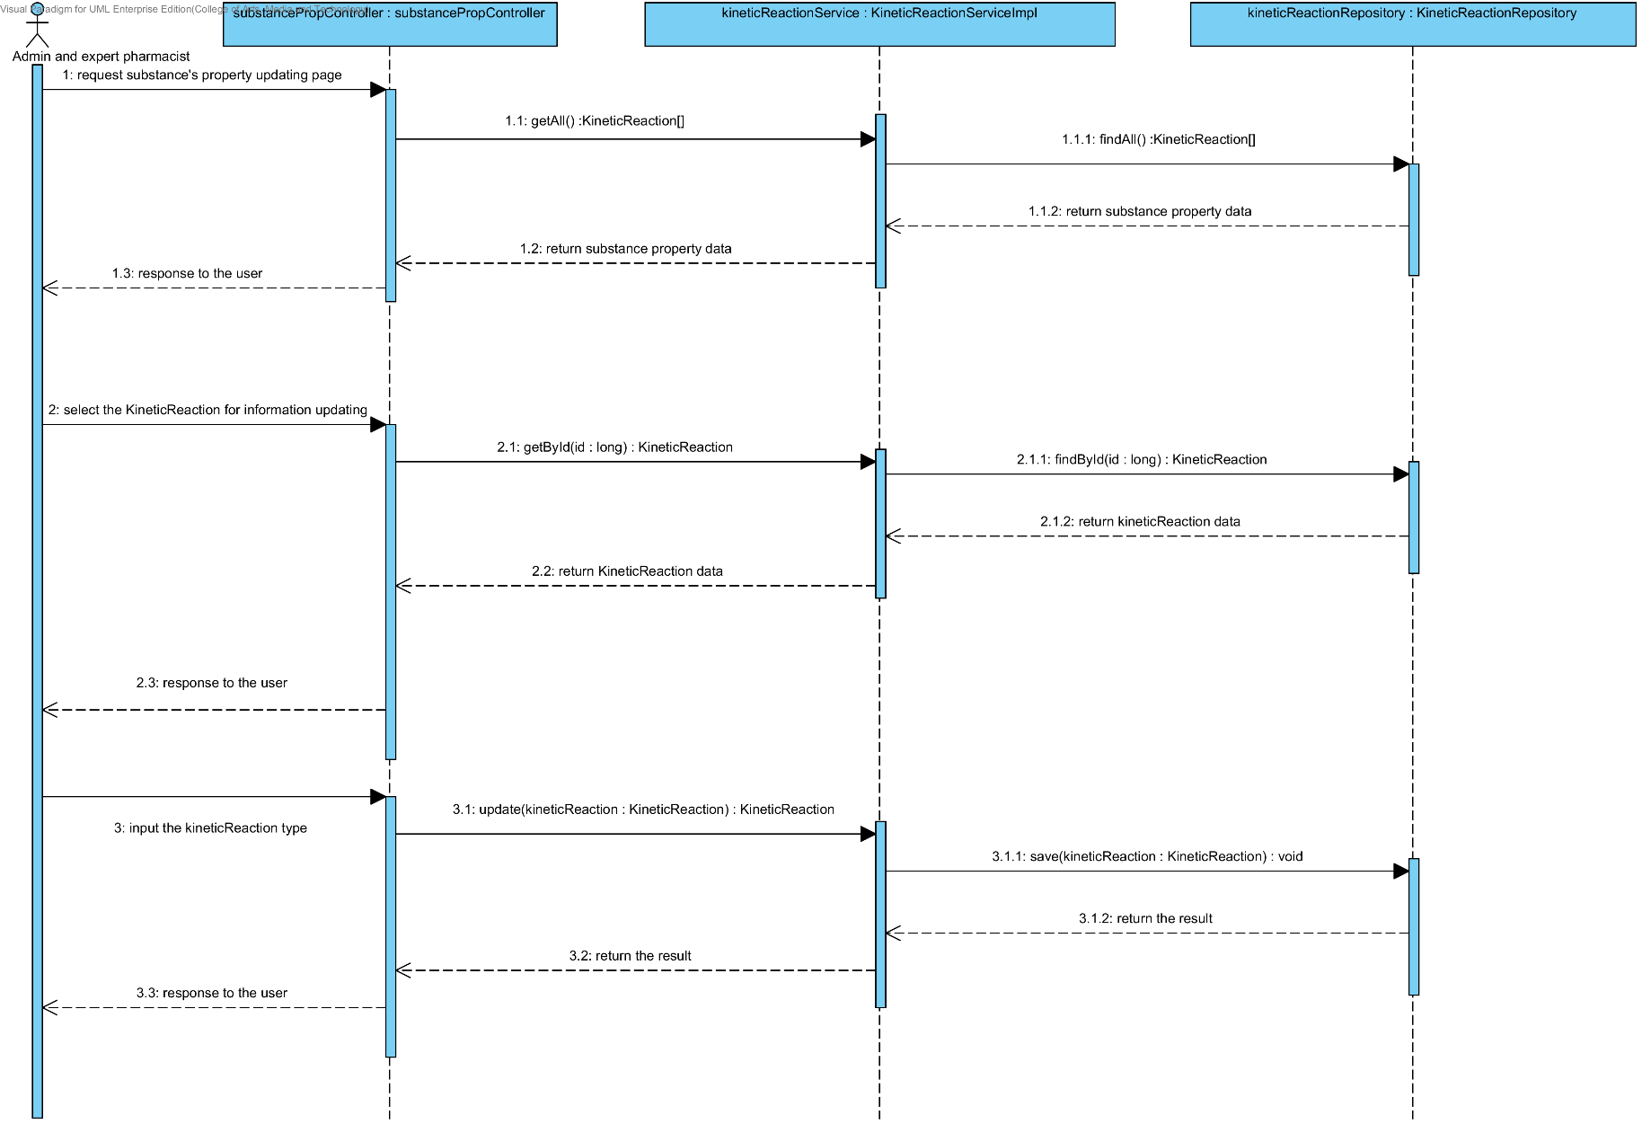

##### 4.1.2.4 SD-10D: The user updates an existing substance property into the system (Pka).

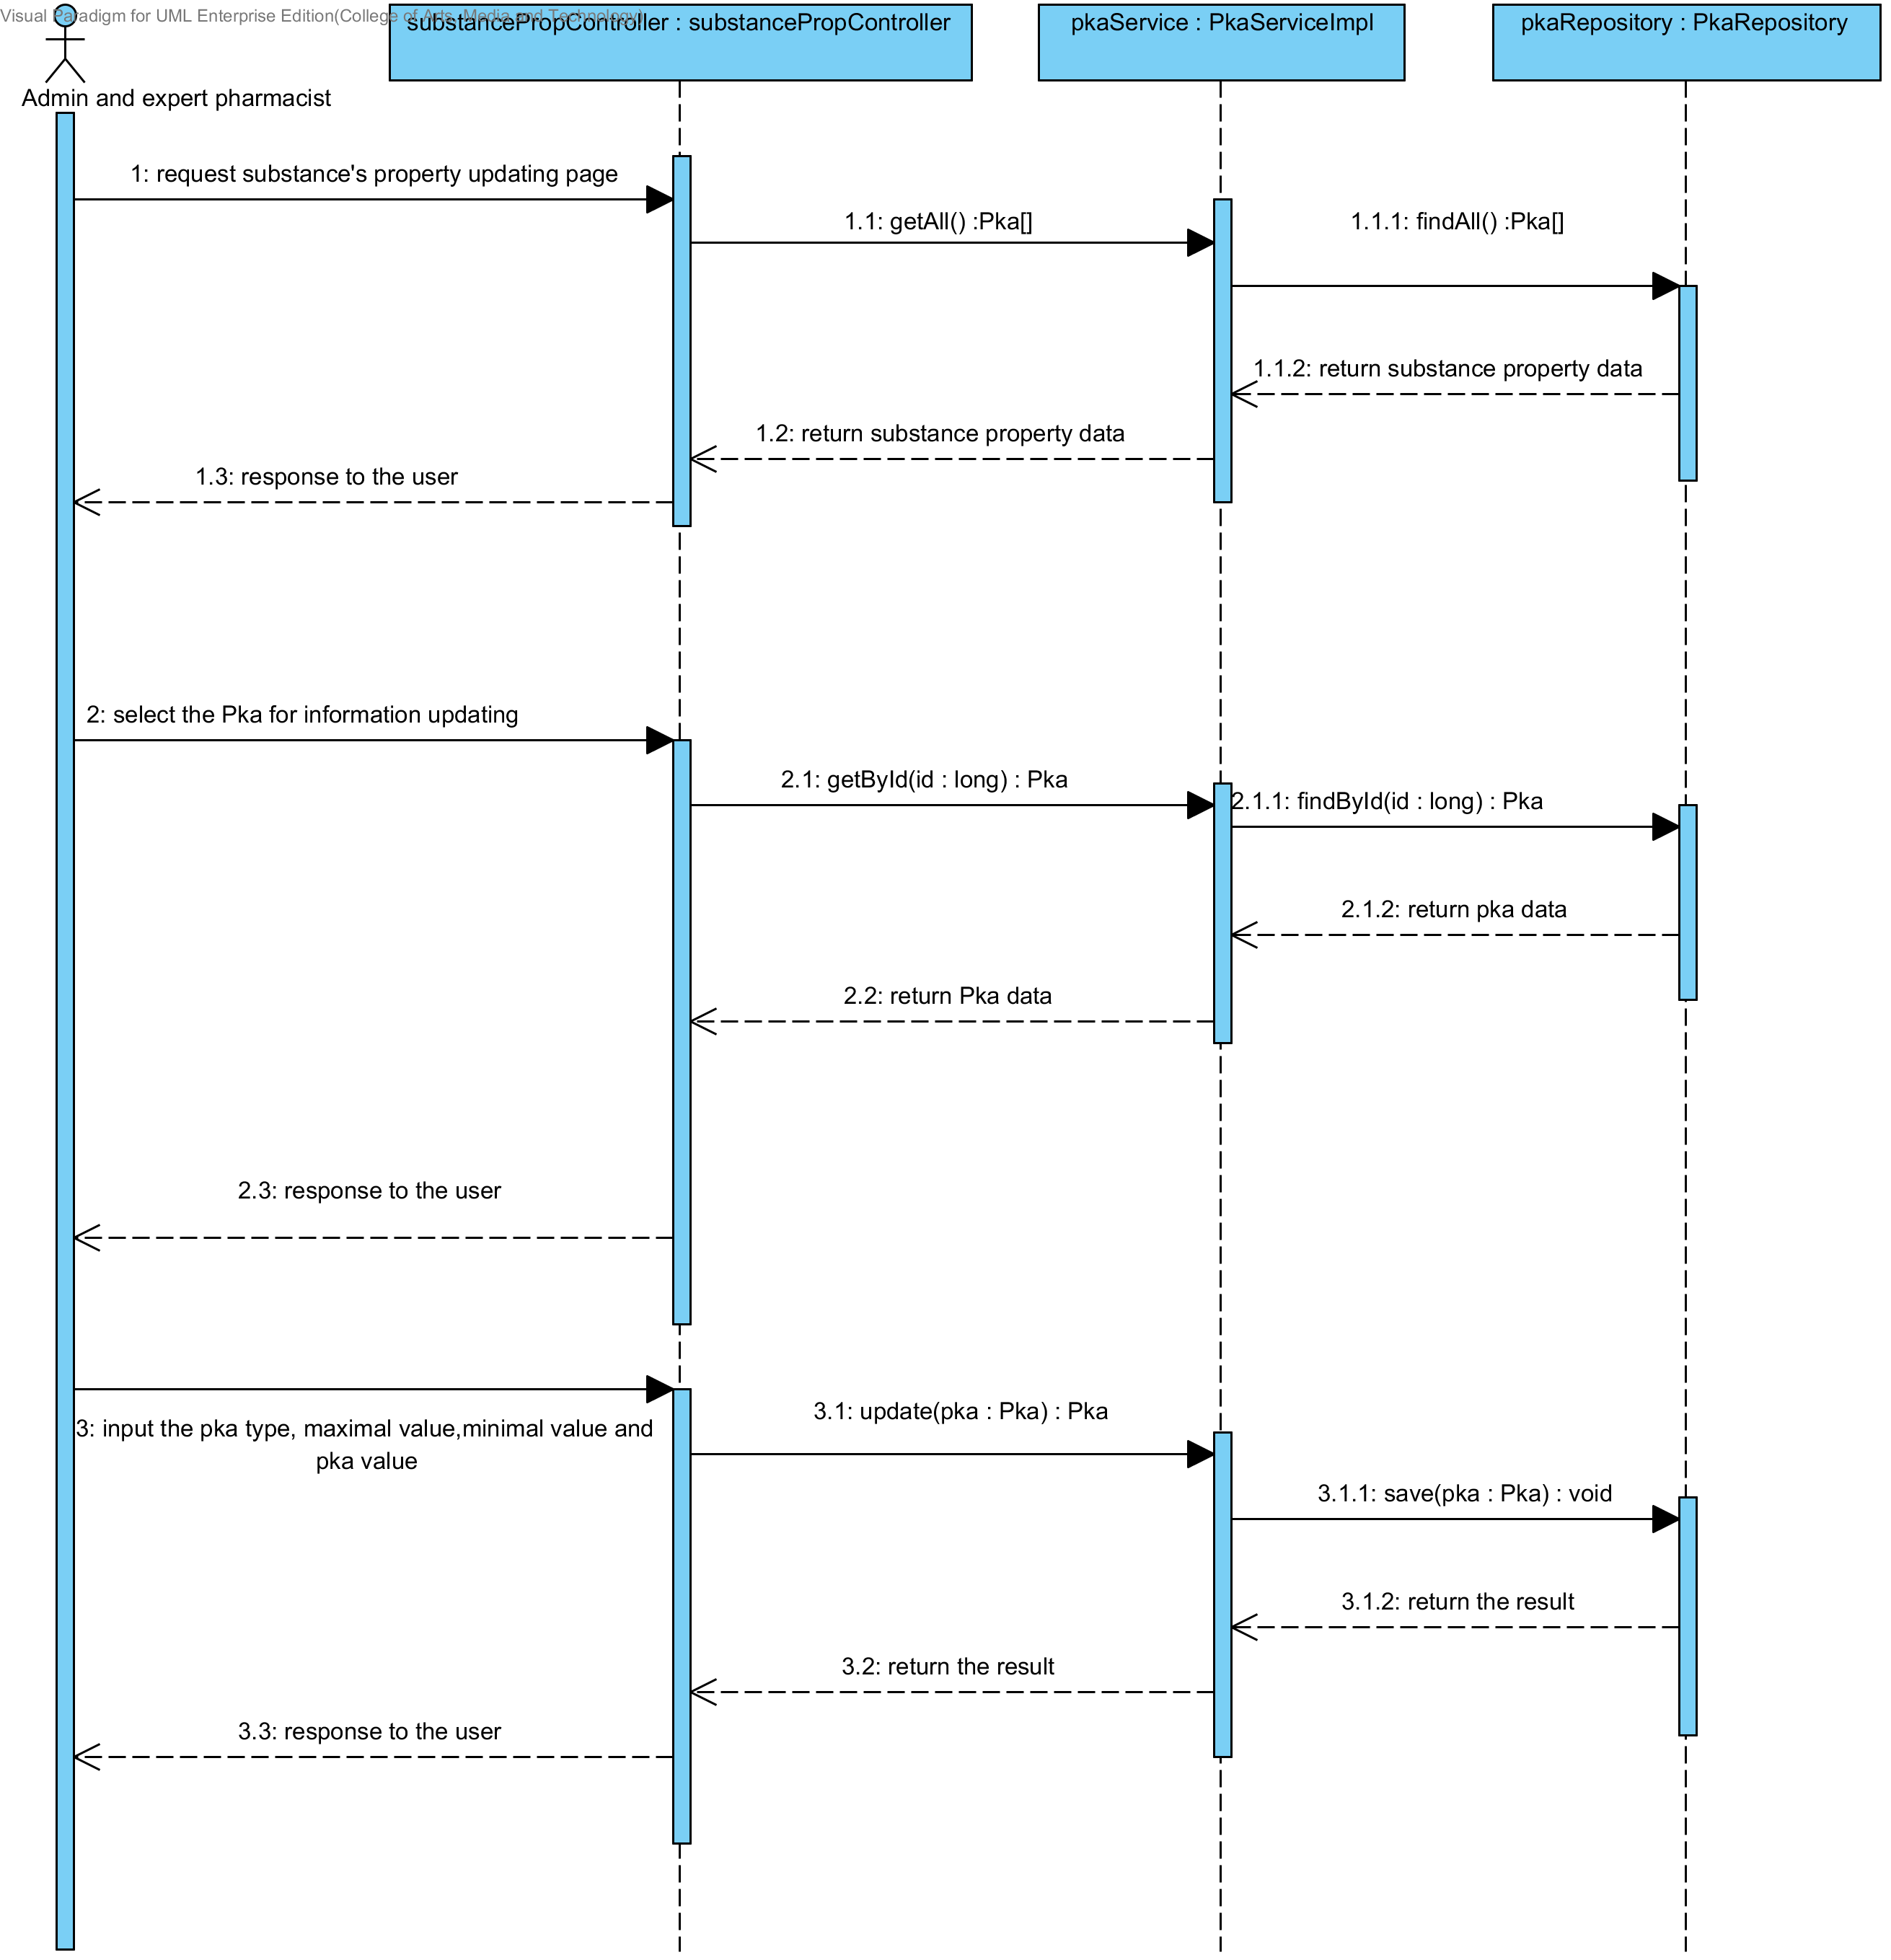

##### 4.1.2.5 SD-10E: The user updates an existing substance property into the system (PartitionCoefficient).

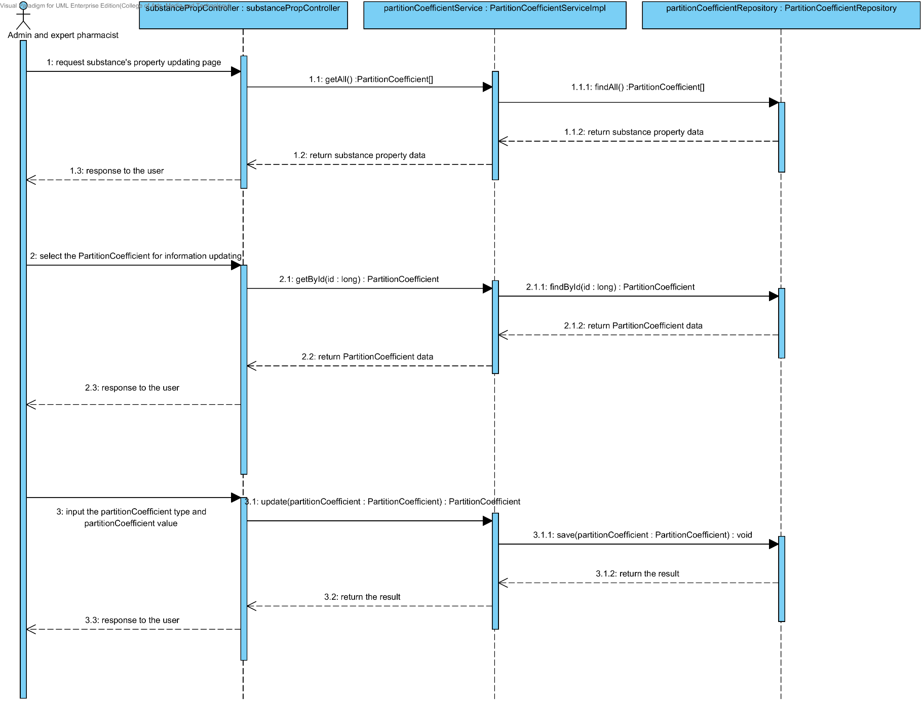

##### 4.1.2.6 SD-10F: The user updates an existing substance property into the system (Solidstate).

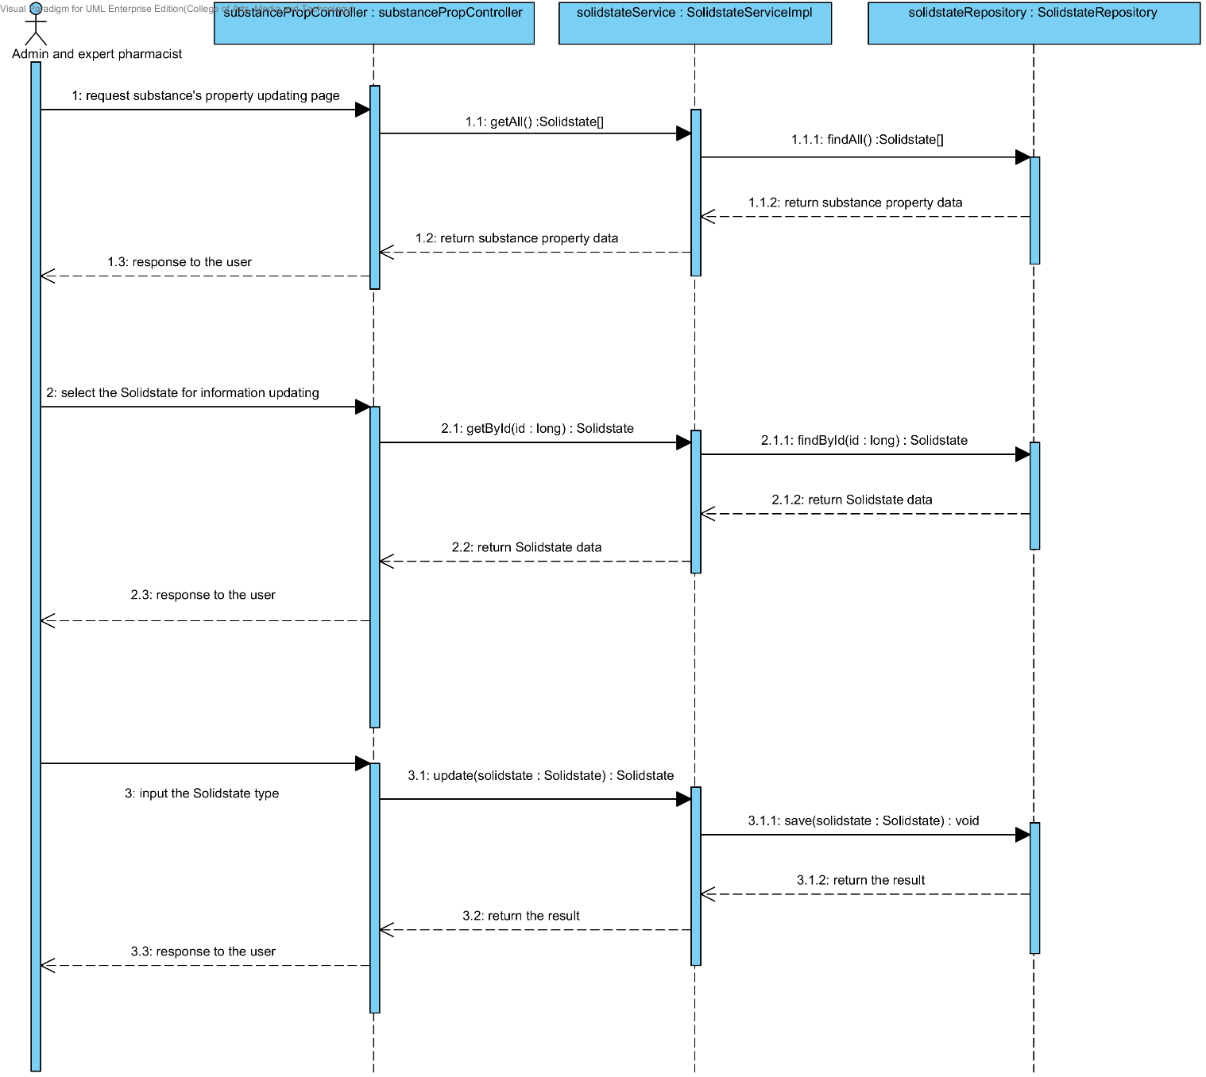

##### 4.1.2.7 SD-10G: The user updates an existing substance property into the system (Hygroscopicity).

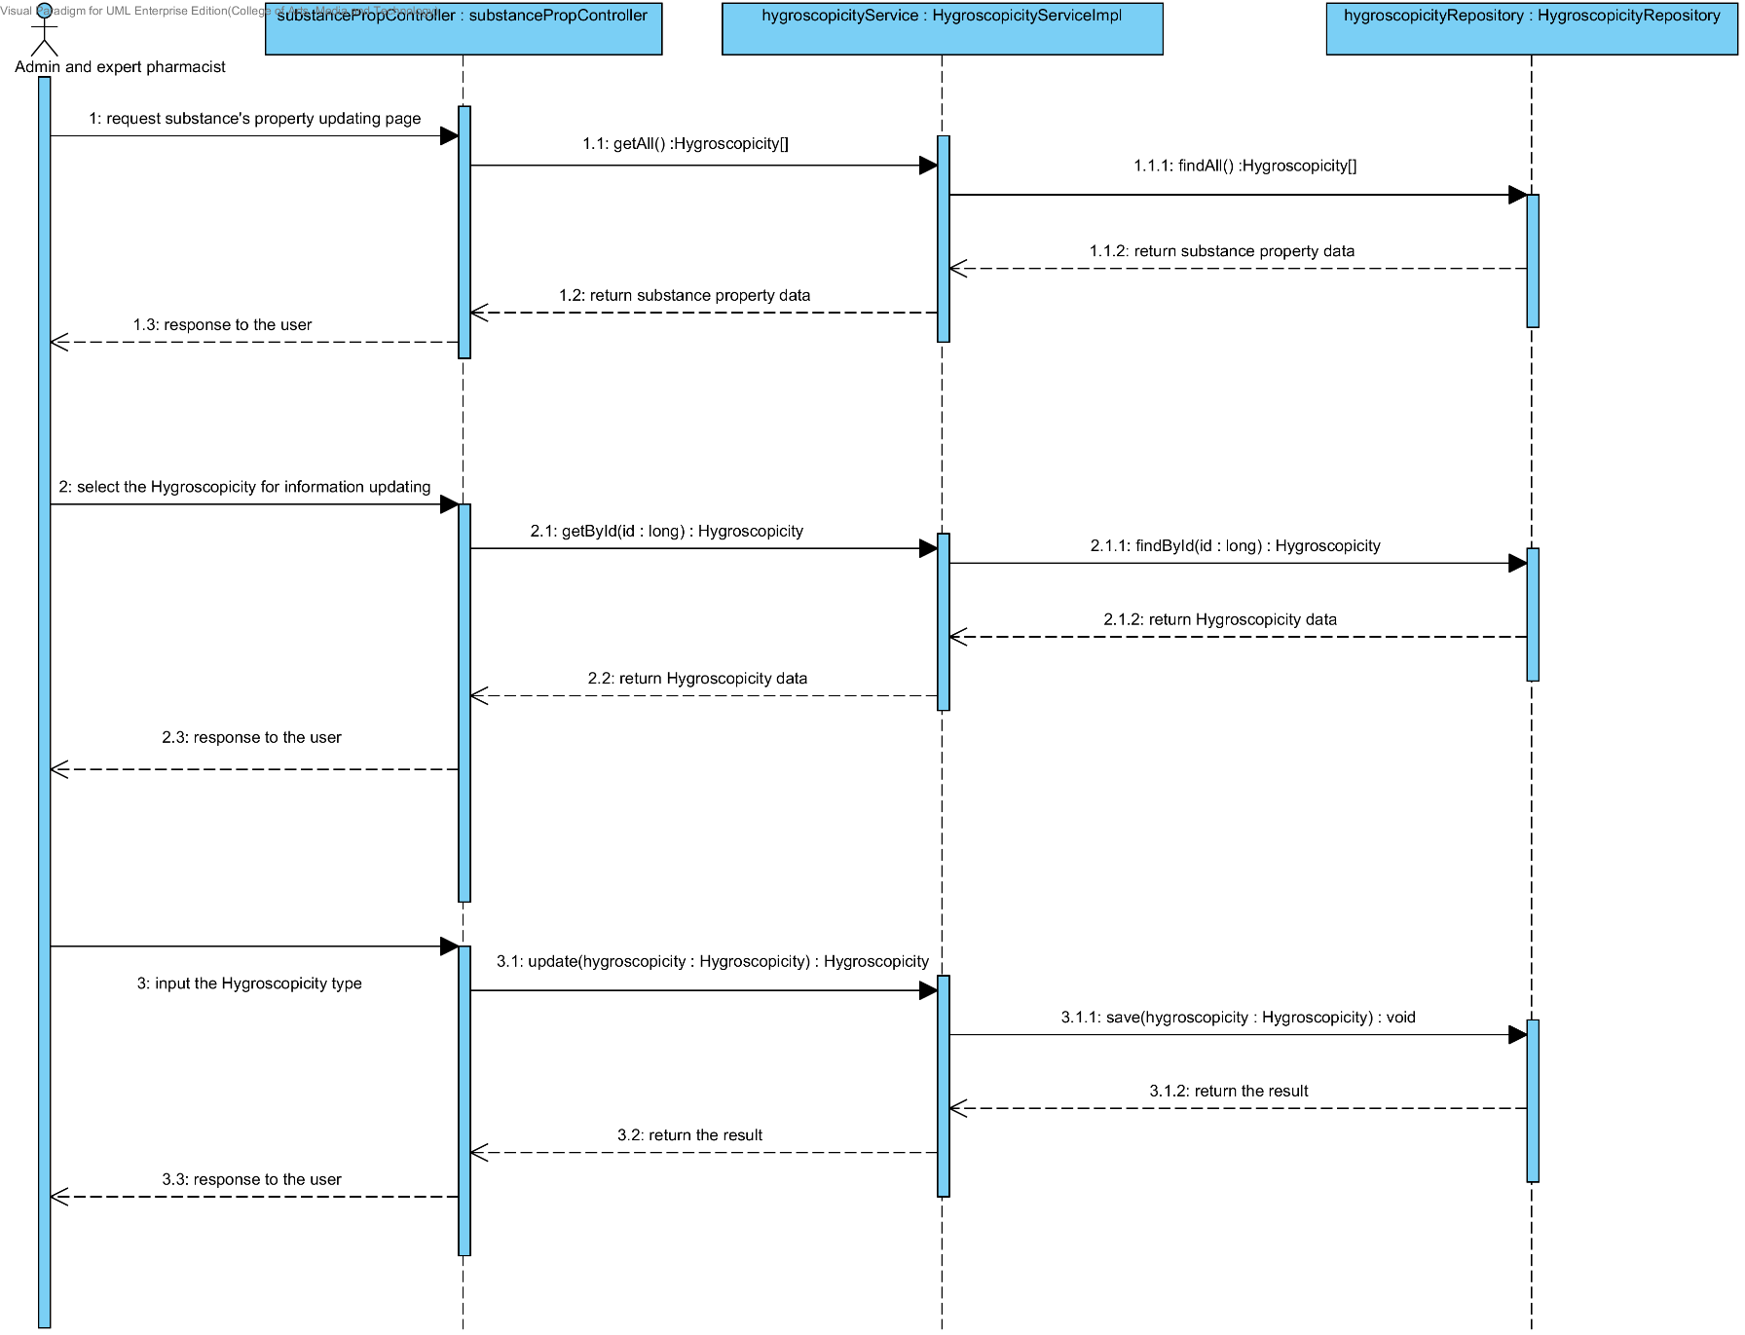

##### 4.1.2.8 SD-10H: The user updates an existing substance property into the system (ParticleSize).

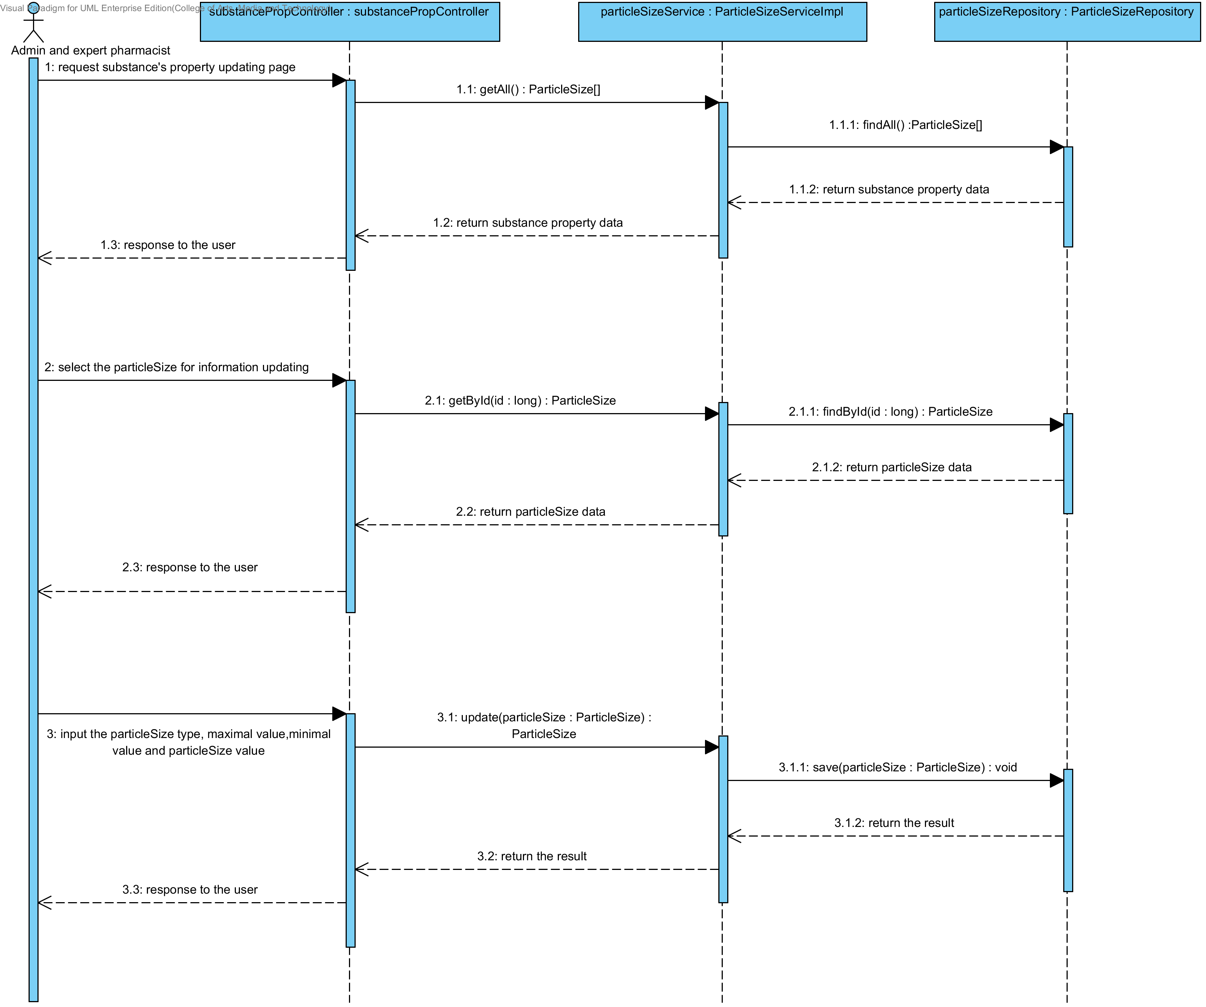

##### 4.1.2.9 SD-10I: The user updates an existing substance property into the system (Flowability).

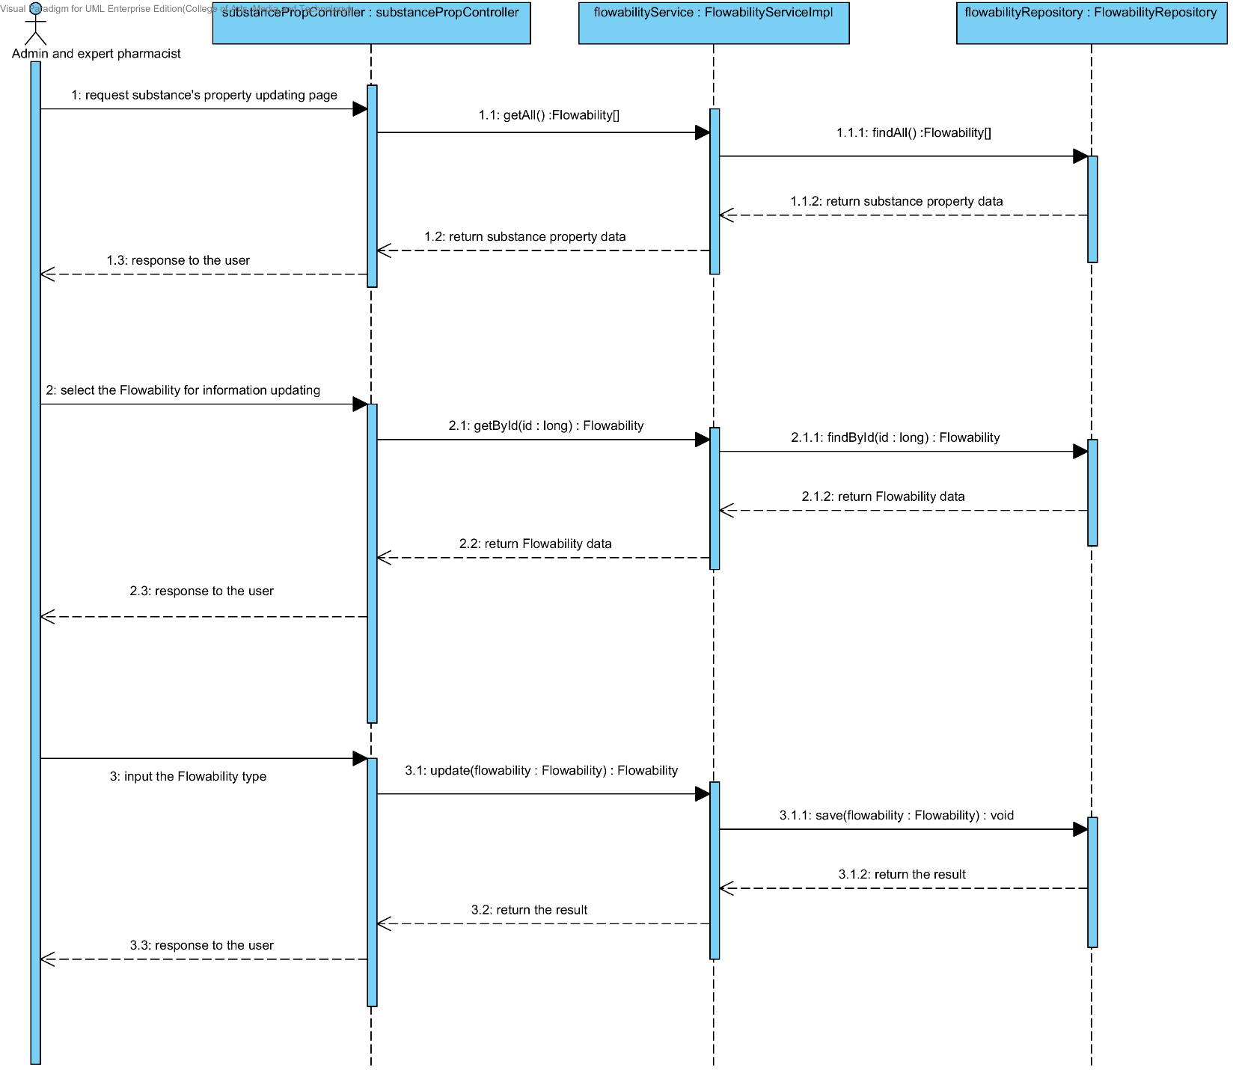

##### 4.1.2.10 SD-10J: The user updates an existing substance property into the system (Density).

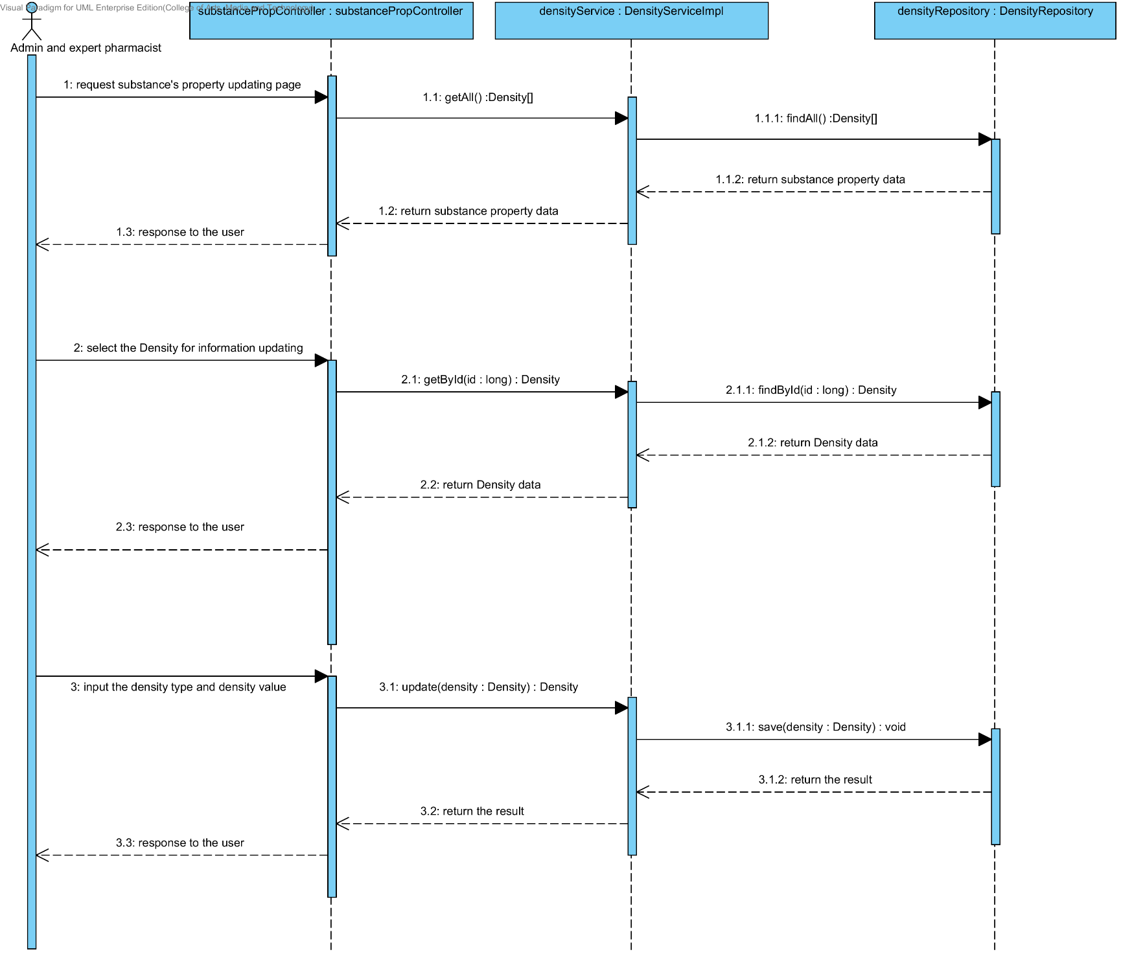

##### 4.1.2.11 SD-10K: The user updates an existing substance property into the system (Compound function).

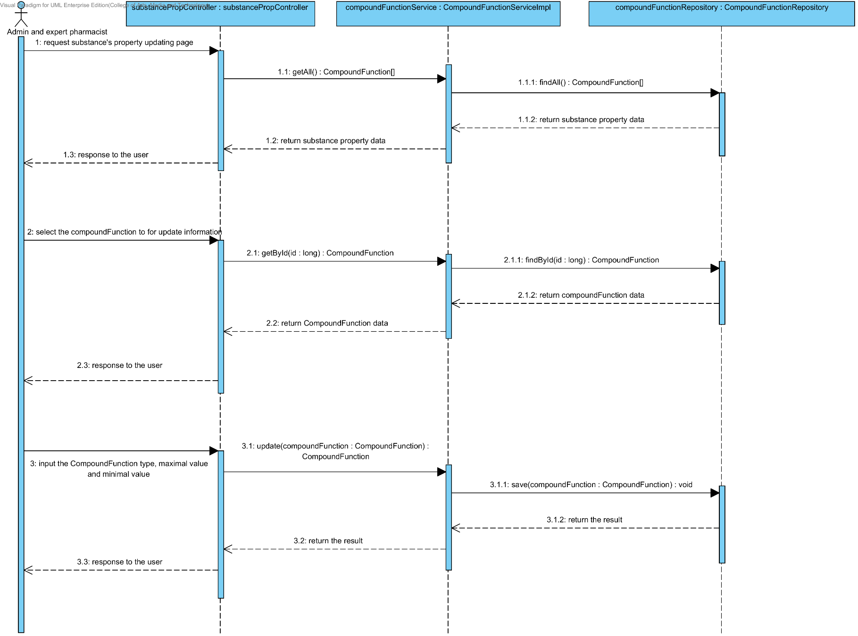

### 4.1.3 URS-11: The user deletes an existing substance property from the system.

In the sequence diagram, the user can delete an existing substance property from the system. Firstly, the user opens the substance property deleting page. The system shows all substance property data on the screen, then the user selects substance property value for deleting. After that, the substance property controller finds an appropriate service for substance property deleting. Finally, the substance property controller shows a substance property that already deleted on the deleting substance property substance page.

##### 4.1.3.1 SD-11A: The user deletes an existing substance property from the system (Solubility).

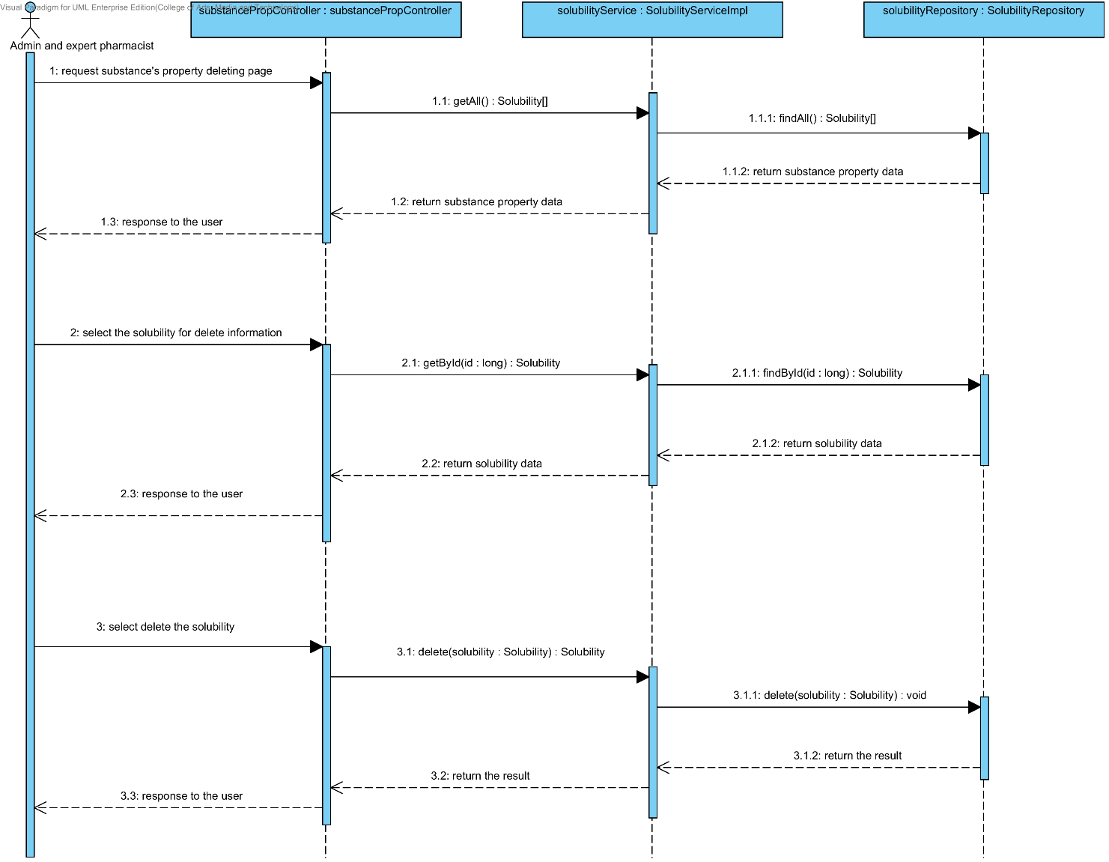

##### 4.1.3.2 SD-11B: The user deletes an existing substance property from the system (DegradationMechanism).

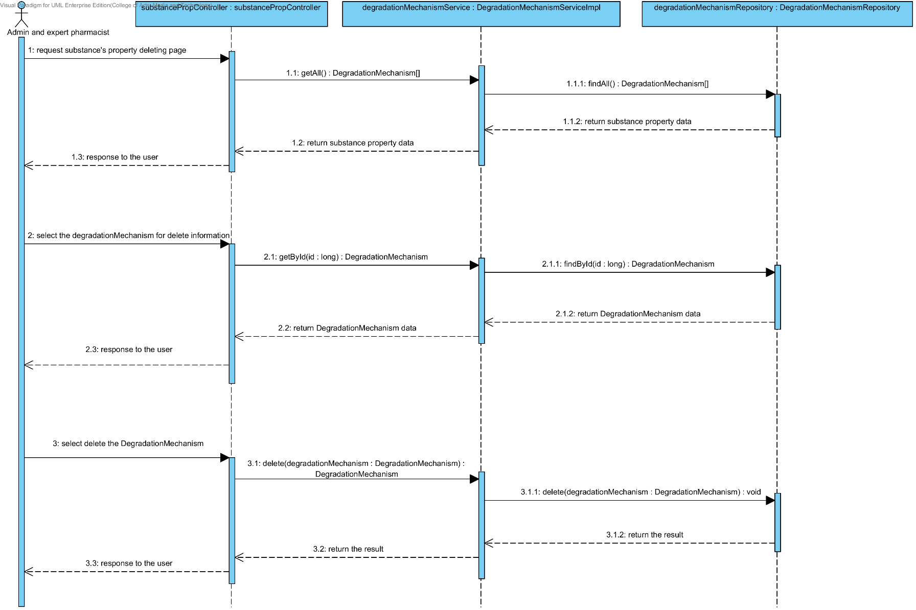

##### 4.1.3.3 SD-11C: The user deletes an existing substance property into the system (Kinetic Reaction).

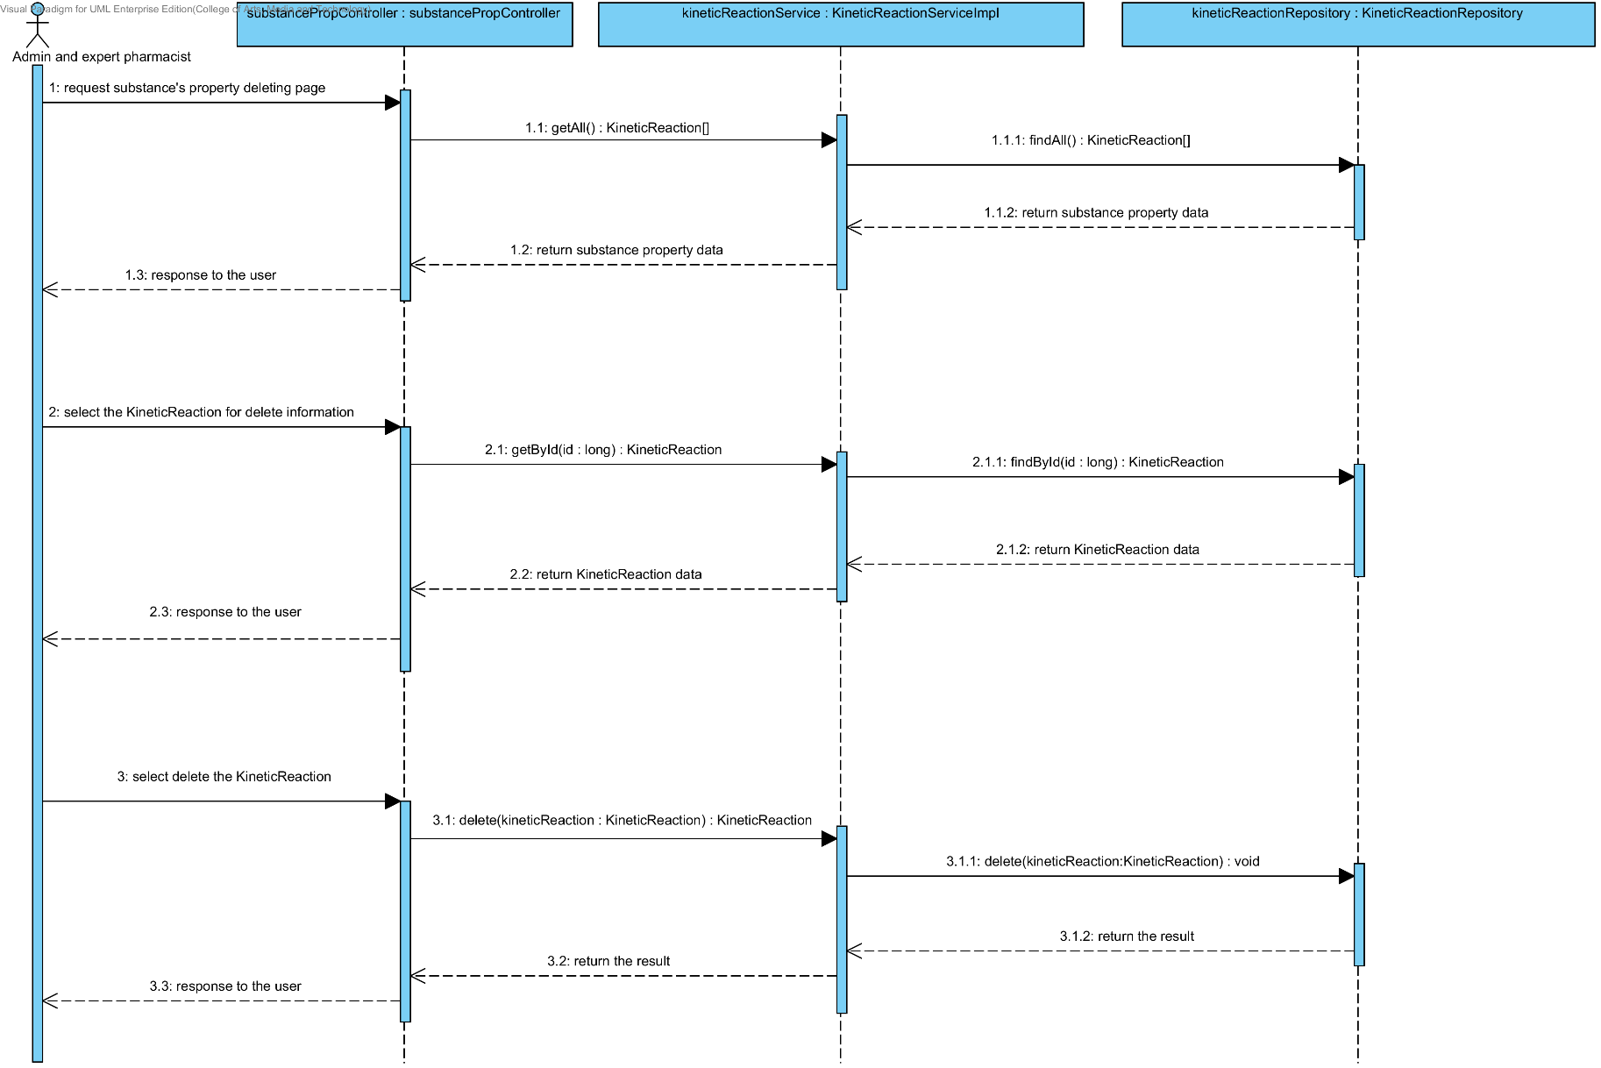

##### 4.1.3.4 SD-11D: The user deletes an existing substance property from the system (Pka).

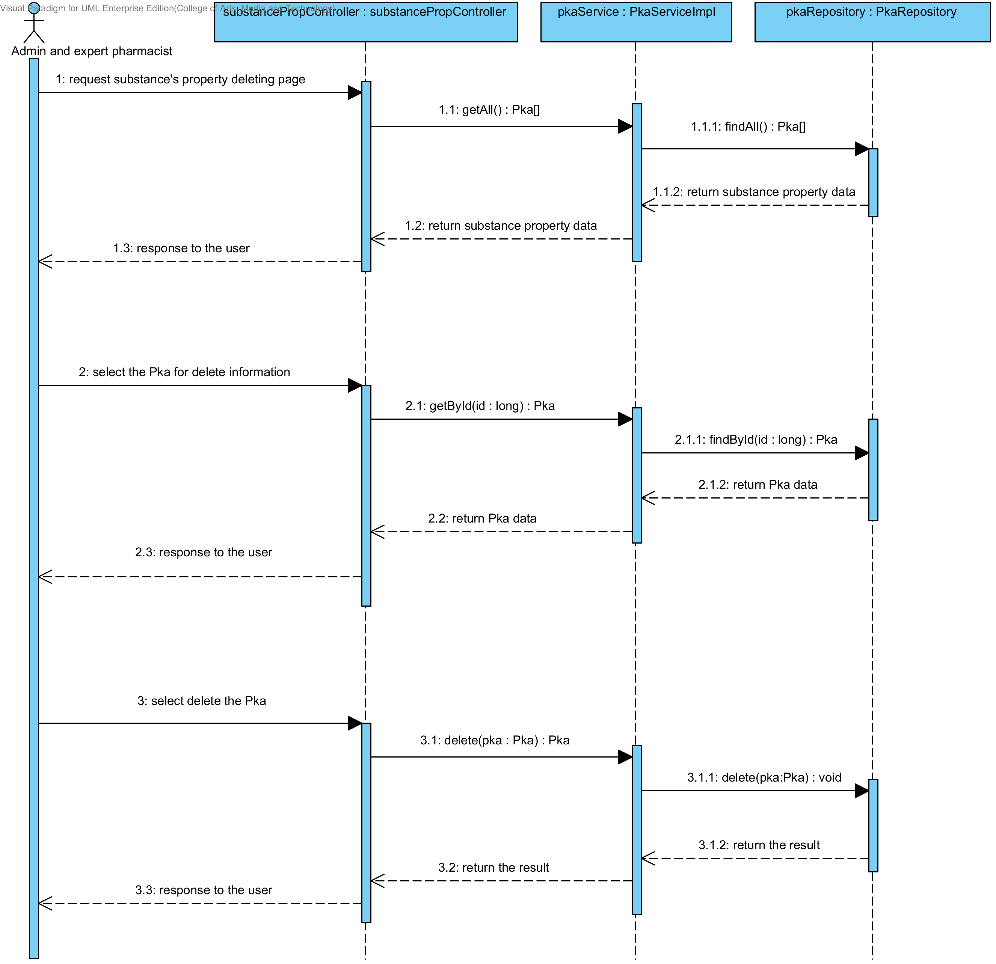

##### 4.1.3.5 SD-11E: The user deletes an existing substance property from the system (PartitionCoefficient).

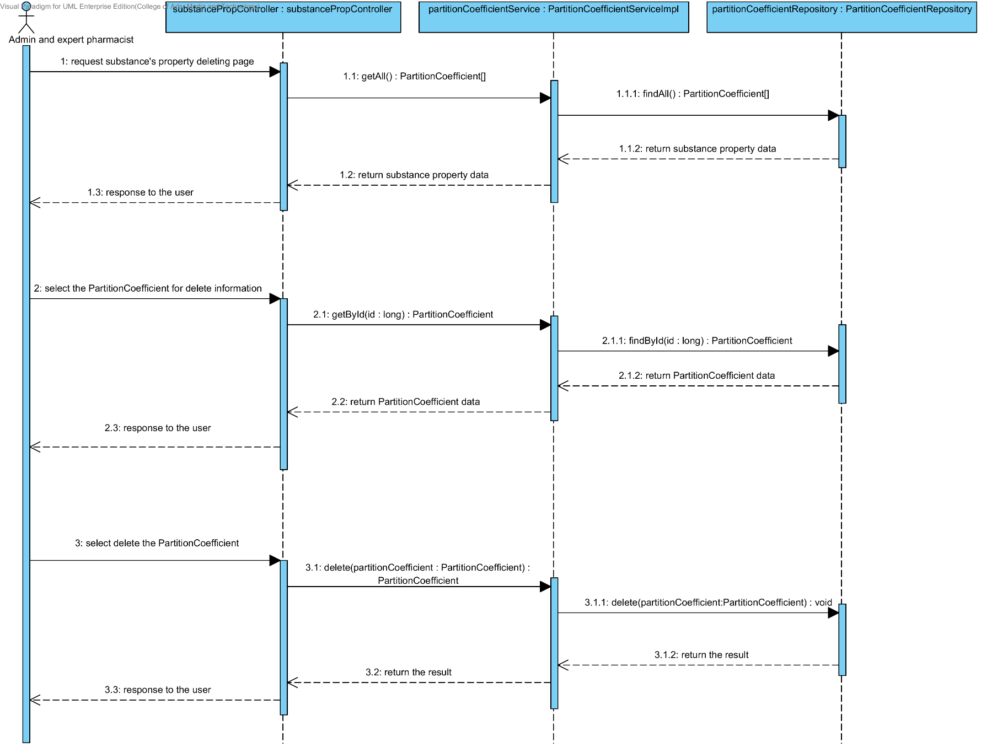

##### 4.1.3.6 SD-11F: The user deletes an existing drug substance property from the system (Solidstate).

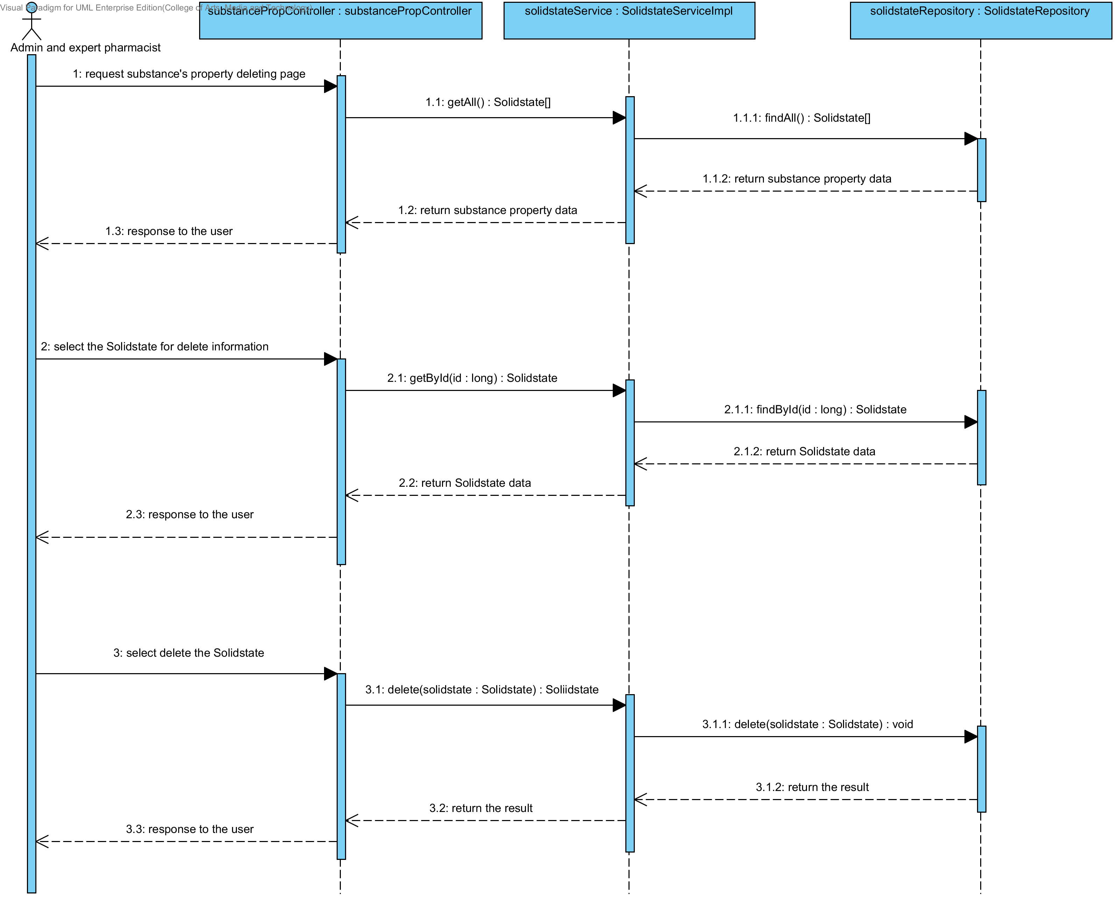

##### 4.1.3.7 SD-11G: The user deletes an existing substance property from the system (Hygroscopicity).

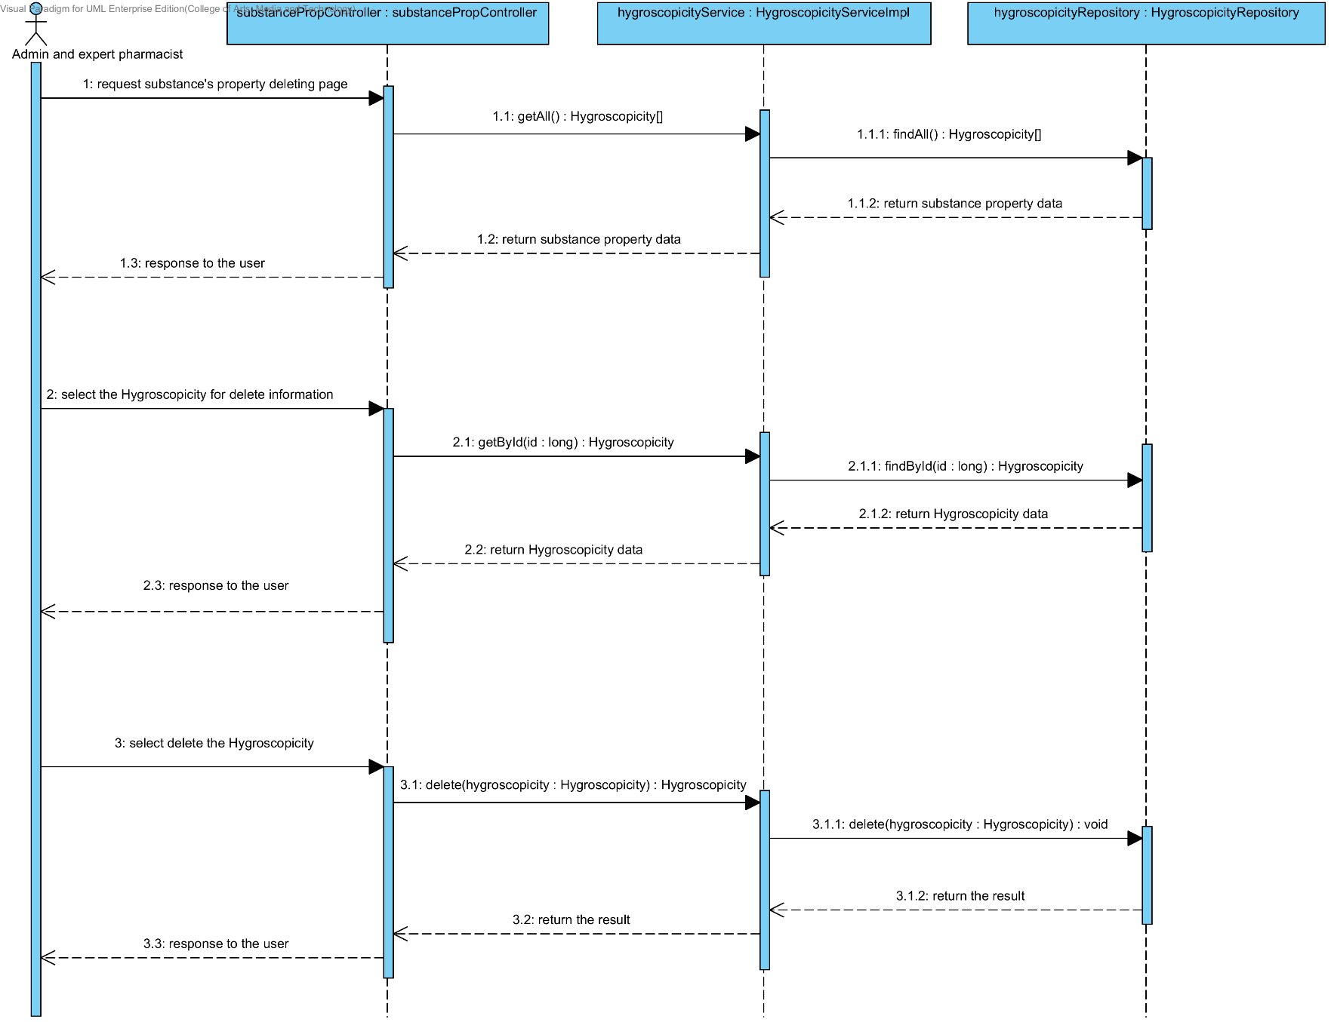

##### 4.1.3.8 SD-11H: The user deletes an existing substance property from the system (ParticleSize).

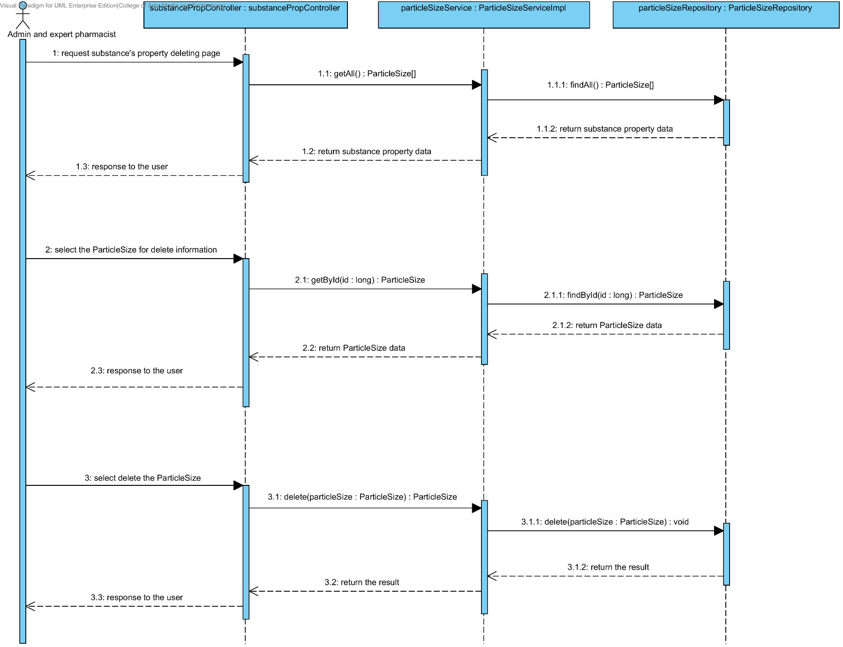

##### 4.1.3.9 SD-11I: The user deletes an existing substance property from the system (Flowability).

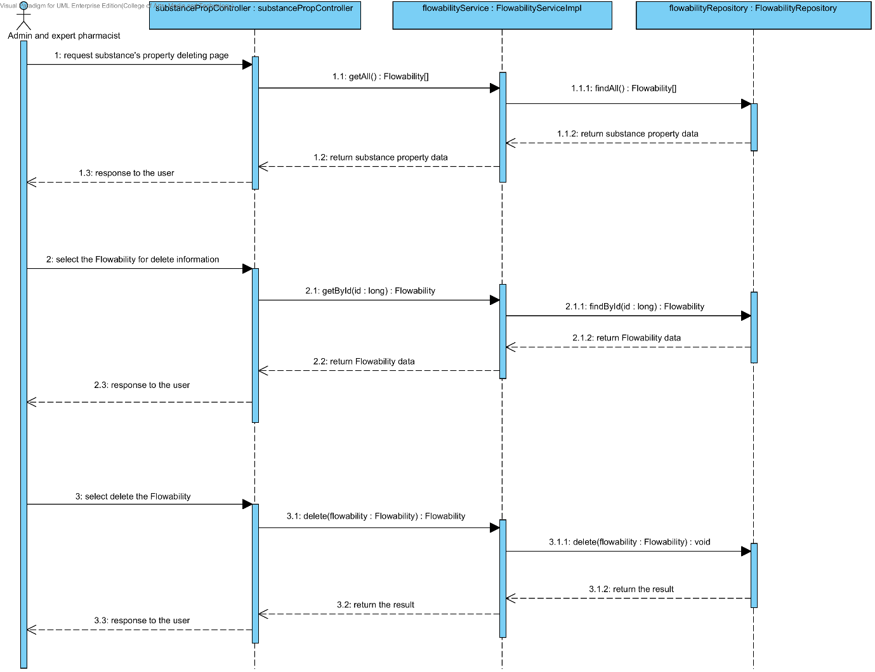

##### 4.1.3.10 SD-11J: The user deletes an existing substance property from the system (Density).

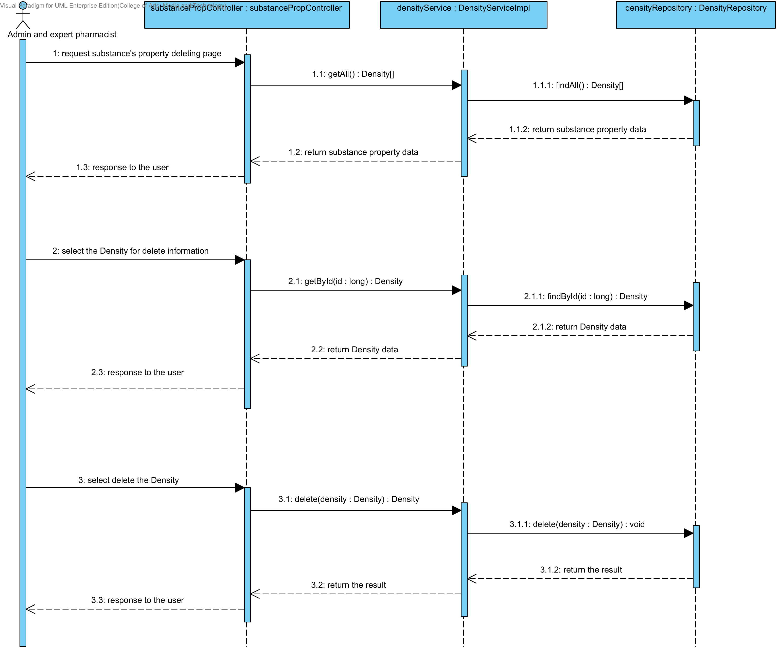

##### 4.1.3.11 SD-11K: The user deletes an existing substance property from the system (Compound function).

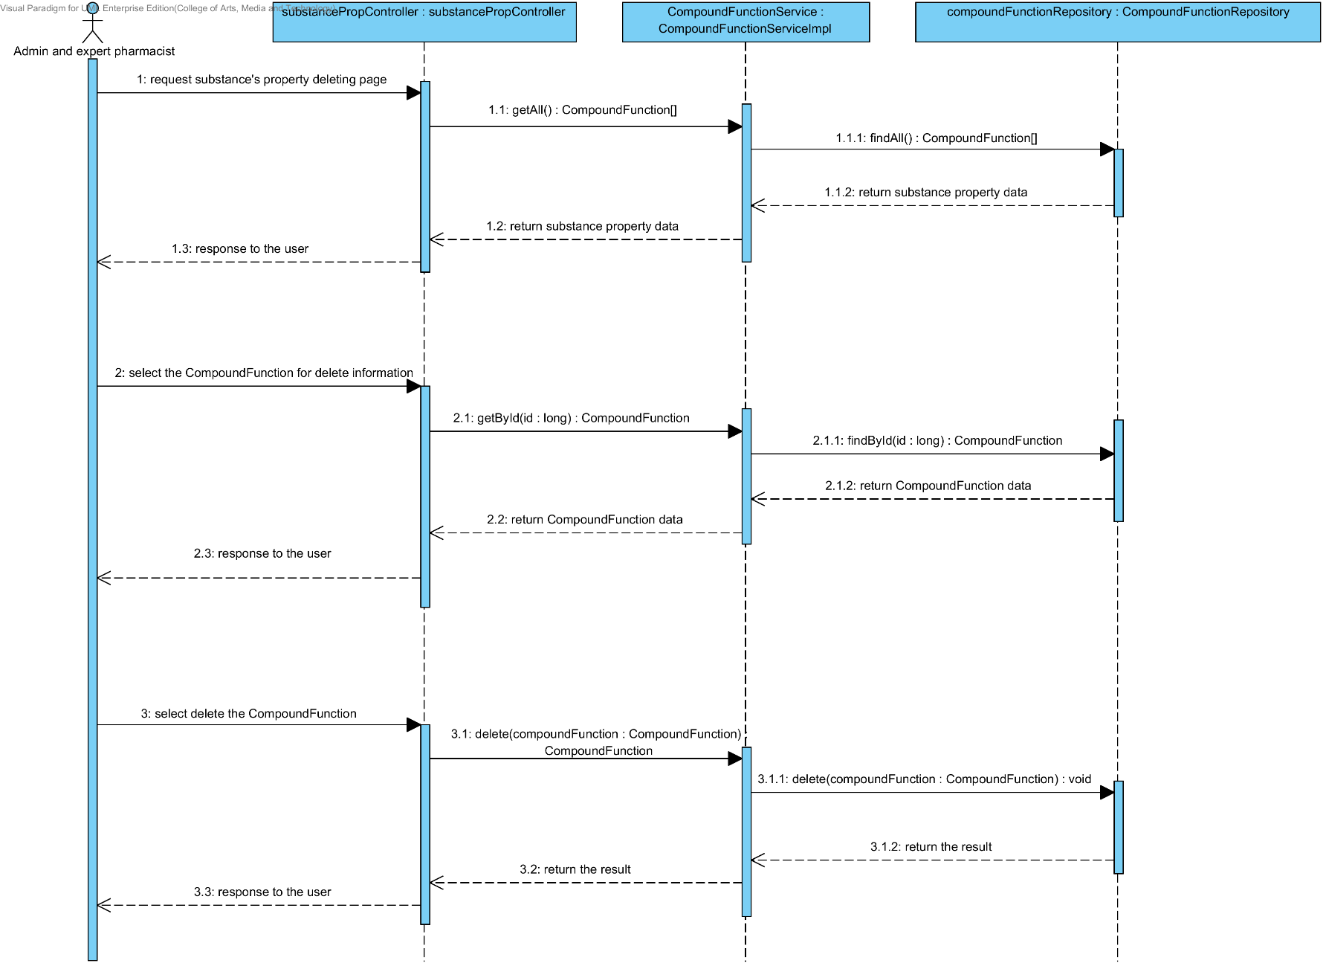

## 4.2- Feature 6: Manage the drug substance

### 4.2.1 URS-12: The user adds a new substance to the system.

In a sequence diagram, the user can add a new substance to the system. Firstly, the user opens the substance adding page, then the user input substance data such as name, substance property, weight property and lonicity. The substance controller gets an input data from the user. After that, the substance controller send a new substance data to appropriate service for adding a new substance. Finally, the system show a new substance with the adding substance successful page.

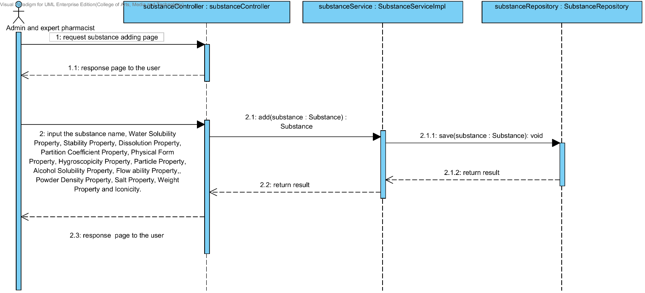

### 4.2.2 URS-13: The user updates an existing substance in the system.

In a sequence diagram, the user can update an existing substance in the system. Firstly, the user opens the substance updating page, then the user input substance data such as substance property, weight property and lonicity. The substance controller gets a substance data from the user. After that, the substance controller send a new substance data to appropriate service for updating an existing substance in the system. Finally, the system show substance that already update with the substance adding successful page.

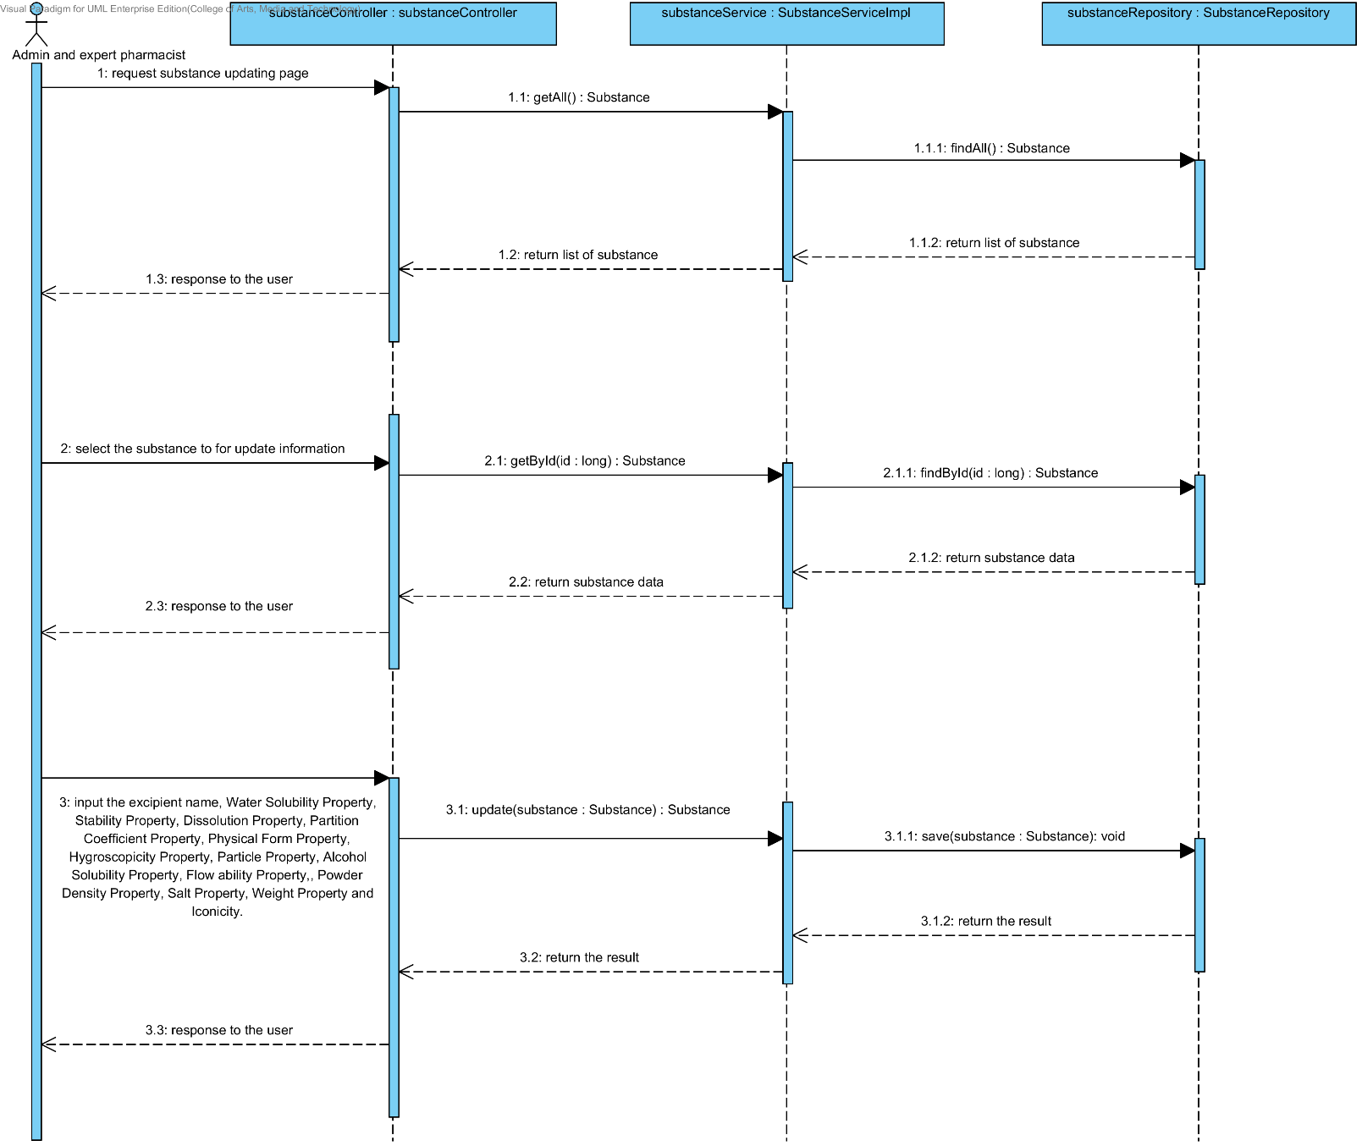

### 4.2.3 URS-14: The user deletes an existing substance from the system.

In the sequence diagram, the user can delete an existing substance from the system. Firstly, the user opens the substance deleting page. The system shows all substance data on the screen, then the user selects substance for deleting. After that, the substance controller finds an appropriate service for substance property deleting. Finally, the substance controller shows a substance that already deleted on the deleting substance successful page to the user.

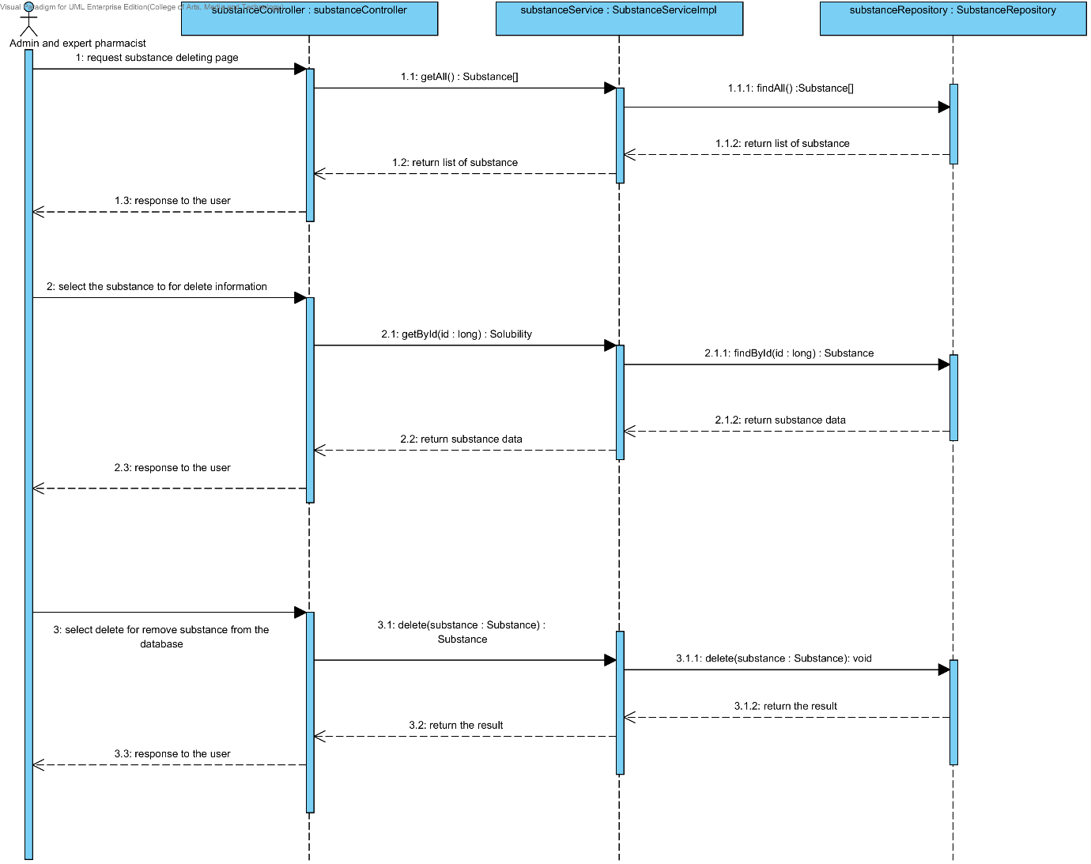

### 4.2.4 URS-15: The user views the substance in the system.

In the sequence diagram, the user can delete an existing substance from the system. Firstly, the user opens the substance deleting page, then the system shows all substance data on the screen.

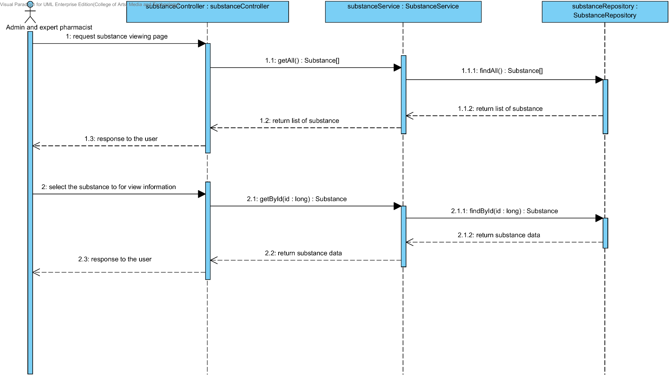

## 4.3- Feature 7: Manage the drug substance

### 4.3.1 URS-16: The user adds a new excipient to the system.

In a sequence diagram, the user can add a new excipient to the system. Firstly, the user opens the excipient adding page, then the user input excipient data such as substance property and compound function. The excipient controller gets an input data from the user. After that, the excipient controller send a new excipient data to appropriate service for adding a new excipient. Finally, the system show a new excipient with the adding excipient successful page.

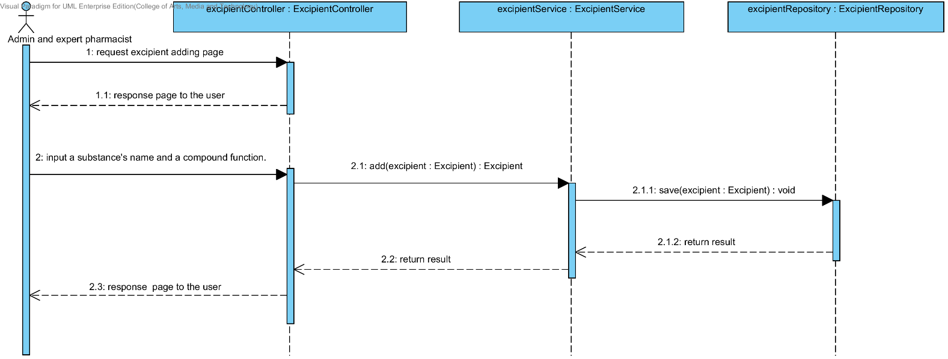

### 4.3.2 URS-17: The user updates an existing excipient in the system.

In a sequence diagram, the user can update an existing excipient in the system. Firstly, the user opens the excipient updating page, then the user input excipient data such as substance property and compound function. The excipient controller gets an excipient data from the user. After that, the excipient controller send a new excipient data to appropriate service for updating an existing excipient in the system. Finally, the system show excipient that already update with the excipient adding successful page.

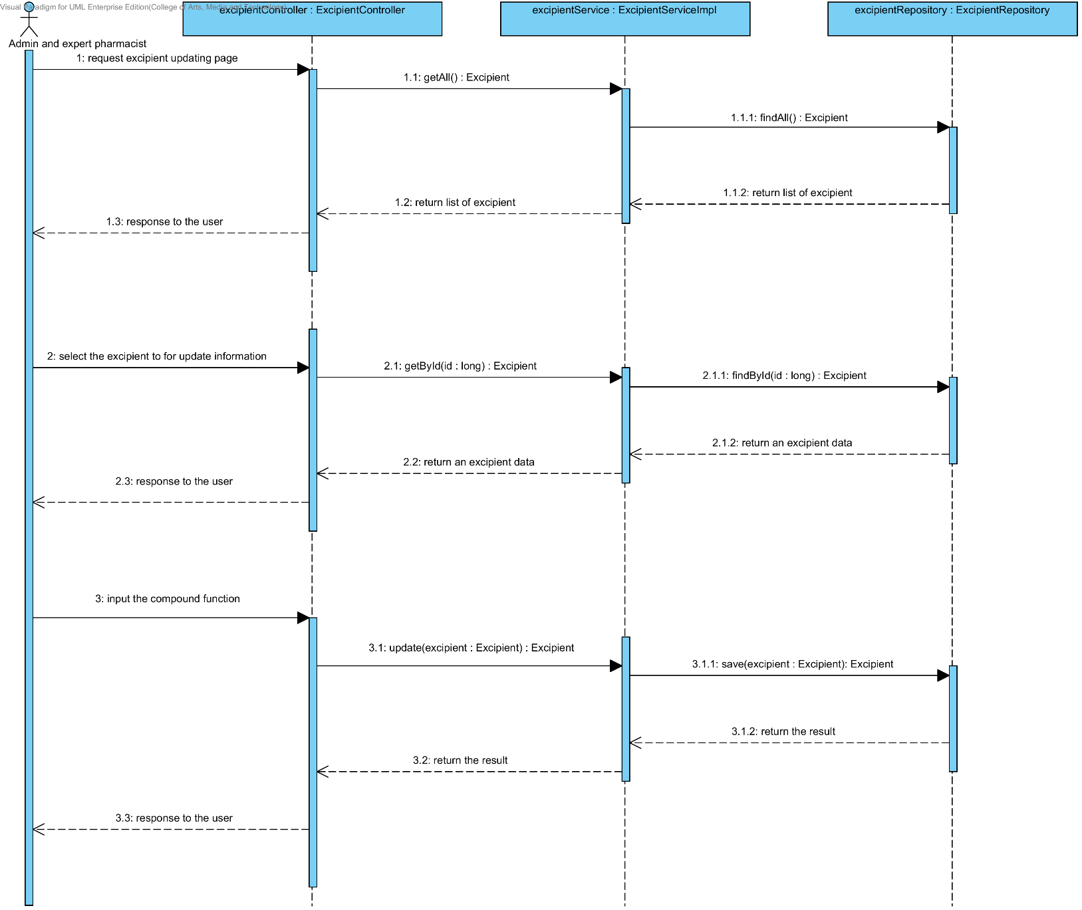

### 4.3.3 URS-18: The user deletes an existing excipient from the system.

In the sequence diagram, the user can delete an existing excipient from the system. Firstly, the user opens the excipient deleting page. The system shows all excipient data on the screen, then the user selects excipient for deleting. After that, the excipient controller finds an appropriate service for excipient deleting. Finally, the excipient controller shows the excipient that already deleted on the deleting excipient successful page.

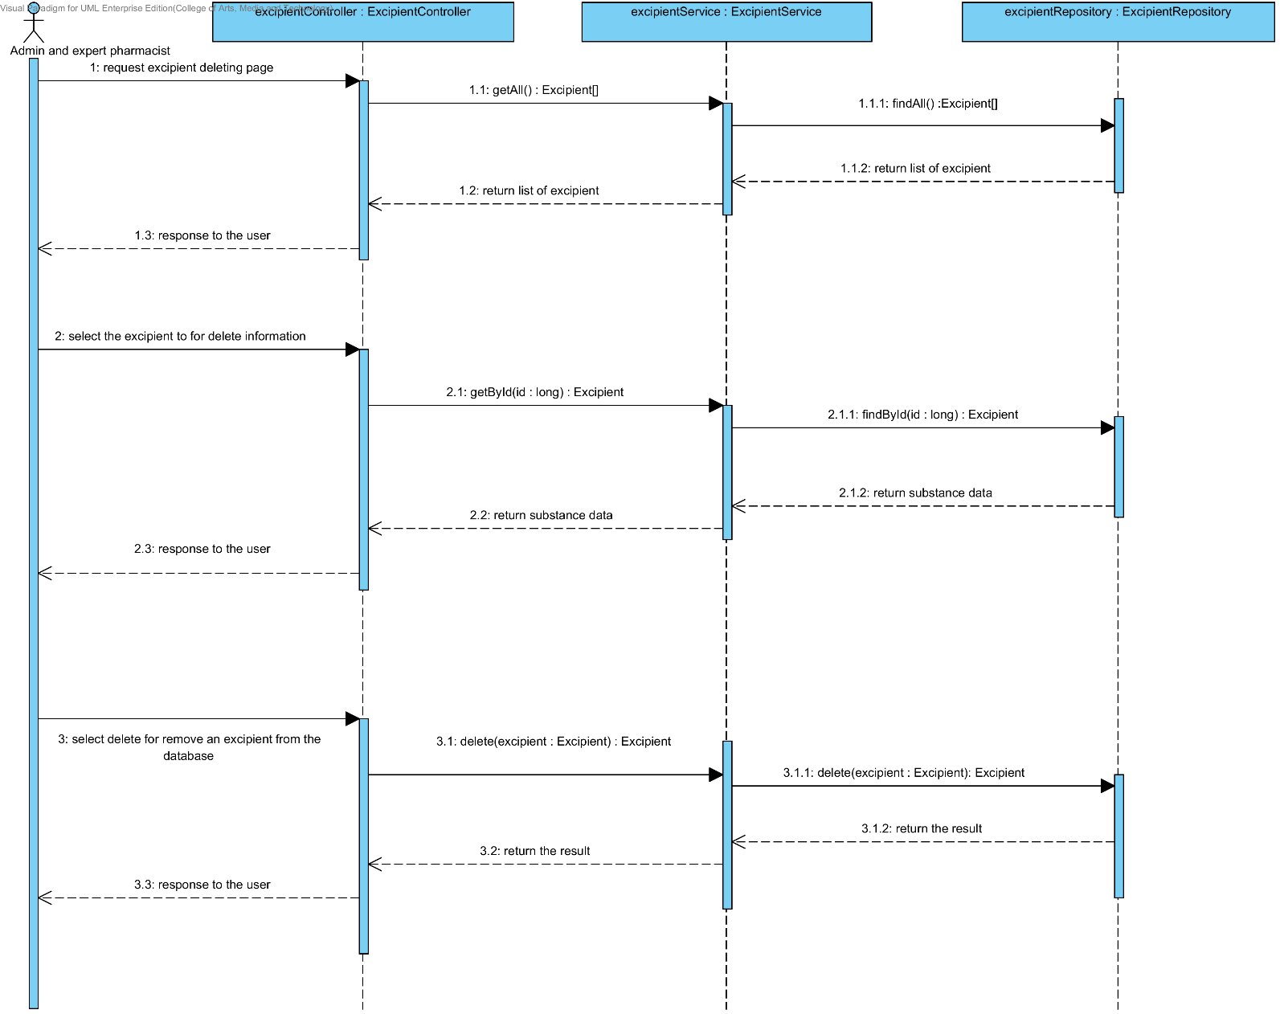

### 4.3.4 URS-19: The user views the excipient in the system.

In the sequence diagram, the user can delete an existing excipient from the system. Firstly, the user opens the excipient deleting page, then the system shows all excipient data on the screen.

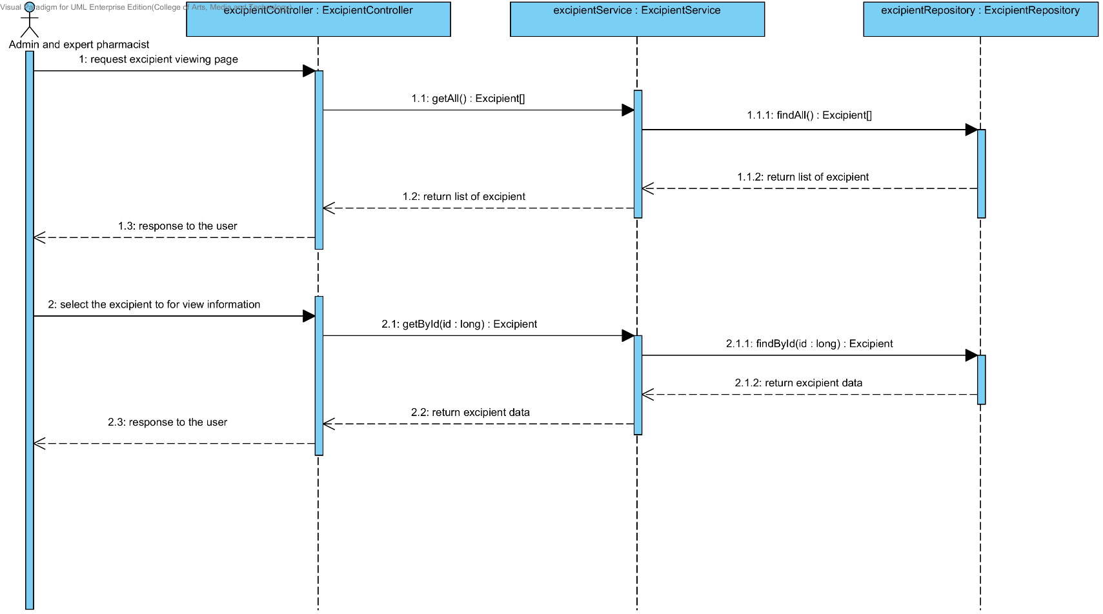

## 4.4- Feature 8: Manage the drug formulation

### 4.4.1 URS-20: The user adds a new drug’s formulation to the system.

In a sequence diagram, the user can add a new drug’s formulation to the system. Firstly, the user opens the drug’s formulation adding page, then the user input drug’s formulation data data such as name, excipient, substance quantity and substance intensity. The drug’s formulation controller gets an input data from the user. After that, the drug’s formulation controller send a new drug’s formulation data to appropriate service for adding a new drug’s formulation. Finally, the system show a new drug’s formulation with the adding drug’s formulation successful page.

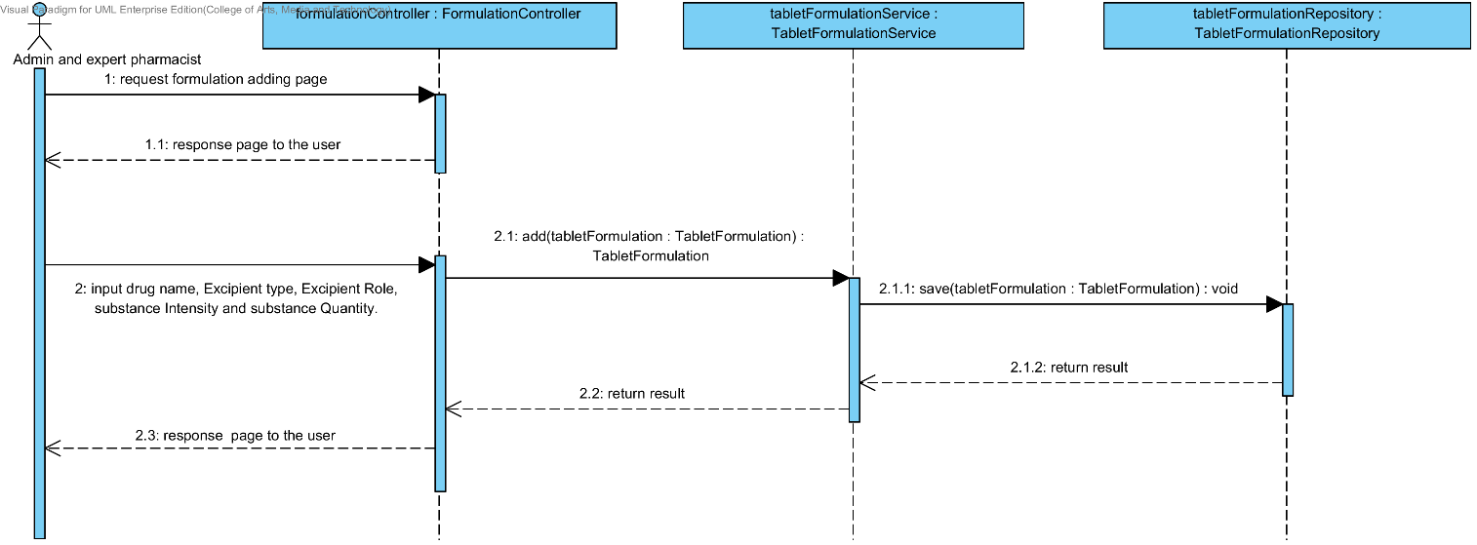

### 4.4.2 URS-21: The user updates an existing drug’s formulation in the system.

In a sequence diagram, the user can update an existing drug’s formulation in the system. Firstly, the user opens the drug’s formulation updating page, then the user input drug’s formulation data such as name, excipient, substance quantity and substance intensity. The drug’s formulation controller gets a drug’s formulation data from the user. After that, the drug’s formulation controller send a new drug’s formulation data to appropriate service for updating an existing substance in the system. Finally, the system show drug’s formulation that already update with the drug’s formulation updating successful page.

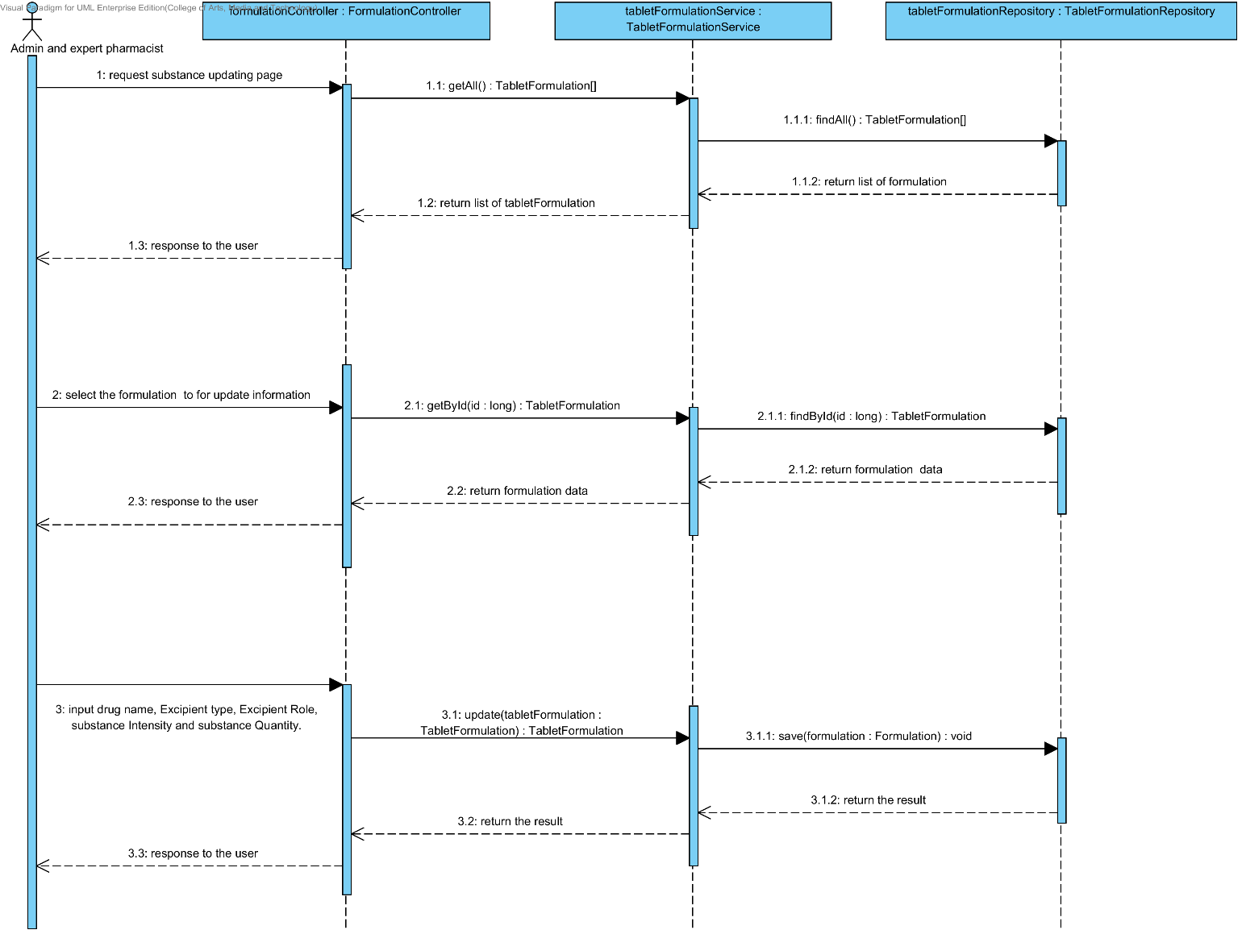

### 4.4.3 URS-22: The user deletes an existing drug’s formulation from the system.

In the sequence diagram, the user can delete an existing drug’s formulation from the system. Firstly, the user opens the drug’s formulation deleting page. The system shows all drug’s formulation data on the screen, then the user selects drug’s formulation for deleting. After that, the drug’s formulation controller finds an appropriate service for drug’s formulation deleting. Finally, the drug formulation controller shows a drug’s formulation that already deleted on the deleting drug’s formulation successful page.

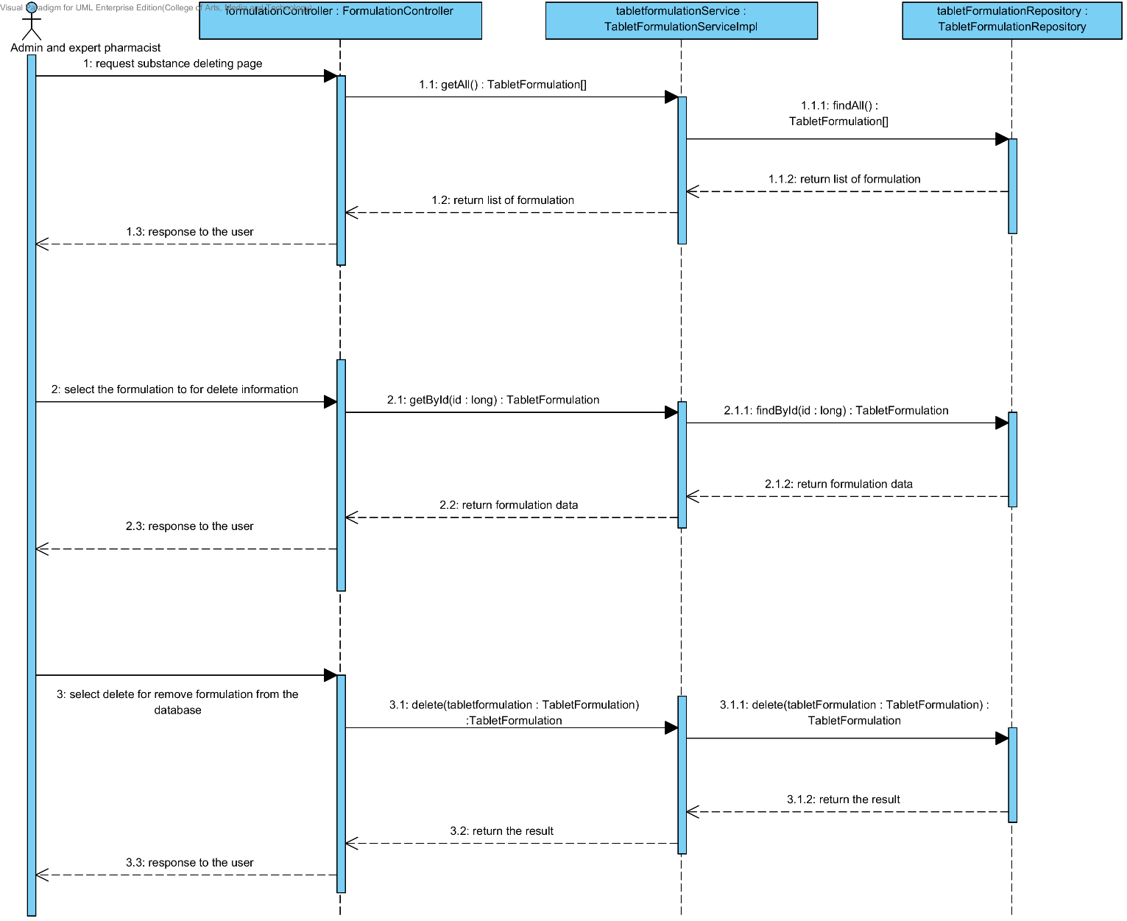

### 4.4.4 URS-23: The user views the drug’s formulation in the system.

In the sequence diagram, the user can delete an existing drug’s formulation from the system. Firstly, the user opens the drug’s formulation deleting page, then the system shows all drug’s formulation data on the screen.

